Russia May Increase its Influx of Migrants from Southeast Asia
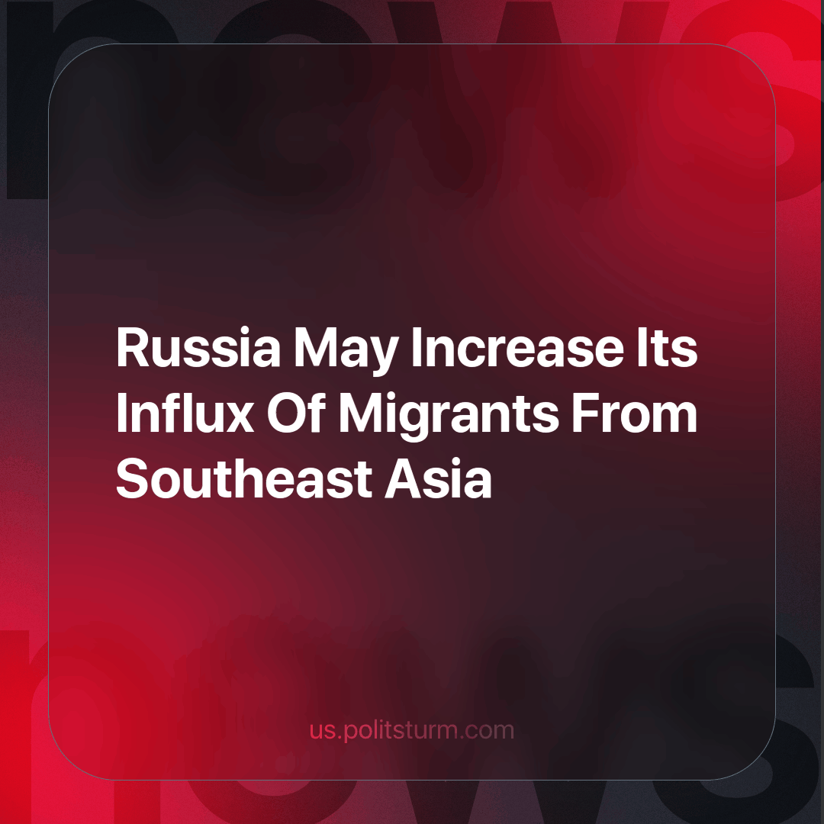

Original article
2023-11-20
2 min read

Russian Business Ombudsman Boris Titov recently presented measures to Vladimir Putin, proposing a simplified labour migration mechanism to alleviate labour shortages.
The primary emphasis of this proposal is on citizens from visa countries—individuals who require a pre-issued visa to enter Russia. Specifically, the Ombudsman has directed attention towards citizens from Southeast Asia. This encompasses countries such as Vietnam, Cambodia, Laos, Myanmar, Thailand, Brunei, East Timor, the Philippines, Malaysia, Indonesia, and Singapore.
Titov’s letter to the president highlights that Russia has reached record-high labour shortages. According to Titov, nearly 54% of entrepreneurs surveyed by the Stolypin Institute for the Economics of Growth reported a shortage of workers.
Simultaneously, Titov argues that relying solely on citizens from the Commonwealth of Independent States (CIS) to meet labour needs is no longer feasible. To address this, he suggests expanding the foreign labour force from countries with visa entry requirements. For workers from visa-required countries staying in Russia for less than a year, Titov proposes replacing a work permit with a patent, mirroring the arrangement with visa-free countries like Tajikistan, Uzbekistan, Moldova, and Azerbaijan. Additionally, RBC reports that issuing visas for groups of labour migrants could be moved online at the employer's request.
Earlier, The Higher School of Economics stated that to maintain its population of 146 million people, Russia needs to attract between 390,000 and 1.1 million migrants annually until the end of the century. The University simulated three different scenarios involving different fertility rates, life expectancies, and population outflow indicators. None of these scenarios indicated significant population growth without the influence of migration.
In Russia, the mortality rate has exceeded the birth rate for years. Despite this, the government seems slow to address issues like healthcare, education, and low wages. Instead of improving citizens' lives in order to solve demographic issues, there's a focus on attracting migrants. This benefits Russian entrepreneurs, who exploit migrants willing to work for lower wages and endure labour rights violations due to their challenging situation and ignorance of the Russian language.
The use of cheap migrant labour creates additional pressure on the labour market, reducing average wages and complicating job searching for Russians themselves. Consequently, this dynamic contributes to a negative sentiment among many Russian citizens towards migrants who have “come in large numbers” and “taken up jobs”, providing fertile ground for nationalism.
Workers worldwide must recognize that societal divisions based on nationality only serve the ruling class. The state aims to pit working masses against each other, diverting attention from their common enemy—capitalism. Only unification and the struggle for socialism, which eliminates all exploitation of man by man, can provide us with the essential social benefits for a dignified and comfortable life for all.
Sources:
1. RBC - “Russia may expand the influx of migrants from Southeast Asia” dated September 27, 2023.
2. News agency “Nakanune.RU” - “Up to 1 million per year for 80 years: HSE proposed to flood Russia with migrants” dated April 13, 2023.

Original article

