Russia has captured 2/3rds of all valuable Ukrainian deposits
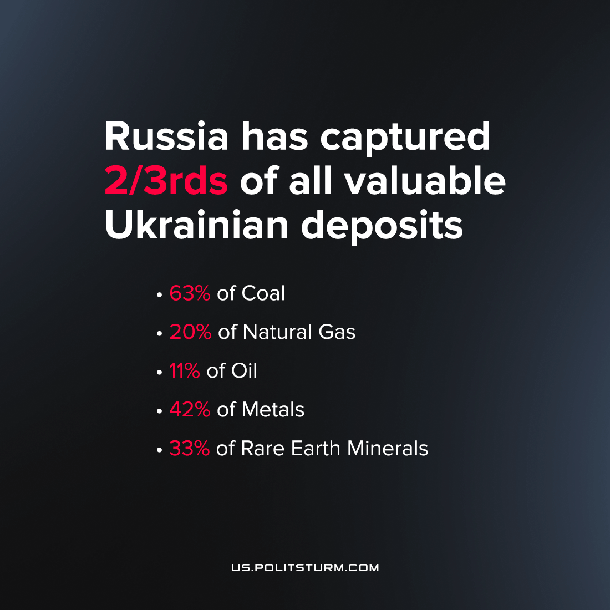

Original article
2022-08-29
2 min read

The Washington Post reports that the Russian Federation now controls 63% of coal deposits in Ukraine, 11% of oil, 20% of natural gas, 42% of metals and 33% of rare earth worth $12.4 trillion. The publication is based on the estimates of the Canadian company SecDev, which provides services in the field of data analysis.
According to their study, since February 24th, Russian Armed Forces captured 41 coal deposits, 27 natural gas deposits, 14 propane deposits, 9 oil deposits, 6 iron ore deposits, 2 titanium ore deposits, and 2 zirconium ore deposits. In addition, one each of strontium, lithium, uranium, gold and a large limestone quarry was captured.

Error loading image
Map of Ukraine showing the regional concentration of mineral resources.

As a result of the loss of territories during the armed conflict, Ukraine has not only lost 19% of its pre-war GDP but also faced serious risks for investment in the mining industry, which plays a significant role in the Ukrainian economy. In addition, experts also note that for this reason, Western Europe will lose one of the alternatives to the supply of raw materials from Russia and China.
For clarity, the publication cites the experience of the Polish-Ukrainian investment company Millstone & Co, which in 2021 concluded a deal with an Austrian mining company regarding the exploration of two untapped lithium deposits, which became impossible due to hostilities. However, plans to build a lithium battery plant also failed.
With this example, the imperialist nature of the current conflict is clearly laid out. The current situation shows that the ruling classes of the opposing countries resort to violence not by the will of a “mad dictator” who satisfies his “morbidly manic ambitions” but because of objective internal contradictions that make up the very essence of monopoly capital, with the sole goal of making a profit by any available means and without overlooking brute force if it will bring them success in the corporate division of the earth’s riches.

Original article

