Russia Offers to Hand Over the Development of its Rare Earth Minerals to the US
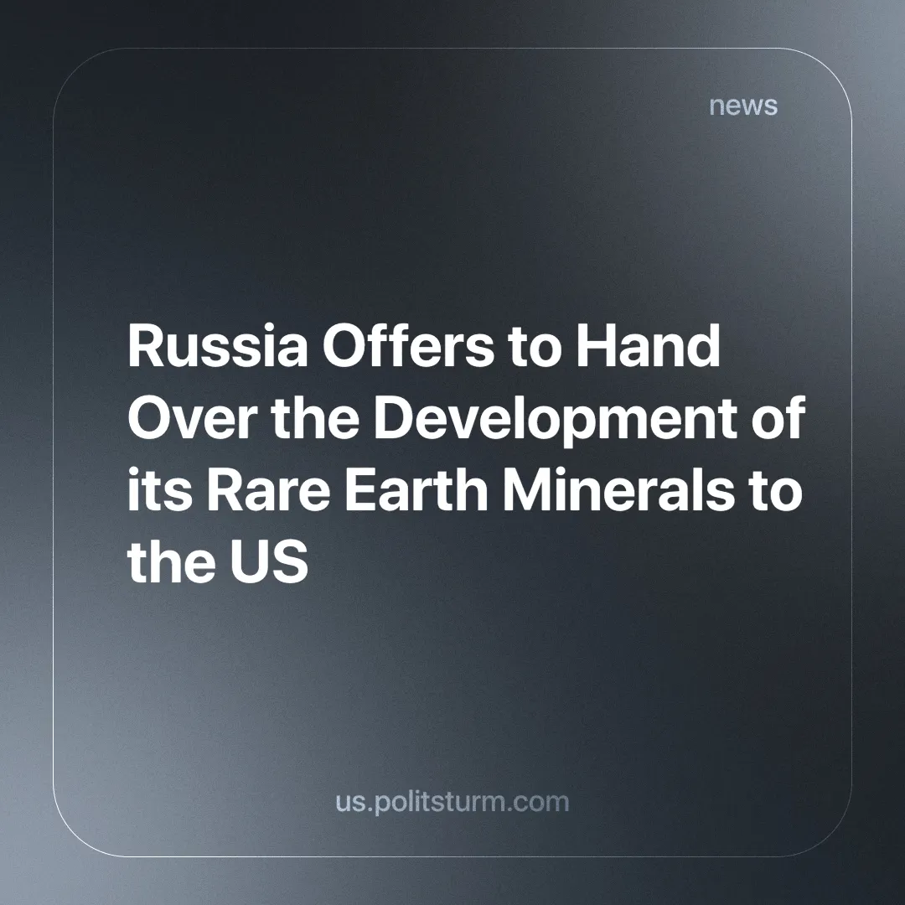

Original article
2025-03-11
3 min read

The Russian presidential envoy to the Ural Federal District, Artyom Zhoga, held a meeting to discuss the strategic importance of rare earth metals. He set the goal of creating a reserve for them, explaining it as in the interest of the state [1]. The statement of the official is not without significance, as rare earths are quite literally the key to technological sovereignty.
Control over their production ensures the future because "green" energy, digitalisation, and artificial intelligence development depend on it. Today, China dominates this area, providing them with an advantage in the struggle for raw materials markets and promising huge profits for national oligarchs [2].
At the same time, the Russian Federation is estimated to hold about 20-25% of the world's reserves of all rare earth metals [3]. For Russia, the development of this industry is an opportunity to strengthen its position, reduce dependence on imports and create new jobs. But so far, huge reserves remain untapped due to outdated infrastructure and lack of investment [3].
In practice, however, these resources are the subject of negotiations with “foreign partners”, such as the United States, whose authorities openly declare their desire to acquire Russian minerals. US President Donald Trump stated that he would like to buy minerals, including rare earths, produced on Russian territories, noting that this would be beneficial for both countries [4]. The Russian authorities have on their part expressed the willingness to cooperate with the United States on this matter, emphasising that the Russian Federation has significant reserves of these resources [4].
This contradicts the Envoy's view that these resources must be conserved for the development of the national economy. But it follows the logic of the market economy. The patriotism of the Russian authorities is limited by the interests of capitalists who are ready to sell strategic resources to foreign partners, whom Sergei Naryshkin, Director of the Foreign Intelligence Service of the Russian Federation, called Russia's most dangerous geopolitical opponent only a year and a half ago [5].
In an interview with the Russian magazine "National Defense", [5] Naryshkin (Director of the Foreign Intelligence Service) stated that "after the collapse of the Soviet Union, the "main enemy", which was unfairly being called Russia's "partner", was again leading various world "hyenas" in the "creeping campaign" against Russia".
Thus, instead of developing national industry and technology, rare earth metals, which are used in key industries such as aeronautics, space and battery production, Russia instead becomes the subject of transactions that primarily benefit multinational capital. And, of course, the local capitalists who are part of it instantly forget the "geopolitical" rivalry when there is a possibility of making a profit.
The Soviet government invested a lot of money in geological exploration, the results of which are still being used not only in Russia but also in former Soviet republics such as Kyrgyzstan. At the same time, the head of Rosgeologiya, Sergei Gorkov, admits that the deposits discovered in the Soviet Union are being depleted and that the authorities are not allocating enough money to develop new ones [6].
It turns out that modern and “efficient” managers of the market economy still rely on the results achieved within "unviable" centrally planned economy of the USSR. And now, after 30 years of parasitising the Soviet legacy, it suddenly turns out that the Russian monopolists do not want to spend their money on geological exploration and mining. It is much easier for them to attract richer Western partners, even those who have recently been called “main rivals” and “hyenas”.
There's no contradiction and there is nothing personal — it's just a business. In a market economy, business protects only their own pocket. The sale of rare earth metals by capitalists is a natural consequence of capitalism, where profit always concentrates in the hands of the few. A society whose resources are used to enrich a minority remains deprived of access to the fruits of its own labor. The capitalist distribution of wealth is based on the exploitation of labor and resources for the benefit of a small elite. This is the outcome of a system that prioritizes profit over the needs of society.
Rare earth metals, as part of our shared planet’s natural wealth, should inherently be public property since they belong to society as a whole. However, under capitalism, they become private property, leading to their exploitation in the interests of the capitalist class. Only under socialism, when the means of production are transferred to society's hands, can rare earth metals truly become public property, used for the benefit of all. Сurrent capitalist practices regarding the country's resources may threaten future generations’ access to them. However, the businessmen do not think about this, and in order to enrich themselves, they declare "After me, the flood".
Sources:
[1] Nakanune.ru — “Zhoga instructed to conserve reserves of rare metals in the Sverdlovsk and Chelyabinsk regions” from 26.02.2025
[2] RBK — "Rare earth metals: their properties and where they are mined" from 27.02.2025
[3] Kommersant — "Rare earth demand" from 25.02.2025
[4] Nakanune.ru — "Trump: The United States would like to acquire natural resources not only of Ukraine, but also of Russia" from 26.02.2025
[5] RIA — "Naryshkin named Russia's most dangerous geopolitical opponent" from 06.09.2023.

Original article

