Russia continues to pay for gas transit through Ukraine
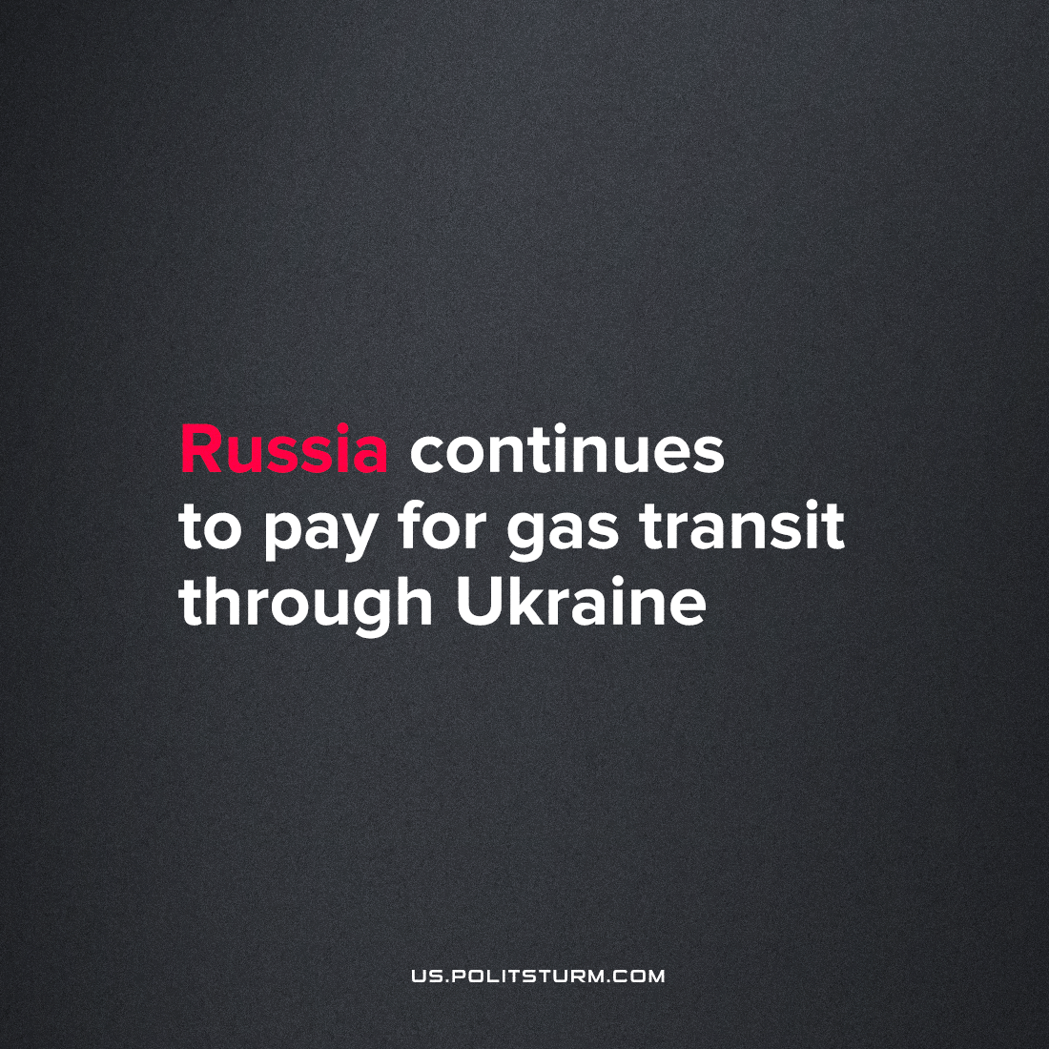

Original article
2022-08-26
1 min read

“Russia’s payment to Ukraine for natural gas transit this month has gone through without problems, even after a glitch with a similar oil transaction, according to people familiar with the situation.
State-run Gazprom PJSC sent its regular monthly payment to Ukraine’s NJSC Naftogaz Ukrainy last week and it has been accepted, according to people on both sides, who asked not to be named as the information isn’t public. ” – states Bloomberg.
The company withholding comment is intended to avoid uncomfortable questions from “patriotic” people. For them, the fact that Russian-owned natural gas is still pumping through Ukrainian territory remains an open secret.
Media controlled by the ruling class, as usual, produces everything possible to distract attention from these facts which are in obvious contradiction with the official propaganda.
In this case, particularly noteworthy is the dissonance between the public calls to impose an embargo on all Russian fuels and simultaneous profit-making from its sale and transfer to the EU.
When we look at the current military conflict in Ukraine, behind the scenes we find that it’s not a battle against “Ukrainian nazis” or “Russist orcs”, it’s not “denazification” or a fight for “freedom and democracy against totalitarianism” – it is a conflict in business interests. And if business needs gas, then it doesn’t matter who ensures the delivery.
Source: 1

Original article

