Russia Drafts Ceasefire Terms After Calling It “Unacceptable”
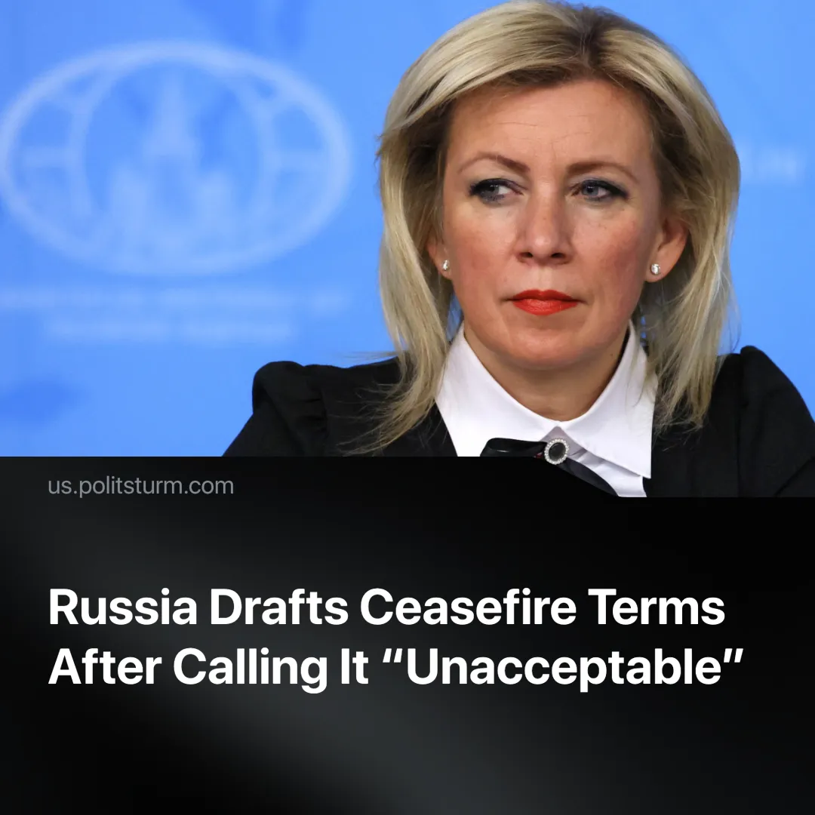

Original article
2025-06-01
1 min read

Russia and Ukraine are preparing for a temporary ceasefire. Earlier, the Russian leadership had declared a ceasefire before a peace agreement to be "unacceptable".
Details. President Putin's press secretary, Dmitry Peskov, said that the Russian and Ukrainian negotiation teams are working on a list of conditions for a temporary ceasefire.
► Peskov's statement is at odds with the words of other Russian leaders. Two weeks ago, Russian Foreign Minister Sergei Lavrov said that a ceasefire would allow Kyiv to prepare for further conflict.
► At the end of February, Lavrov's deputy Ryabkov made a statement about the "unacceptability of just a ceasefire in Ukraine."
Context. The second round of negotiations between Russia and Ukraine is expected to take place tomorrow in Istanbul. Ukrainian officials have signalled conditional readiness to attend the planned June 2 talks, but only if Russia presents a full proposal in advance. Zelensky accused Russia of dragging out the process.
► Former U.S. President Donald Trump has stepped up rhetorical pressure on Moscow, claiming in a May 29 interview that Russia had “two weeks” and warning that Putin was “playing with fire.”

Original article

