Russia And Ukraine Prepare For Peacetime
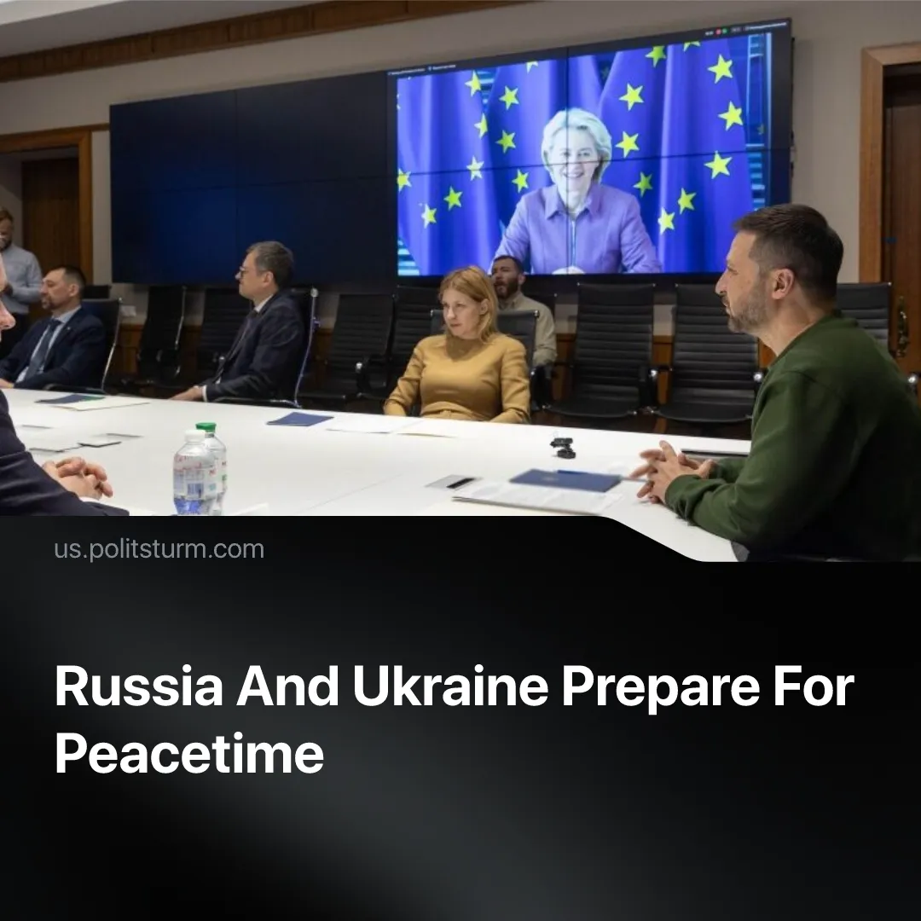

Original article
2025-09-17
2 min read

Despite the failure of negotiations, Russia and Ukraine are preparing for a transition to peacetime.
Details. Following the recent Putin–Trump summit, Russia stepped back from insisting on full control of four Ukrainian regions — Donetsk, Luhansk, Zaporizhzhia, and Kherson. Instead, Moscow proposed freezing the frontline in the southern regions (Kherson and Zaporizhzhia) while demanding that Ukrainian troops withdraw completely from eastern Donetsk. President Putin also expressed readiness to discuss security guarantees for Ukraine, provided they did not involve NATO countries.
► Volodymyr Zelensky has indicated readiness for a 30-day ceasefire under Western supervision. Alongside this, Ukraine is preparing for the deployment of the so-called “Multinational Forces of Ukraine” (MNF-U), drawn from 26 countries. Formally presented as peacekeepers, these troops would likely be organised as forces of control, reconnaissance, and coordination with the Armed Forces of Ukraine (AFU) — prepared for a potential general EU–Russia conflict.
Context. Attempts to achieve a ceasefire date back to the start of the so-called “Special Military Operation” (SMO) in 2022. The first negotiations in 2022, held in Istanbul, showed the gap in the parties’ interests.
► In early 2025, following Donald Trump’s return to the US presidency, new talks were initiated to revive a peace process, to focus on its intra-imperialist conflict with China. These rounds included proposals for temporary ceasefires and prisoner exchanges, but no comprehensive agreement was reached
► During the Easter Truce in April 2025, Russia declared a short, unilateral 72-hour ceasefire over the Orthodox Easter period. Both sides accused each other of violations.
► July 23–24, Russian and Ukrainian delegations met in Istanbul to discuss ways of ending the conflict. While no peace agreement was reached, both sides signalled some willingness to reconsider their demands.
► As of September 12, 2025, the Kremlin announced that peace talks are paused, blaming European countries for hindering the process.
Important to Know. The conflict has severely strained the economies of both countries, pushing them toward negotiations. In Russia, inflation remains high at 9.5%, while Housing and Communal Services (HCS) prices are set to rise by 12%. The transport and logistics sector is under pressure, with declining railway shipments disrupting exports and domestic supply chains. Russia also faces a labour deficit of approximately 10.6 million workers amid negative population growth.
► As of mid-2025, Ukraine’s debt stands near 97-99% of GDP and is projected to exceed 110% by the end of 2025. Main creditors are the EU countries and the US. Ukraine faces acute labour shortages amid the mobilisation, infrastructure destruction and consequent energy shortages, weak harvests and 15.9% inflation in May 2025.
► Global tensions are increasing as imperialist powers prepare for a new redivision of the world. The EU is rapidly militarising, US defence spending is projected to reach $1 trillion in 2026, and China continues heavy military investment in preparation for direct conflict.
► Europe seeks to deploy tens of thousands of troops to secure a pro-European course of the Ukrainian government, protect Western capital interests, and act as a “mediator” among factions of the subordinate Ukrainian bourgeoisie.

Original article

