Russia and Sweden Adopt New Laws on Stricter Censorship
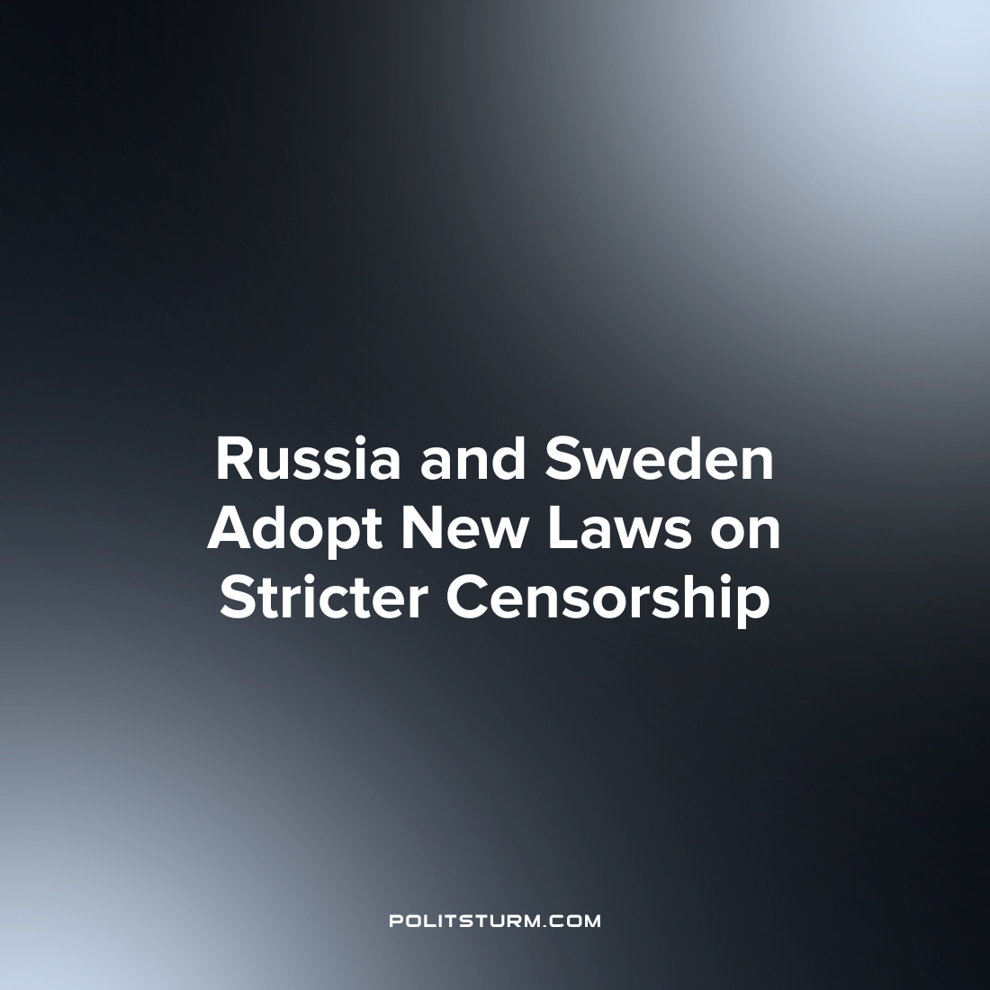

Original article
2023-04-06
3 min read

On the territory of the post-Soviet space, the "law about fakes" is widely known (Article 207.3 Public dissemination of deliberately false information about the use of the Armed Forces of the Russian Federation, the execution of their powers by state bodies of the Russian Federation), introduced into the Criminal Code of the Russian Federation on March 25th, 2022. According to this law, the dissemination of false information about the Russian army will be punishable by a fine of up to one million rubles, forced labor for up to three years or imprisonment for up to three years.
On March 1st, 2023, the State Duma introduced amendments to Article 207.3 of the Criminal Code of the Russian Federation, which provide for even stricter penalties for the dissemination of false or defamatory information. After amendments to the Criminal Code of the Russian Federation, violators of the law can receive a fine of up to five million rubles and a prison term of up to fifteen years. Moreover, this time the ban will concern information not only about the Russian army, but also about all participants of the SMO (special military operation), including volunteers and former prisoners serving in private military companies.
Strikingly similar laws are being adopted simultaneously in Sweden. On November 16, 2022, the Swedish parliament voted to introduce new amendments to the constitution that severely restrict freedom of speech and the press.
According to these amendments, the dissemination of information that "may harm Sweden's relations with another State or international organization" will be considered a criminal offense and may be punishable by up to 8 years in prison. It is noteworthy that the information should not be considered "false", but only "harmful" in order to fall under a criminal article.
In the official Swedish media, the censorship amendment is issued for "protecting democracy" and "strengthening the protection of classified information" in order to counteract "espionage in favor of a foreign state" on the territory of Sweden. In fact, the new amendment criminalizes criticism of the Swedish government or the allied states of the EU and NATO.
For example, coverage of Sweden's plans to build a weapons factory in Saudi Arabia can be classified as sabotage against the Swedish state. It may also be considered a criminal offense to disseminate information about US incursions into foreign countries or the persecution of Kurds in Turkey.
Simultaneously with the amendments to the Criminal Code of the Russian Federation in March 2023, the Swedish government is taking measures aimed at tightening censorship laws in its own country. To speed up the process of joining NATO, the Swedish parliament is considering a new law proposed on March 9, which will establish criminal penalties for "assisting or supporting terrorist organizations."
At the same time, a "terrorist organization" can be considered a political or public organization banned on the territory of any EU or NATO country. For example, waving the flag of the Kurdistan Workers' Party, banned in Turkey, may entail criminal liability in Sweden in the future.
"The fact that such a law is necessary is quite obvious. Sweden has had weak legislation regarding participation in terrorist activities for too long," Swedish Prime Minister Ulf Kristersson said at a meeting of parliament on March 1st.
New laws in Sweden clearly reveal the hypocritical rhetoric of bourgeois-democratic regimes about "human rights". Behind the beautiful words about "freedom of speech" are the intentions of the bourgeois class to protect their own interests in the media, and not at all to allow the proletariat to criticize the existing order.
Therefore, it should not be surprising that similar laws on censorship of "harmful" information are being introduced in parallel in the Russian Federation and in the capitalist countries of the West. As long as the capitalists are in power, they will continually try to restrict and curtail the rights and freedoms of the working class, whose interests are in direct conflict with the interests of the capitalist class. True freedom for the proletariat can be achieved only with the transfer of power into the hands of the working people and the establishment of socialism.
Sources:
"Article 207.3 of the Criminal Code of the Russian Federation. Public dissemination of deliberately false information about the use of the Armed Forces of the Russian Federation" dated March 5th, 2022
74 RU – "The punishment for discrediting the Armed Forces will be even stricter: violators face a term of up to 15 years" from March 14th, 2023
Riktpunkt – ”Har vi en yttrandefrihet om den nya lagen antas?” from November 15th, 2022
Sveriges Radio – ”Grundlagsändring om hemliga uppgifter kan försvåra för medier” from November 4th, 2022
SVT – ”Riksdagen beslutar om ändring av grundlagen – spionerilagen blir tryckfrihetsbrott” from November 16th
Tidningen Näringslivet – ”Riksdagen antog lagen om utlandsspioneri" from November 16th, 2022
Dagens Nyheter – ”Regeringen går vidare med terrorlag – trots Lagrådets kritik" from March 1st, 2023
Riktpunkt – “Skärpta straff för stöd till terrorism” from March 11th, 2023

Original article

