Russia and Imperialism
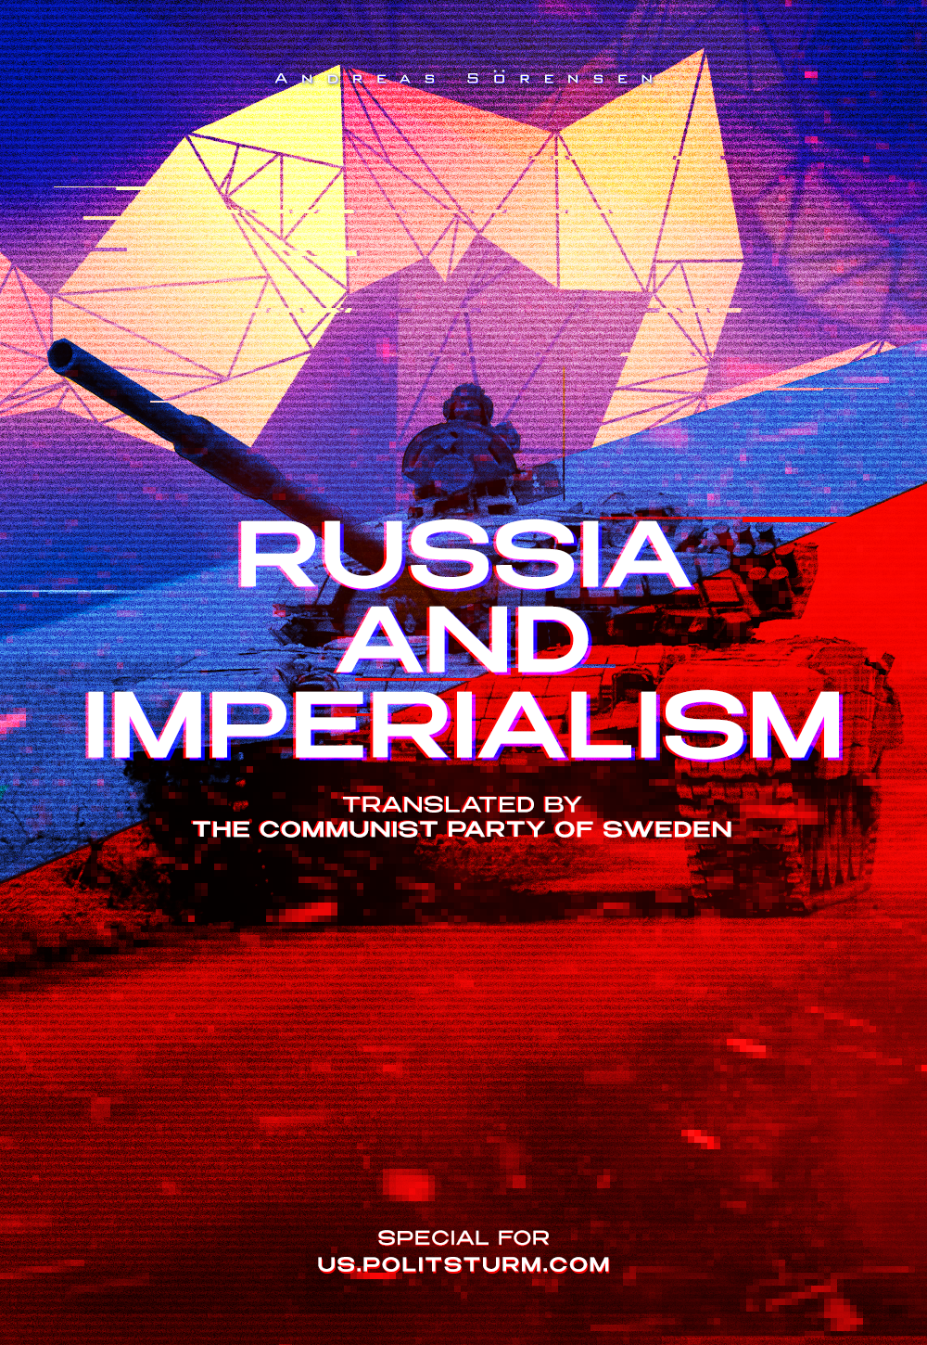

Original article
2022-05-22
23 min read

Preface by Politsturm
This article by Andreas Sörensen – the General Secretary of the Communist Party of Sweden – opens a series of materials, as a part of our collaboration with CP of Sweden.
The original material titled “Anders Carlsson, Ryssland och imperialismen” was published in “Riktpunkt” magazine in June 2020, almost 2 years ago. Anders Carlsson was a chairman of the “Communist Party”, known as “Communist Party Marxist-Leninists (Revolutionaries)” between 1999 and 2014.
Today, when social-chauvinist hysteria rages on, it’s important to keep sober view of the current events, and modern Russia is no exception. We can see such people in other countries as well (Mikhail Popov in Russia, for example), so these views of Russia as “non-imperialist” country are not rare. This material makes contribution to the problem of the objective, Marxist-Leninist view on the situation.
Error loading image
Almost a year ago, a longer article by Anders Carlsson was published in Proletären (weekly newspaper of the Carlsson’s “Communist Party” – Politsturm), in which he set out to analyze modern Russia. It is undoubtedly an interesting article in which Carlsson seeks to substantiate his thesis with both theory and facts that Russia is not actually imperialist, but rather to be considered both a “semi-colony” and a great power.
This article will focus on two aspects, both of which are interrelated: the view of imperialism and the view of Russia’s role in the imperialist system. This presentation will contrast with the one made by Carlsson and the conclusions will contradict those drawn by Carlsson. In doing so, I hope to contribute to the concreteness of the discussion of imperialism and hopefully offer a different perspective that breaks with established and conventional patterns.
By discussing the concrete example of Russia, I also hope to prove my thesis with the help of a not entirely uncontroversial country: there are no imperialist countries, but only capitalist countries that compete with each other within the capitalist system at their imperialist stage. From this, we finally draw a number of political conclusions that can hopefully guide us in the future.

How does Anders Carlsson understand imperialism?
Carlsson has the theoretical basis for his analysis of imperialism and Russia in the analysis made by Lenin as early as 1916, and published in the book Imperialism, the Highest Stage of Capitalism. Lenin’s book was in many ways groundbreaking and was a continuation of Marx’s analyses of capitalism. Carlsson himself writes the following about Lenin’s analysis:
“In his book Lenin defined imperialism as the highest stage of capitalism, imperialism as monopolistic capitalism, but he himself found this definition too brief, and thus too superficial, hence his famous five points.
I shall not list all five here, but shall confine myself to the three most relevant to the analysis of Russia today:
• The fusion of bank capital with industrial capital and the emergence of a financial oligarchy on the basis of this financial capital.
• The export of capital, as distinct from the export of commodities, acquires particular importance.
• International monopolistic associations of capitalists, dividing the world among themselves, are formed.”
I shall dwell here for a moment before going on to analyze what these points meant to Lenin and how Anders Carlsson chooses to interpret them in a Russian context. In this first paragraph, which is the only one in which he explains his theoretical starting point, a number of questions arise.
Only three of Lenin’s five points have been selected. Why these? Why not the remaining two, which he does not discuss further? No explanation is given for the selection, but the reader must rely on the fact that his selection is correct and guided by intellectual honesty.
While I will not speculate on Carlsson’s motives, it can be said that if Carlsson had included all five of Lenin’s points, his analysis would have been impossible to carry out. It would have become obvious that these points are not meant to be applied to a given capitalist country, as Carlsson does, but that they are meant to be applied to the capitalist system as such.
We shall look quickly at the fifth of Lenin’s points, because that is all that needs to be done to defeat Carlsson’s entire theoretical foundation:

The territorial division of the earth between the great capitalist powers is complete.
To try to interpret this last point as if it concerned the degree of imperialist development in each individual capitalist country is impossible. Not even Anders Carlsson can do that, and so he has made it easy for himself: he simply left the point without further explanation.
If Anders Carlsson is to pursue his theorizing, he has a number of questions to answer. Why can some of the points be applied to individual countries but not others? If Carlsson is right, he must be able to answer why Lenin intended some of these points to apply to individual countries and why some would apply to several. The last question is really the most important: why did Lenin define imperialism as such by means of his five points while Carlsson reduces them to points by which he measures Russia’s imperialism?
Anders Carlsson will not be able to answer these questions because he is simply wrong. Lenin himself described these points as characteristics of a developing phenomenon and that is precisely how we must understand them.
“And so, without forgetting the conditional and relative value of all definitions in general, which can never embrace all the concatenations of a phenomenon in its full development, we must give a definition of imperialism that will include the following five of its basic features” – Vladimir Lenin.
What Anders Carlsson reduces to “points” is in fact characteristic of the system. It means that in each capitalist country concentration is increasing; that in each capitalist country finance capital is forming; that in each capitalist country capital exports are growing at the expense of the importance of commodity production; and that in each capitalist country the monopolies are concluding international agreements aimed at the division of the market and profits. This means nothing other than that this development and its driving forces are in full operation everywhere and all the time.
In fact, it is not at all about how imperialist a country is, but about the fact that every capitalist country competes with every other capitalist country within the capitalist system at its imperialist level. Precisely because Lenin understood that this was the case, he was able to call Russia, for example, “crude, medieval, economically backward and militarily bureaucratic” imperialism in one of his articles. To Anders Carlsson, this must seem incomprehensible.
Error loading image
For the sake of argument, however, we assume that Anders Carlsson is right: we are right to interpret Lenin’s points as precisely criteria to be applied to each individual capitalist country in order to determine whether a country is imperialist or not. This would mean that we need to establish, in the first place, at what point a given country goes from being capitalist to imperialist. Does a country become imperialist at a given concentration of ownership? Or when a certain number of banks are merged with a certain number of industrial companies? Or when capital exports reach a certain level?
These boundaries are bound to be arbitrary and, therefore, they have no claim to objectivity and are completely meaningless.
There is little doubt that the theoretical basis on which Anders Carlsson bases his analysis is shaky, but what about the actual analysis of Russia? Is he not correct in the figures he has chosen to prove that Russia is not imperialist?
No, he is not right here either. The figures and statistics he presents are either the result of a very sloppy job, or him carefully selecting what he wants to present in order to support his thesis.
In what follows, we will look at each of the points he presents. In doing so, we want to show that it is not just an arbitrary selection of figures that gives a picture of Russia that fits the one he wants to present, but we also want to show some additional theoretical errors that ultimately lead Carlsson to abandon not only the Leninist analysis, but also the Marxist one

Russia and the imperialist system
Starting from the beginning, we highlight the first of Lenin’s points which, Carlsson chose not to raise in his analysis, despite its importance, particularly with regard to Russia.

Concentration of production and capital, which has reached such a high stage of development that it has created monopolies, play a decisive role in economic life.
This point is fairly self-explanatory and Marx already discussed the concentration and centralization of capital. The tendency of capitalism, whether it is at its imperialist stage or not, is always to concentrate ownership in the hands of fewer and fewer capitalists. This is a truth which applies to every capitalist country and which no one can or wants to dispute.
Since it applies to every capitalist country, it naturally applies to Russia too, even more so than compared to other capitalist countries: as much as 85% of Russian private assets are in the hands of 10% of the population. In the United States, “only” 75% of private wealth is held by the richest 10%. One wonders why Mr Carlsson did not mention this. Could it be because the results did not fit in with the thesis Carlsson wants to push?

The merging of bank capital with industrial capital and the emergence of a financial oligarchy on the basis of this “finance capital”.
This is the first of Lenin’s five characteristics that Carlsson discusses. In Lenin it deals, among other things, with the personal union between the leading representatives of the banks and industry, and the cross-ownership between them. On this point, Carlsson’s study can hardly be said to be an investigation. He takes a brief look at the size of finance capital and draws conclusions from it, but he does not look at the actual conditions prevailing in Russia (For those who want to compare with the Swedish conditions, we refer to the brochure that SKP published in 2016 called “Sweden and imperialism”).
We shall therefore stop a little at Russia and look at what it actually looks like.
By far, the largest private gas and oil company in Russia is Lukoil. Out of this company grew the IDF Kapital group in 2003. Russia’s second largest asset management company is linked to this group and it owns 20% of Russia’s fourth largest bank, Otkritie FC.
One of Russia’s largest business groups is the Alfa Group, in which four of the richest people in Russia own shares (We have recently published an article about some capitalists from Alfa Group stuck in Britain – Politsturm). In addition to Alfa Bank, which is one of the largest private banks in Russia, it owns insurance companies (AlfaStrakhovanie, which claims to control 9.1% of the Russian market), the sixth largest telecommunications company in the world, Vimpelcom, and Rosvodokanal, which is engaged in water activities.
The company group, Basic Element, which represents major industrial interests in Russia (producing vans, trucks, aircraft, cars, trains and train carriages, among other things), is linked to the fast-growing Soyuz Bank.
The Volga Group, which owns a number of companies including Transoil (one of the largest gas and oil transport companies) and major construction companies, which also has major investments in the insurance companies Sovag and Sogaz, as well as in Rossiya Bank (the 17th largest bank in Russia).
The Interros Group is the last example. The group is owned by Vladimir Potanin, Russia’s richest man. The main company in the group is Norilsk Nickel, but it also controls Polyus Gold, which is Russia’s largest and the world’s tenth largest gold producer. In addition, it also owns 17% of the bank Rosbank.
Error loading image
We could go on to look at the specific relationship between banking and industrial capital, but five examples should be enough to demonstrate, above all, that the merging of banking and industrial capital is an ongoing process in every capitalist country, regardless of its own strength in relation to other capitalist countries.
The next item on the list is:

The export of capital, as distinct from the export of goods, acquires particular importance.
For Anders Carlsson, this is one of the most important points. He argues that the main characteristic of the modern Russian economy is the escape of money, not the export of capital. He bases his assertion on the large sums kept by Russian oligarchs in Cyprus and elsewhere. It is hardly possible to deny that huge sums have been sent from Russia to Cyprus, but is it really true, as Anders Carlsson says, that this money is lying idle there and that it is “not being invested in a process of consolidation” and is therefore not being transformed into capital either? And what is the real meaning of Mr Carlsson’s assertion that the money is lying idle?
First, Russian capital exports are very much alive. We can easily see this when we look at the investments that Russian companies have made and are making, mainly in neighbouring countries, but also in more distant ones. However, there is little point in making a list here that would take up too much space, but we can easily note that Russian companies – both state and private – own everything from steel mills in Italy, banks in Turkey and gambling companies in Greece, to pipe production in the US, telecommunications in Iran, and oil in Venezuela and Brazil. Russian capital, like any other capital, seeks the most favourable investments possible and they find them all over the world.
Secondly, money in Cyprus is far from stagnant. Cyprus, together with some other tax havens, including the Netherlands, accounts for a large part of the investments made in Russia. According to the Central Bank of Russia, by the end of 2018, more than a quarter of foreign investment in Russia had come from Cyprus – well over a hundred billion dollars of the roughly $400 billion in foreign investment. Is it then that the spider in the imperialist web is little Cyprus? No, of course not. The capital invested from Cyprus obviously belongs to other countries and monopolies but, because of favourable tax legislation, Cyprus is used as an intermediary. According to the business magazine bne Intellinews, it is clear that “a majority of the money [invested in Cyprus] is in circulation.” So it is Russian capitalists who are reinvesting the money in their own country. So far, we can see that the money is hardly sitting idle in Cyprus, but is being put back into the circulation process and thus becoming capital.
So far, however, we have not proved any export of capital with the Cypriot assets, but only a reinvestment in their own country. If we look at the Russian neighbours, however, the matter is clear: the Russian capital in Cyprus is being used for capital export.
The largest foreign investor in Belarus is, unsurprisingly, Russia. They account for 30% of total foreign direct investment. The second largest investor in the country is Cyprus, which accounts for 17.6% of investments. Hardly a coincidence.
According to the UN agency UNCTAD, Cypriot investments in the region amount to 39 billion. This makes it the second largest investor in the region after the Netherlands, whose investments are estimated to be Russian to some extent (7%). By comparison, Chinese investments are estimated at $27 billion, German at $26 billion and French at $30 billion.
We know that money in Cyprus does not sit still, it is recycled in the circulation process. We also now know that it is not only reinvested in Russia, but also exported to other countries. Mr. Carlsson’s assertion that ”this is not about investment, but about securing looted assets from clumsy tax authorities and other contingencies” thus falls flat on its face.
We have now reached the point where Anders Carlsson is leaving not only Leninism but even Marxism.
By claiming that the money of the Russian capitalists in Cyprus is lying idle, he exempts the Russian capitalists from the pressing need to increase their capital to which every capitalist is subject. In Capital, Marx writes, among other things, about the “insatiable hunger for surplus labour” and capital’s “werewolf hunt for surplus labour” – do these fundamental laws of capitalism not apply to the Russian capitalists? Are they not subject to a need to grow constantly? To constantly increase exploitation? To constantly multiply their capital? Why should they, of all people, be able to keep their money still while all the other capitalists in the world are subject to these laws?
On the basis of an inadequate (or arbitrary) collection of facts and a theoretical foundation that collapses like a house of cards on closer inspection, Carlsson fails to see that the Russian capitalists also behave like every other capitalist in the world: out of the need to constantly grow and to constantly seek the most profitable investment, Russian capital exports part of its capital. This fundamental truth is avoided by Carlsson, who thus completely leaves the domains of Marxism.
Before leaving the export of capital, let us look a little more at the theoretical aspects of the question, since they are not always obvious. The condition that forces each individual monopoly to export its capital, as opposed to investing it in its own country, is simply that the possibility of profit is greater in countries other than its own. In Lenin’s own words:
“The need to export capital arises from the fact that in a few countries capitalism has become “overripe” and (owing to the backward state of agriculture and the poverty of the masses) capital cannot find a field for “profitable” investment.”
In order to understand the export of capital, we must also understand that it is a concept which denotes the relation between the level of development reached by capitalism in any given country and the capital of that country. The over-maturity of any given capitalist country can arise in no other way than in relation to the capital of its own country, when it no longer finds a profitable investment in its own country. A surplus of capital has been created and thus must be invested. The same process takes place in all capitalist countries, which is why all countries’ capitalists seek more interest-bearing investments for their capital. However, what is profitable for one country’s capital need not be profitable for another’s, and what is not profitable for one may be profitable for another.
This relationship also explains why countries can receive exported capital and export their own capital at the same time. Capitalism develops differently and, therefore, what can be considered as an interest-bearing investment is also relative.
It is also important to point out that capital exports do not replace goods exports, but that the relative importance of goods exports is reduced at the expense of capital exports.

International monopolistic associations of capitalists, dividing the world between them, are formed.
We have now reached the third and last of Lenin’s characteristics that Carlsson chooses to discuss. The only problem is that he doesn’t actually discuss the international monopolistic associations, but under this point he chooses to compare the number of Russian companies on Forbes’ list of the world’s 2000 largest companies to conclude that “Russia is not much of a competitor in terms of dividing up the world.”
What happens is that Carlsson completely misses the efforts actually being made by Russian companies to divide up both the domestic market, but also their participation in the division of the world market. This effort is evident not least in the many cases of price-rigging, cartelization, and market-sharing that occur both inside and outside Russia involving Russian companies; most recently the uncovering of a price-fixing cartel in the pharmaceutical sector, where the market-leading Russian company Delrus, along with other companies, has divided up the Kazakh market. Perhaps the clearest example is the way in which Gazprom has dominated the Eastern European states and, through its monopoly position, has pushed through agreements favorable to its own company and to Russian capitalism.
As in all capitalist countries, the Russian capitalists are seeking to strengthen their competitiveness by all means by concluding contracts, dividing up markets, and rigging prices. There is nothing strange about that. The strange thing would be if they didn’t – the Russian capitalists are no more honest than anyone else, they are subject to the same pressures as everyone else.
The most revealing of Lenin’s characteristics, which Carlsson chooses not to discuss, is this:

The territorial division of the earth between the great capitalist powers is complete.
Since the counter-revolution in the Soviet Union, large parts of the world have again been able to be incorporated into the capitalist system, allowing a relatively frictionless capitalist expansion. This period is now over and the world is divided. What then remains is that all capitalist nations must begin to expand at each other’s expense and the contradictions within the system thus increase.
Here Carlsson’s own interpretation runs into further problems. He argues that Russian capitalism would not be imperialist – what might this mean for the participation of Russian capitalism in the re-division of the world? The distinction Carlsson makes is arbitrary and does not hold in reality, because all capitalist nations are participating in this struggle, they cannot do otherwise. The Indian, Lithuanian, Hungarian and Brazilian capitalists participate alongside the American, Swedish, German and Russian. Are Carlsson’s non-imperialist capitalist nations subject to different laws than the imperialist nations? Of course not.
In fact, it is not possible to distinguish between capitalist and imperialist nations and countries. All countries, where the capitalist class is in power, are involved in this struggle.
With this, we have returned to our starting point. In order to separate capitalist and imperialist nations, there needs to be a qualitative boundary where one passes into the other. By definition, such a boundary must be arbitrary and therefore meaningless, not to say unscientific.
It takes only a quick glance to see that what Carlsson calls Lenin’s “points” cannot be used to measure whether a country is imperialist or not. They cannot be applied to individual countries at all, but must be seen as characteristics of a developing phenomenon and therefore as processes at work in all countries.

Conclusion
At the end of this review, we must begin by noting one thing: quite apart from Carlsson’s theoretical shortcomings, he has presented an imperfect picture of the Russian reality. He has done this in order to advance a thesis. He has cherry-picked certain facts and left out (ignored?) other facts, and has thus been able to portray Russia as something it is not.
Moving on to the theoretical aspect of his “analysis”, we quickly see that it is flawed. Questions arise that he cannot answer every time he tries to use Lenin and it is clear that there is a great deal more to be desired from his use of Lenin’s own analysis. We have even found that Carlsson undercuts Marx himself!
The picture of imperialism that I have tried to paint and concretize through my own analysis differs not only from Anders Carlsson’s attempt to analyze, but also from much of the left. Where many choose to see a capitalist system consisting of a series of capitalist nations, from which a few imperialist nations have emerged, one must instead see the capitalist system at its imperialist stage, where monopolies have become the determinant of the system instead of free competition (Lenin himself argues that the transition of capitalism to imperialism does not abolish free competition, but that it continues to exist. However, it is no longer the defining feature of the system – it is the monopolies). There can in fact be no division into capitalist and imperialist nations. All capitalist nations are capitalist and they are within the imperialist system and subject to its laws and modes of operation (for this very reason the concept of anti-imperialism also falls on its own absurdity: to recognize anti-imperialism as something separate from anti-capitalism is to separate capitalism from imperialism and thus also to leave Lenin out of it).
I hope that I have succeeded in my intention and that I have thus contributed to deepening the theoretical discussion within the Swedish left. It is imperative that we adopt a correct position on these questions and analyses, which we can only do after we have arrived at a correct position through study, discussion, and polemic.
Andreas Sörensen

Original article

