Ron DeSantis on Marxists Across the U.S.
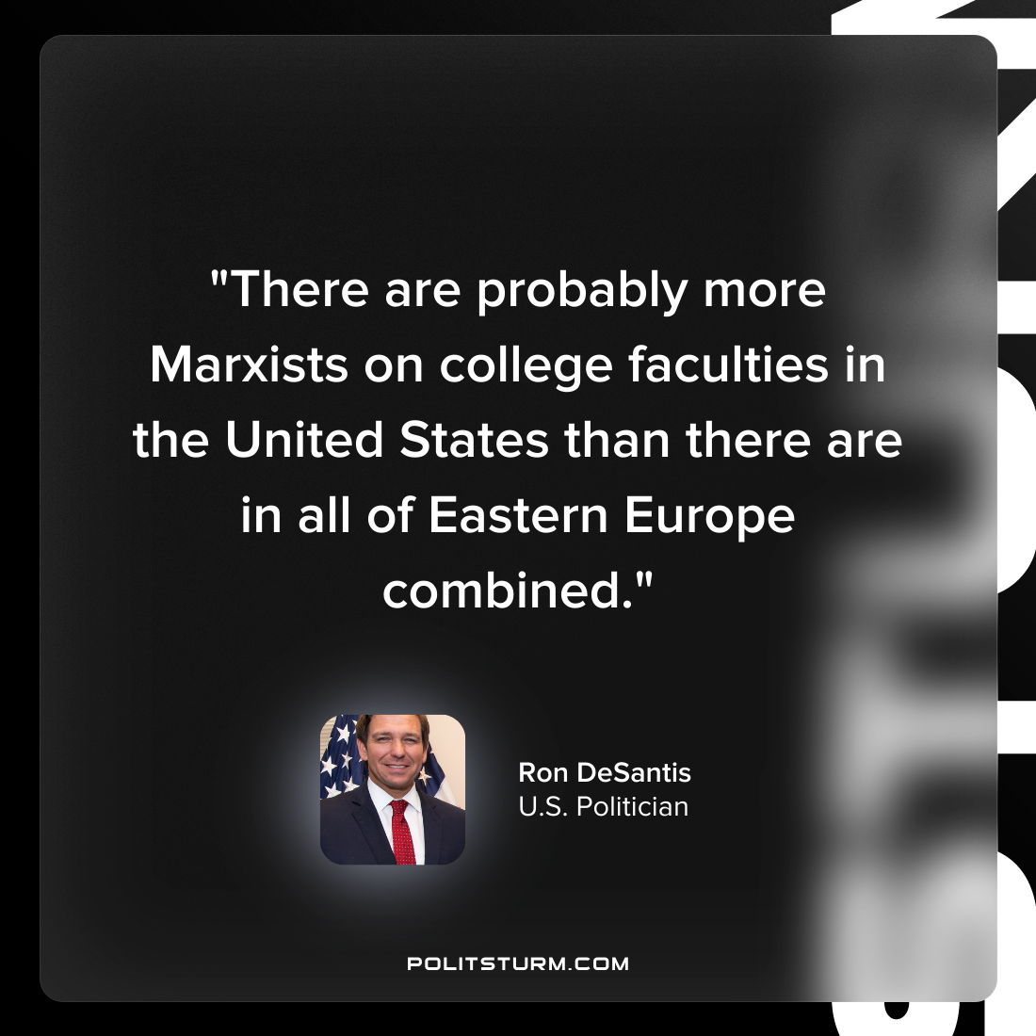

Original article
2022-05-13

“There are probably more Marxists on college faculties in the United States than there are in all of Eastern Europe combined.”
Ron DeSantis
U.S. Politician

Original article

