Rising Unemployment and Poverty in Palestine
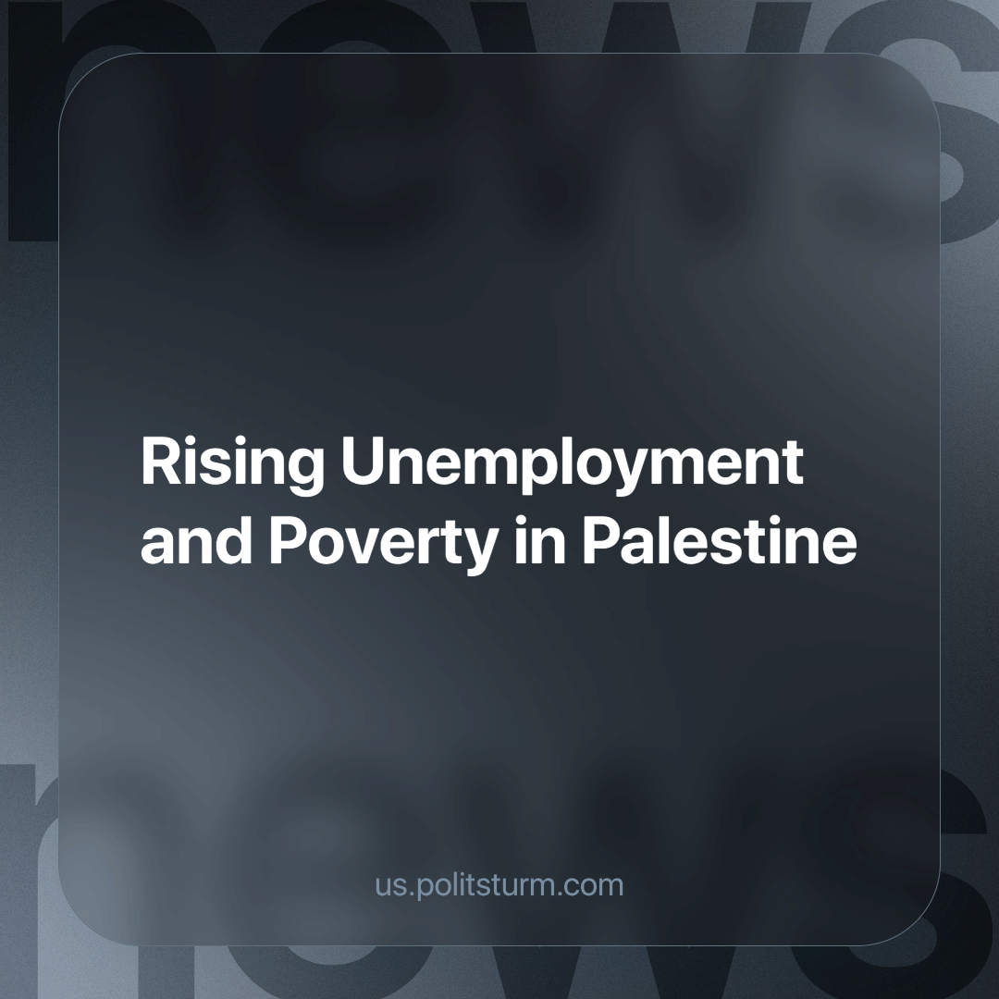

Original article
2024-05-22
1 min read

The poverty rate in Palestine could rise from 38.8% to 60.7% if the active phase of the war in the Gaza Strip lasts for nine months. This means about 1.86 million Palestinians could fall below the poverty line. Additionally, as of the first quarter of 2024, unemployment in the captured Palestinian territories reached 57%.
The capitalists, who own the means of production and political power, try to convince their population of the necessity of war with phrases about an abstract “homeland” and “defense of the fatherland”. Behind such words, a struggle for territories and markets to obtain maximum profits is hidden.
The conflict between Palestine and Israel is a natural result of the development of capitalism, which leads to the aggravation of contradictions between various transnational corporations with business interests in these regions.
Behind each side of the conflict are reactionary forces, inciting hatred and chauvinism between peoples on the basis of the unresolved Arab-Israeli issue. War brings nothing to the working people except death, poverty and hunger. At the same time, corporations are making incredible profits from orders for military needs. The stocks of arms companies are rising unprecedentedly.
Domestically, in both Israel and Palestine workers must seek to find common ground and connect their struggles against capitalism, only united workers can bring an end to the perpetual bloodshed. Abroad, seeing the devastation of the war, workers all over the world have come out in various ways demanding a ceasefire, whether it be the mass demonstrations globally or the more recent spread of student protests across the USA and Europe. But with no genuine vanguard party to explain the cause of conflicts and guide the mass movements of workers, this energy sowed chaotically by the masses is bound to reap little or no fruit.
It is possible to eliminate wars forever only after the victory of socialism everywhere, eradicating the material cause of wars.
Source: TASS - “The UN believes that the poverty level in Palestine by July 2024 may exceed 60%” dated May 2, 2024.

Original article

