Hitler's Heirs: The Rise of the European Far Right
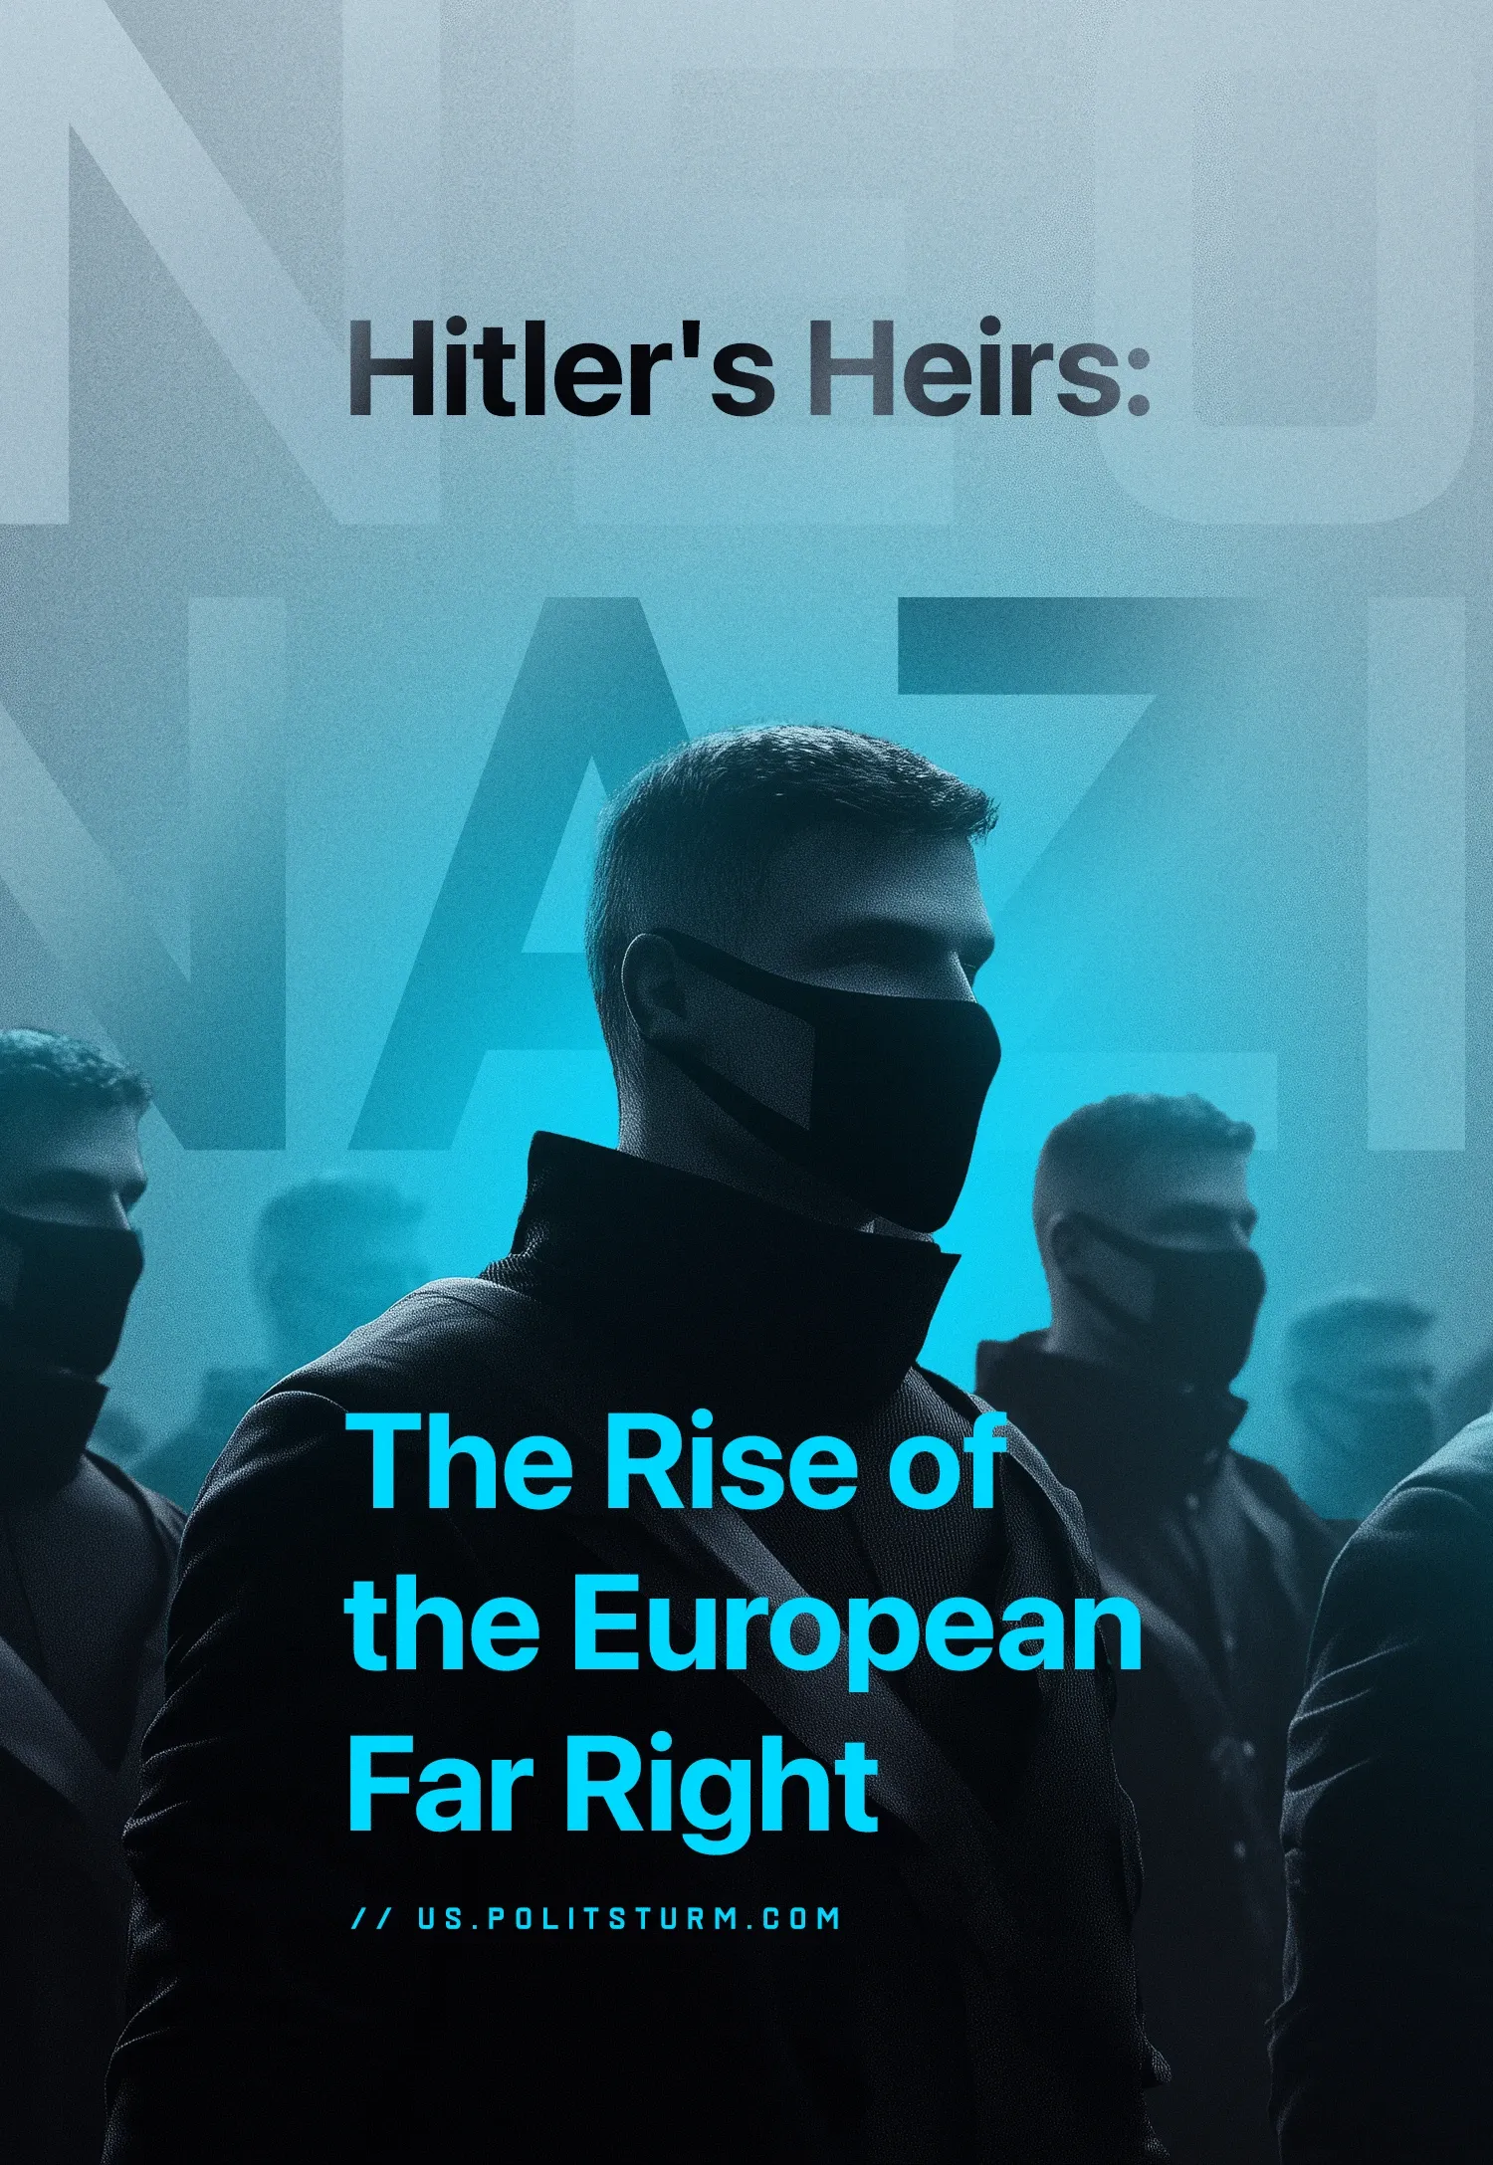

Original article
2025-03-08
32 min read

Across Europe, far-right movements are experiencing a revival, positioning themselves as “patriots,” defenders of “European traditions” and “indigenous interests”. Underneath this facade, however, lies a mixture of nationalism, anti-immigrant rhetoric, and rehashed sympathies for fascism. The ultra-right has mastered the art of masking its extremist ideologies with populist appeals and patriotic rebranding, making it appeal to a wider audience. This revival is not happening in a vacuum; the European economy is experiencing a slump, which is creating tensions in society and the rise of protest movements. We will explore the capitalists' benefit from the rise of far-right parties, what purposes they are being used for, and break down their most popular ideas and slogans that will supposedly help save Europe.

Overview of modern far-right groups in key European countries
Last year, European Parliament elections were held in Europe, where we have already noted the growth of right-wing forces. Last September, this trend continued, with the Austrian Freedom Party (founded by “former” Nazis) gaining 28.9% of the vote in the national elections. It is known for wanting to “re-emigrate” Austrian citizens if they have a “migrant past”.
Thus in Europe, another party with a significant share of the vote joined the list of preeminent far right parties, alongside the French “Rassemblement Nationale”, “Alternative for Germany”, “Brothers of Italy”. In addition to these, in some countries, the ultra-right is already in government in countries such as the Netherlands, Poland, Finland, Slovakia, Hungary, Croatia, and the Czech Republic [1]. The map below shows the data before the elections, which clearly shows a serious increase in the influence of right-wing forces.
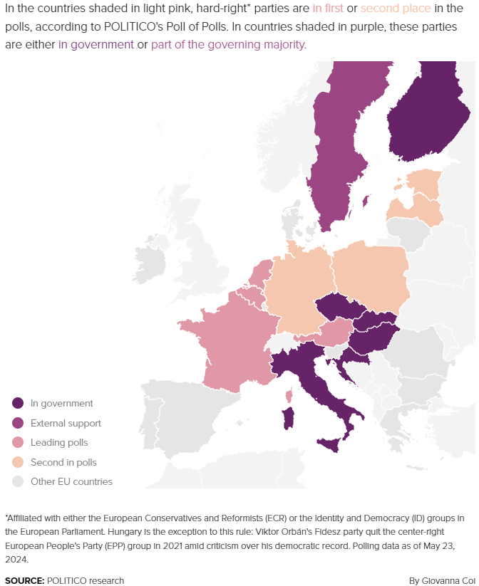
It is already a fact that ultra-right sentiments are growing in European society. Which parties are behind this “success”?

Italy
The rise of the Fratelli d'Italia (Brothers of Italy), led by Giorgia Meloni, reflects the escalating contradictions of capitalism in Italy. Despite the attempt to position itself as a conservative force, the neo-fascist origin of the party serves as a reminder of what the ruling class is ready to do in order to maintain its power in conditions of economic instability. Meloni's harsh immigration policy and nationalist rhetoric serve as tools to redirect the discontent of the proletariat to vulnerable groups of migrants, masking the systemic failures of Italian monopoly capitalism.
A year ago, there was a scandal in Rome with a mass fascist salute, when a group of neo-fascists held a meeting in honor of fascist terrorists killed by left-wing radicals [2]. The Brothers of Italy, as the ruling party, did not condemn the action. Moreover, the fascist salute is now legally allowed in Italy [3]. This year, the action was repeated legally.

France
In France, the National Rally (Rassemblement National), led by Marine Le Pen, has become a significant player in national politics. The party advocates for anti-immigration measures and has distanced itself from its extremist roots to appeal to a broader electorate. Despite gaining substantial seats in recent elections, it struggles to form coalitions with other parties due to its controversial reputation. For example, Le Penn in her public speeches compares Muslims to the Nazi occupation [4]

Germany
The far-right Alternative for Germany (AfD) has seen increasing support, positioning itself as a significant challenger to the traditional parties. The AfD's rise is attributed to public discontent over immigration policies and economic issues, leading to fears about German national identity being eroded [5]. The AfD sympathizes with the Nazis and, moreover, uses some of their terms, openly discusses “re-emigration”, has ties with even more extreme radicals and neo-Nazis and is itself even under the supervision of the German security services [6].

Hungary
Hungary's ruling party, Fidesz, under Viktor Orbán, exemplifies the far-right's influence through its autocratic governance and nationalist rhetoric. Since coming to power in 2010, Fidesz has implemented policies that restrict immigration and undermine democratic institutions, often invoking anti-EU sentiments to bolster its support [7].

Poland
The Law and Justice Party (PiS) has dominated Polish politics since 2015, promoting a nationalist agenda that emphasizes Catholic values and restricts immigration from Muslim-majority countries. Led by Jarosław Kaczyński (veteran anti-communist campaigner), PiS has garnered support through its hardline stance on cultural identity and social conservatism [8].

Others
In England, there are no popular political representatives of ultra-right parties in parliament, but there have been anti-Islamic pogroms that we have previously written about, with about 5000 anti-Islamic discrimination cases recorded over the last year [9]. Finland has a far-right party and president in power. In Spain, the far-right Vox party entered parliament for the first time.
So far, we can conclude that these parties have a lot in common - an anti-immigrant agenda (mostly anti-Muslim), protection of "traditions" and "identity," populist accusations against “globalists” and statements against the European Union.

Reasons for their success and the far-right’s rhetorical camouflage
What is the main reason for their growth? Despite the national differences in right-wing rhetoric, the success of the far-right parties is ubiquitous. But this success lies not in the demands of the masses, but in something else.
The main reason lies in socio-economic relations; their rise is deeply rooted in the material conditions created by capitalism. Periods of economic crisis — marked by inequality, unemployment, and alienation — generate mass discontent among the working class and broader society. Instead of addressing the real contradictions of capitalism, far-right ideologies scapegoat marginalized groups or appeal to nationalism, providing a reactionary outlet for this frustration. Their rhetoric serves to mask the true source of discontent: the exploitative nature of the capitalist system, and in doing so divide the working class.
As we see, since the pandemic, governments have been actively frittering away money, driving up inflation. From around 2022, the energy crisis exacerbated already deteriorating living conditions across Europe, with prices rising by 21.3% from 2020 [10]. There was a wave of farm protests (which we covered), union actions, strikes...with very little effect and subsequent layoffs in large companies (Volkswagen, UBS, Nokia) [11]. Disappointment remains, prices have not normalized, and wages, if they have been raised, are generally not significantly higher or below inflation on a national scale across Europe. No real improvements have been proposed or implemented by the current governments; moreover, in some places, the situation of the working masses is even worse (e.g. raising the retirement age in France [12], Finland has limited strikes to 24 hours [13], Britain has taken similar measures to limit protests [14]). Forecasts for the future are depressing, “experts” talk of recessions and a lost decade for Europe [15].
The key aspect here is the direct support the bourgeoisie provides to these groups through its monopolized media outlets. This phenomenon can be exemplified by the case of France. Ultra-right rhetoric is propagated via media controlled by billionaires [16], which, when coupled with the crisis of governance in the country — manifested even within the French National Front (once envisioned as a “bulwark for democracy”) — and the widespread public disillusionment caused by deteriorating living standards, creates a fertile breeding ground for extremism. Recently, publicly exemplifying this, the richest billionaire oligarch in the world, Elon Musk, supported and promoted the far-right AfD [17]. Consequently, the bourgeoisie achieves its objective: the rise of far-right forces. This leads to the fragmentation of the working class, who largely end up divided between "liberals" and "conservatives" perceiving one another as adversaries while both overlooking the true source of their struggles — the capitalist system.
It is within this context that a familiar force resurfaces, camouflaged under a "new" guise, but embodying the same reactionary ideologies as their predecessors. Rebranding themselves from fascists to “patriots,” the ultra-right presents itself as a vehicle for change — a supposed solution to current challenges. But what exactly do these parties propose to “fix” society’s problems?
Let us look at the most common points of all these organizations.

Anti-migrant policy
Migrants and the current migrant policy are declared to be the key cause of all problems. It is because of them that the interests of the indigenous population are forgotten, because of them wages are falling, crime is increasing, jobs, housing and healthcare are in short supply etc. In addition, they emphasize cultural differences - their religion is different, democratic values are not adhered to, education is poor and some people do not even know the language. They are not accustomed to the local (or supposedly pan-European) culture and moreover - they are actively replacing it with their own, so there is a need for retaliatory measures for protection.
The fact that Europeans have become worse off economically cannot be ignored by any opposition parties. Therefore, for the far-right parties, one of the most popular methods is to focus on the interests of the “indigenous” population. Under this guise, they "mask" the concept of a nation, conflating it with race and “indigeniety”, so we need to clearly and consistently define what it is.
“This community is not racial, nor is it tribal…A nation is a historically constituted, stable community of people, formed on the basis of a common language, territory, economic life, and psychological make-up manifested in a common culture” - “Marxism and the National Question” J. V. Stalin, vol. 2, p. 296.
Do the ultra-right use this definition of a nation (which is the only consistent one) in their rhetoric? No, they distort or cherry-pick concepts depending on their specific ideological bent. For some, it means individuals holding citizenship in a particular country; for others, it refers to Europeans as a whole, or even to those deemed ethnically white. These shifting definitions serve their divisive agendas but lack coherence.
The Marxist definition of a nation (as outlined above) is the only consistent and logically sound one because it is rooted in objective, current material realities (shared economy, territory, culture, psychological make-up, and language) — rather than more arbitrary markers like ethnicity or “bloodlines”. Nations are defined by the actual human relationships and systems that develop over time, not by unchangeable biological (“ethnically pure nation”) or mythological notions (“great, unique nation”). Human beings, unlike the more primitive animals, grow and develop through conscious social production, not genetic memory and predetermination. The movement and interbreeding of peoples across national borders (which are only a fairly modern invention) has gone on for millennia. Any attempt to reduce a nation to “blood and soil” not only ignores history but collapses under logic.
To illustrate this, let us consider an example: a German man immigrates to the U.S., where his grandchildren are born, raised, and immersed in American culture. These grandchildren grow up speaking English, studying American history, living within U.S. territory, and participating in its economic and cultural life. Despite their ethnic heritage, would anyone reasonably call these individuals, who cannot speak a word of German and have never set foot on German soil, "Germans"? Ethnically, they might be descended from Germans, but culturally, linguistically, and psychologically, they are Americans. To claim otherwise would ignore their material reality, sever their ties to their actual community, and prioritise a meaningless concept of “blood” over tangible reality.
When discussing indigenous peoples, it is critical to recognize that nearly all contemporary nations are products of historical convergence among diverse tribes over centuries. The idea of ethnic "purity" within any nation is not only historically unfounded but also unsustainable under scrutiny. Every modern nation, without exception, is a richly woven tapestry of various constitutent tribes, cultures, territories, languages, and economic systems that have gradually unified into a shared identity. Additionally, this identity and its constituent makeup is not something static or eternal, but just as it has changed in the past, it continues to change in the present and will change in the future. Far-right ideologues often disregard these nuances or selectively acknowledge them to fit their narratives and real objective, which far from “protecting the nation”, is dividing the working class of each nation.
Furthermore, far-right rhetoric frequently manipulates the grievances of the working class, breeding animosity and mistrust towards those perceived as different. This divisive narrative denies the possibility of collective progress and class solidarity with migrants or newcomers. Negative news involving migrants is often sensationalized, while comparable incidents involving locals are downplayed or reported with detached neutrality. Such tactics intentionally fuel division, obscuring the broader systemic issues that many people face.
Blaming migrants for all the troubles is a typical trick of the ultra-right for all occasions. The focus of attention shifts from the capitalist who makes an additional profit (when he hires an almost powerless and desperate migrant at a lower wage) to the migrants themselves. This is exemplified by the fact that none of the far-right powers promise to punish the capitalists who hire the migrant labour, but the migrants themselves. The logic of “why are they here and not at home?” breaks down, as the same European capital actively participates in the looting and sometimes military interventions in Africa and the Middle East, not allowing local workers to live in peace, while European corporations reap incredible profits. Some of the ultra-right, which is more sophisticated in their rhetoric, may even declare “the migration crisis” as “payback” for the sins of their capitalists. However, migration is not a “moral” event or “punishment”, but an objective phenomenon - a fact of life under capitalism caused by uneven development, desperate poverty, war and crises, especially in dependent countries.
The decline of the welfare state, rising inequality, and job insecurity stem from systemic flaws inherent in the capitalist system. The dismantling of public services, privatization, and austerity policies — primarily driven by profit motives — create conditions where wages stagnate, social support diminishes, and competition among workers intensifies. Capitalists benefit by reducing labor costs and weakening unions, resulting in a race to the bottom for working-class living standards. Migrants are convenient scapegoats in this process, despite the true causes being rooted in economic exploitation and policies that prioritize corporate gains over social welfare. An example is the support measures taken by the European Union during Covid-19. The main thing is that the workers were lucky to keep is...their jobs. But their employers got government benefits, tax holidays and cheap loans [18].
Highlighting differences (whether they be national, linguistic, or cultural) is a well-worn tactic. However, this strategy is already extensively employed by capitalists of all kinds and their supporters. Their primary goal is to ensure that workers remain divided, preventing them from uniting in the fight for a better future. Instead, they encourage workers to view each other as enemies, fostering conflict among themselves instead of solidarity.
The only tactic that can be opposed to this division of workers is internationalism. And internationalism does obviously not mean NATO or the European Union (an alliance of several capitalist states), but the union of workers independent from the capitalists, regardless of their origin, faith, etc.

Anti-EU and “anti-globalist” statements
The European Union is criticized as a “disadvantage” for the nation to participate in. This is often mixed with anti-globalization statements and they place an emphasis on national rather than EU interests.
Where do such ideas come from? Doesn't the imperialist alliance give them more opportunities to collectively divide the world in their “national interests”?
Yes, but there is a contradiction at the heart of any alliance of capitalists. Despite the lofty ideals of European unity, competition remains the fundamental nature of capital, and inter-European competition continues to shape the actions and rhetoric of national elites.
The European Union is often portrayed as a mechanism of unity, fostering collaboration and shared economic growth. However, its structure and policies also bring nations into direct competition with one another, particularly in terms of market access, resource allocation, and influence over shared decision-making. This reality sets the stage for various national bourgeoisies to prioritize self-interest over collective European ones. Anti-globalization rhetoric, which emphasizes sovereignty, culture, and "national interests," often serves as a vehicle for such nationalist agendas. These so-called "national interests," however, overwhelmingly reflect the aspirations of a nation’s bourgeoisie rather than the broader population (i.e. the whole nation).
For example, Italy has received significant funds under the Easy Recovery and Resilience Facility (SRF), amounting to $194.4 billion as of 2024. However, access to these funds is conditional on implementing structural reforms in areas like infrastructure, health, taxation, and ecological transition. Delays in meeting these conditions have led to negotiations with Brussels, with the EU requiring stricter adherence to agreed milestones before disbursing additional payments [19].
Italy has struggled to meet the EU's fiscal rules under the Stability and Growth Pact (SGP), which requires member states to maintain a budget deficit below 3% of GDP and a public debt-to-GDP ratio under 60%. Italy's debt, standing at over 130% of GDP, far exceeds this threshold. The EU has demanded that Italy reduce its debt at a pace of 1/20th of the gap between its current debt ratio and the 60% target annually, which Italy has consistently failed to achieve [20].
And this is not the only contradiction within the EU (we wrote about Germany’s debt trap of Greece here). This is not an exception to the rule, but the rule itself. After all, under capitalism, the main goal is profit, and when we research the role of the state, it is about control over financial flows. There will always be winners and losers in this fight.
But would leaving an "unprofitable" alliance like the EU really improve conditions for workers? Consider the example of Brexit. Although many of its advocates framed it as a reclaiming of sovereignty and control, the movement was heavily backed by segments of the British bourgeoisie. Brexit released the UK from enforced privatization, anti-union and anti-democratic rulings by the European Court of Justice, growing European militarism, and EU constraints on public ownership, however, the British ruling class pursued this not to break from these policies but to advance them even further than the EU itself. These groups saw EU regulations and policies as obstacles to profitability and viewed leaving the EU as an opportunity for deregulation and trade deals tailored to their own interests, in a (failed) attempt to reassert themselves as an independent world power. Similar motivations underpin nationalist arguments in other EU countries, where the focus on opposing European integration is often driven by capitalists eager to protect their market share from regional competitors.
For workers, however, these "national interests" bring no real benefits. The UK provides a stark example: post-Brexit, it continues to grapple with the same challenges as the rest of Europe, including the energy crisis, issues surrounding migration, declining living standards, and widespread labor strikes.

“Defenders” of the peace
The ultra-right sees themselves as defenders of traditional values and even peace, often criticizing military support for Ukraine and Israel and advocating for a greater focus on addressing domestic problems instead.
However, this rhetoric often masks their true motives and reflects inconsistent principles when scrutinized closely.
This guise of "defending peace" serves as a populist tactic to undermine struggling mainstream leadership. With the ongoing so-called “special military operation” in Ukraine affecting European politics for the third consecutive year, the public grows increasingly disillusioned with rising military expenditures amidst declining living standards. The far-right capitalizes on this discontent, framing themselves as the voice of the working people frustrated by their governments’ disregard for household economic pressures. These narratives help them galvanize support by promoting the illusion that they advocate for domestic welfare over costly foreign policies.
An example of such hypocrisy is the actions of the far-right Alternative for Germany (AfD) party, which, in exchange for Russian sponsorship, put forward the idea of blocking military aid to Ukraine, and wrote letters to the Pope and other organizations [21]. In 2022, three state parliament members wanted to visit the Russian part of Donbass, but after public condemnation, they did not do so [22].
Having achieved power, against such a background, the ultra-right will inevitably talk about the need to restore its former military power, of course, to “protect” itself from threats. The far-right in power in Finland (increased military spending from $3,5 to $6.1 billion in 2023) and Poland (allocated 4.7% of GDP for militarization, well above NATO’s 2% requirement) are good examples of this phenomenon [23] [24]. In recent years, there has been a trend towards the militarization of Europe (which we previously wrote about), which has been joined by fears that the US, led by Trump, will no longer subsidize Europe's security at its own expense.
At the same time, we observe that the so-called "peace agenda" often serves as mere populism or, in some cases, appears to be directed by external influences, such as the current US administration. On one hand, the US claims to pursue peace; on the other, it demands a drastic increase in Europe’s military spending — from NATO's 2% target to an unprecedented 5%. It is crucial to note that the US, as the largest arms producer in the world, stands to directly benefit from this surge in military expenditure. Although the EU is attempting to rely more and more on domestic military R&D and production, it will still be a while untill this can fully be realised. Such policies highlight the stark contradiction in their approach to peace and militarization. Workers, therefore, must recognize these realities and prepare themselves to actively influence the direction of events. Without preparation, they will find themselves powerless to intervene and prevent future imperialist wars, where they are often expected to pay the price.

Rebranding of fascism/nazi legacy
A covert defense or revision of the legacy of fascist figures and organizations. This can sometimes be understood with the help of politicians who “let it slip”, but more often by their actions or inactions and tolerance towards the radical right.
This rebranding operates through subtle and indirect methods, such as tolerating or overlooking radical right activities and rhetoric, as well as downplaying associations with neo-fascist groups. Politicians and parties adopting this approach aim to publicly whitewash far-right ideologies to appeal to a broader audience, project themselves as legitimate defenders of national sovereignty, and create the appearance of distancing themselves from the explicitly violent and exclusionary reputation of fascism. Yet, the core ideological tenets of far-right nationalism often remain intact. Key to this strategy is the effort to redefine nationalism as "normal" and reputable, creating a political space where dangerous ideas can flourish under a veneer of respectability.
Political examples abound, particularly with parties like Brothers of Italy and Alternative for Germany (AfD). In the case of the Brothers of Italy, the party has strategically distanced itself from overt neo-fascist links, yet its silence during controversies such as neo-fascist rallies and the legalization of the fascist salute by the Italian Supreme Court speaks volumes. This calculated silence enables a tacit normalization of fascist-adjacent behavior within the political discourse. Similarly, the AfD holds covert meetings with far-right neo-Nazi groups despite publicly denying associations, though such meetings often surface in media investigations [25]. Recently, at the AfD conference, Elon Musk said that Germany is being instilled with a sense of guilt that children should not be responsible for the sins of their ancestors. Such blatant manipulations only play into the hands of the AfD rebranding.
All this is necessary in order to to instill in people the idea that nationalism/fascism is "normal" and legitimate. They need to smash their previous image of being pariahs and outcasts and foster the illusion of themselves as saviors of the nation. This change will be used by capital for its own benefit, which we will describe in more detail below. And the masses, dissatisfied with the deterioration of life and disappointed in the usual "democratic" parties, will look for new representatives who will defend their interests.
Despite the rebranding, Nazi ideology remains essentially the same. Revisiting the legacy of fascism only makes it easier to repeat the mistakes already experienced by some peoples of Europe. Only unlike the 20th century, there is no USSR, and the communist movement around the world is fragmented and very weak. This could have the most dire consequences for the workers of Europe, because liberals, Greens, and social democrats will not go underground and fight fascism (that is those of them who are even inclined to fight it in the first place).
Having laid the foundation, we came to the question of why all these rebranding, false rhetoric and speculation on the troubles of the working class were needed.

Capital's Quiet Hand: why the far-right is needed
Previously, in this article, we thoroughly explored the rise of right-wing forces in Europe, examining their rhetoric, which primarily leverages the challenges faced by the working class. We also discussed their process of rebranding and crafting a more "acceptable" public image for Nazi ideology—efforts that required significant financial investment.
As we know, under capitalism, money is typically directed toward projects deemed profitable. The "project" of ultra-right parties serves a specific purpose: for a particular wing of capital to gain control of a critical tool—the state.
To maintain its dominance, the capitalist class has long since seized control of the state, using it as a tool to implement policies that favor the wealthy exploiting minority at the expense of the working majority. But capital is heterogeneous - there are contradictions in the capitalist class. While unified in their interest to perpetuate the system, certain groups of capitalists are constantly fighting with one another for influence in how to maintain their class rule and for their own profit over that of their competitors. It is precisely this struggle that is taking place now with all the hype surrounding Ukraine's negotiations, with the US undermining Ukraine and the EU.
During times of crisis, the masses inevitably protest and oppose the interests of capitalists. When this opposition from the people threatens to reach a critical level, far-right forces are often brought onto the political stage. Capitalists use these forces to stabilize their class position, divide workers, and redirect public frustration by scapegoating others—convincing workers that their struggles are caused by their peers rather than the system itself.
In Europe, it may become advantageous for capitalists to promote ultra-right parties as replacements for existing "democratic" parties. If initiatives like Trump’s push for increased military spending among EU nations succeed, it will exacerbate the decline in workers’ living standards. The energy crisis has already demonstrated that workers are willing to resist the deterioration of their lives and livelihoods, while in the absence of a class-independent viewpoint and party to rally the workers, the populist, nationalist rhetoric of the ultra-right could become increasingly appealing to some, drawing more their cause.
As the fascization of Europe reaches the required level, the deepening crisis brings us ever closer to another world war. The reason for imperialist wars is rooted in imperialism (monopoly capitalism) itself. It stems from the relentless drive to expand monopoly capital despite the world already being fully divided, leading to conflicts over the re-division of labor, markets, resources, and spheres of influence. This unyielding quest for economic dominance, inherent to capitalism in its highest stage, forces imperialist powers into violent confrontations to secure and maintain their global dominance. The growing political reaction driven by the ruling class, aimed at suppressing working-class resistance, goes hand in hand with the preparations for military aggression and the violent reordering of global power. As the Seventh Congress of the Comintern proclaimed, “Fascism is war”. After all, once migrants are transformed into a disenfranchised and even cheaper labor force, capitalists will still require new methods to divide the working class. The next logical step in this process is to create an external enemy—one that can serve as the rationale for a "just" war, waged under the guise of defending the interests of the "nation" or even all of Europe. This fabricated threat is designed to distract workers from their exploitation and justify imperialist aggression in the name of unity and security.
War is a great way for certain monopoly capitalists to make even more profit and get rid of the crisis (in this article we research it more deeply). We have already seen how the shares of military companies have increased significantly since 2022, as they expand the production of weapons. In addition, banks, steel, machinery, etc. industries will boom. At the same time, generous contracts for the supply of food, medicines, clothing, etc. will be issued using the state's expense. The result is that capitalists get super profits, workers get death, starvation, a deterioration in their standard of living and a ban on resisting it.
Briefly, bourgeois politics can be described by the following cycle:
- While far-right forces are not yet in power, it becomes a convenient strategy to raise alarms about the "far-right threat" and call for “unity” with the liberals (e.g., from the so-called “Popular Front” in France, or rhetoric from figures like Kamala Harris in the US [26]). However, such calls for unity always serve the interests of the capitalists, not the working class. The workers are castigated with high-minded lectures and expected to unify with and support the very same liberals that preside over and facilitate their worsening living conditions and increasing exploitation. Sooner or later, workers perceive this reality with greater clarity.
- When the far-right does assume power, attention shifts to empty populist slogans and fruitless initiatives. As we have seen time and again, these measures result in migrants becoming even more vulnerable and exploitable, further oppression through state mechanisms and propaganda, and a consolidation of power for the ruling class. The presence of an external enemy “justifies” the outbreak of imperialist wars. Promises to "save the country" remain unfulfilled, leaving workers no better off and life no easier.
- On the wave of disillusionment, the narrative will inevitably shift. No longer will the primary scapegoats be migrants and outside enemies; instead, the blame will fall squarely on the ultra-right. These groups, it will be argued, dismantled the “European” ideals of democracy, eroded fundamental freedoms, and dismantled the cherished institutions of civilized society. The media and political elites will harp endlessly on how the far-right's misrule plunged the country into chaos. And stepping forward, with feigned solemnity and promises of restoration, will be the so-called rescuers—“we, the social democrats/liberals/centrists (whichever becomes appropriate), will now take on the burden of saving the nation and its people.”
- What follows is an overtly ceremonial game of political musical chairs, with power cyclically passing between these factions. A few governments later, liberals transitioning to social democrats, then to technocratic centrists, perhaps a vibrant new coalition or two, and after several decades, the charade repeats a full circle. One policy failure after another, discontent sown and harvested, the stage is reset for the pendulum to swing again—welcoming an opportunity for either “new” ultra-right movements to rise amid familiar cries of outrage and demands for reform.
This cyclical pendulum, masquerading as progress, is not a bug but a feature of bourgeois democracy itself. The people remain little more than stage props in an endlessly rehearsed play. Puppets on strings, their role is predetermined, constrained to the limits set by the ruling bourgeoisie. They are ushered into action, given a fleeting appearance of agency during times of election or political shifts—only to be left stranded, powerless to truly reshape the entrenched systems of control. Ultimately, that is how democracy works under capitalism.
How do we break Free from this Vicious Cycle of Hopelessness? How can democracy truly work beyond the role of puppets?
The answer lies in the need for a strong Communist Party. Only such a party can unite the working class, offering them the means to actively resist the domination of the bourgeoisie and the state under its control. When a workers' party exists, the working class transforms from passive spectators to active participants in their own independent class struggle. This is not about sitting in the stands of a political "stadium," cheering for one team or another as they change in endless rotation. It’s about workers stepping onto the field as players to shape the outcome of the match themselves.
At present, true communist parties are absent — they must still be created. The collapse of the USSR and the subsequent degradation of communist movements worldwide have left a void. Despite this, the only viable path to resolving the contradictions of the capitalist system is to build a party grounded on the foundations of Marxism-Leninism.
We are already working on this. If you share our vision and want to contribute to the struggle, we invite you to join us. Together, we can lay the foundations for a better future.

Sources:
[1] Politico — Mapped: Europe’s rapidly rising right — May 24, 2024
[2] Izvestia — The media reported on the outrage of the Italian opposition due to a mass fascist demonstration — January 11, 2024
[3] Ansa — “Fascist salutes not liable if mere commemorations says top court” — January 19, 2024[4] Time — French Far-Right Politician Will Go on Trial for Comparing Muslims to Nazis — September 23, 2015
[5] BBC — “Far-right parties on the rise across Europe” — June 30, 2023
[6] Foreign Policy — Germany’s Far-Right Party Is Worse Than the Rest of Europe’s — January 26, 2024
[7], [8] BBC — “Europe and right-wing nationalism: A country-by-country guide” — November 13, 2019
[9] Anadolu Agency — Record spike in anti-Muslim hate in UK one year after Gaza war: Report — October 7, 2024
[10] Tax foundation— The Impact of High Inflation on Tax Revenues across Europe — June 28, 2024[11] The Atlantic — What Is Going On With Europe’s Economy? — March 4, 2024 [12] BBC — France pension reforms: Macron signs pension age rise to 64 into law — April 15, 2023[13] Helsinki Times — Finnish lawmakers vote to pass restrictions to strike rights — May 9, 2024
[14] Monitor Civicus — Government abandons Bill of Rights Bill, controversial laws on migration, protest and strikes remain — October 30, 2023
[15] Politico — Risk of ‘lost decade’ as EU countries face economic cliff edge — March 19, 2024
[16] Friends of Europe — Billionaire media empires: the silent erosion of France’s democracy — October 6, 2024
[17] The New Your Times — “Musk Expresses Support for Far-Right Party in Germany’s Election” — December 20, 2024
[18] European Council — “The EU's response to the COVID-19”— January 30, 2024
[19] Upply — “Italy, one of Eurozone’s essential economies but a fragile one” — April 11, 2024
[20] Bruegel — “Italy’s new fiscal plans: the options of the European Commission” — October 08, 2018
[21] Spiegel — “AfD politician admits sponsorship from Moscow” — June 20, 2020
[22] The Guardian — “Far-right German politicians accused of pro-Putin ‘propaganda trip’” — September 20, 2022
[23] DefenceNews — “Finland eyes defense-spending boost well past NATO mark” — December 27, 2024
[24] Mckinsey — “A different lens on Europe’s defense budgets” — February 12, 2025
[25] Spiegel — “The True Proximity of Germany's AfD To Neo-Nazis” — July 27, 2023
[26] Business Today — US presidential debate 2024 — September 11, 2024

Original article

