Right-Wing Parties Have Won the Parliamentary Elections in Finland
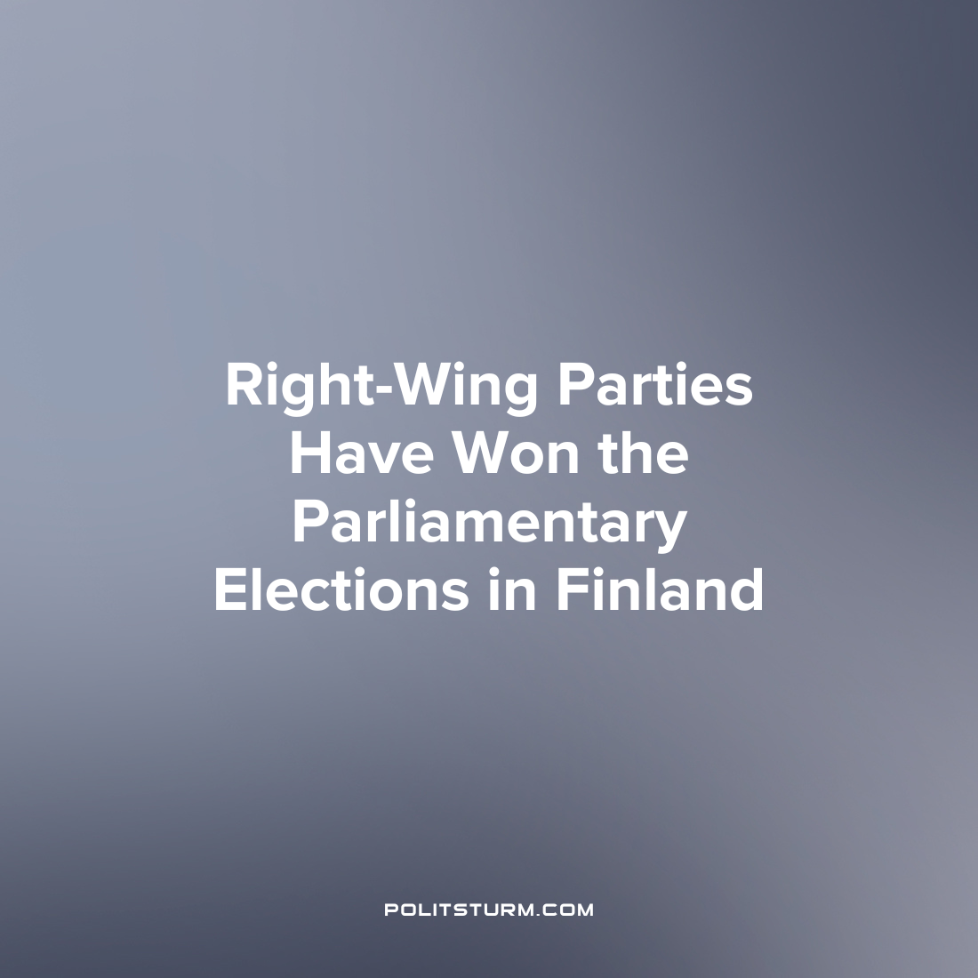

Original article
2023-05-06
3 min read

Parliamentary elections were held in Finland on April 2nd, 2023. As a result of the elections, the center–right National Coalition party received the largest number of votes (20.8% of the votes - 48 seats in parliament). Its leader, Petteri Orlo, will become the new Prime Minister of Finland. The second place was taken by the far-right party "Real Finns" with 20.1% of the vote and 46 seats in parliament. The "Social Democratic Party" of the current Prime Minister Sanna Marin came in third place with 19.9% of the votes and 43 parliamentary mandates.
The "Centrist Party" (11.3%), the "Left Union" (7.1%), the "Green Union" (7.0%), the "Swedish People's Party" (4.3%) and the "Christian Democratic Party" (4.2%) will also be represented in the Finnish parliament.
It is noteworthy that the leader of the far-right "Real Finns" Riikka Purra in the Uusimaa district (42,589 votes) scored the most personal votes (by districts). The current Prime Minister of Finland Sanna Marin in Pirkanmaa district became the second deputy by the number of personal votes (35,406 votes).
Prior to the last election, Prime Minister Marin led a coalition consisting of five parties: The Social Democrats, the Centrists, the Green Union, the Left Union and the Swedish People's Party.
The newly elected Prime Minister, Petteri Orlo, will have to form a new ruling coalition. According to experts, a coalition with the Social Democrats is unlikely due to fundamental disagreements on public finances and budget expenditures. Most likely, the "National Coalition" will enter into an alliance with the "Real Finns" and several other small parties. In this case, the basis of the parliamentary majority will be the right and far-right forces.
According to polls, Finnish voters in 2023 were most concerned about the economy and the distribution of public spending. For comparison, in 2019, respondents answered that they were most concerned with issues of equality, ecology and emigration.
Against the background of the rising cost of living, it seemed to many Finns that the Social Democrats could not cope with the challenges of the economic crisis. Therefore, they relied on political forces, such as the "National Coalition" and "Real Finns", who promised to reverse the trend of declining quality of life. To solve the current economic difficulties, these parties plan to slow down inflation and reduce the national debt by reducing the participation of the state in the economic activities of the country.
In addition to expanding the freedom of action for private entrepreneurs, "Real Finns" advocate a strict restriction on the flow of migrants into the country. Blaming the economic difficulties on the newcomers, representatives of this party promise to correct the situation by closing the borders. Party leader Riikka Purra assures that reducing the number of migrants will allow Finland to simultaneously solve the problem of crime.
As the economic situation worsens, right-wing parties are gaining strength across Europe. In addition to Finland, in the past year, right-wing or far-right forces have won elections in Sweden, Italy and Hungary, and also gained popularity in Germany and France.
This trend is explained by the massive disillusionment with the policies of the Social Democratic parties. For many years, the Social Democrats have promised to act in the interests of the people and ensure a good standard of living for their fellow citizens. In practice, however, the Social Democrats only contributed to the further development of the capitalist system, the concentration of wealth in the hands of a few and the decline in the quality of life of the working majority.
In Finland, for example, according to the latest survey in 2021, the richest 10% of the population own 50% of the country's wealth. In the last years of the crisis, the gap between rich and poor has only increased.
Disillusioned with the policies of the Social Democrats, the people begin to look for solutions to pressing problems from other political forces. Communist parties in many European countries, however, do not represent a serious alternative. This is due to many factors: the consistent suppression by bourgeois states over the past century, the decisions of many organizations to support the "lesser of evils" and their transformation into social democratic parties or broad "left" unions, but above all the lack of a clear theoretical and organizational platform around which modern communists should unite.
Against this background, many voters turn to right-wing parties that are in opposition to the Social Democrats and promise to fix the economic situation in the country.
However, the right-wing agenda to expand the freedom of action of capitalists will definitely not lead to an improvement in the economic situation for workers. The living conditions of the working class can truly improve only with the abolition of private ownership of the means of production and the change of the capitalist system to the socialist one.
Sources:
Yle – "Riksdagsvalet 2023" from April 5, 2023
Dagens Nyheter – "Samlingspartiet utropar sig till segrare i finländska valet" from April 3, 2023
Rossiyskaya Gazeta – "The party of the Prime Minister of Finland was defeated in the general parliamentary elections" of April 4, 2023.
Izvestia – "Finnomenally: what to expect from a change of government in Helsinki" from March 31, 2023
Communist News – "Finland: the Discreet Charm of the Bourgeoisie" from April 4, 2023
Helsinki Times – “New data suggests Finland's wealth gap is increasing” from June 8, 2021

Original article

