Researchers Find Evidence of Racial Discrimination in U.S. Pediatric Surgery
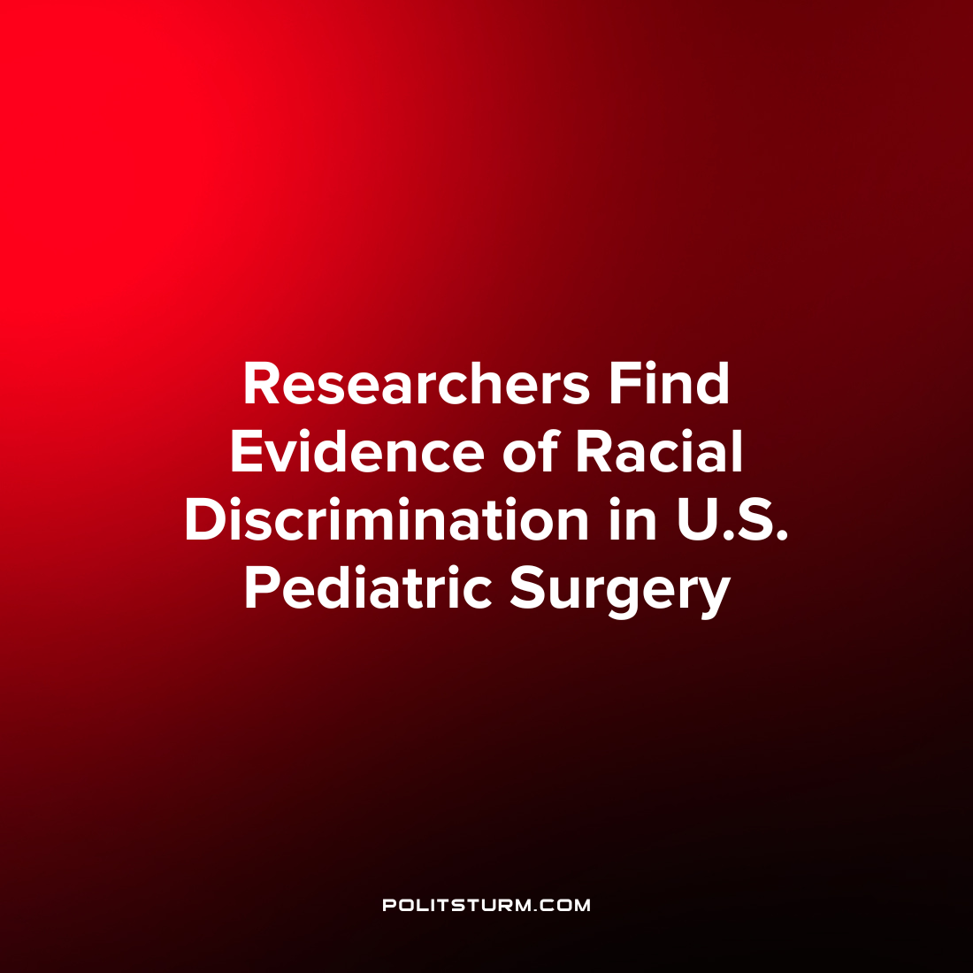

Original article
2022-12-09
1 min read

A recent publication in the Journal of Pediatric Medicine analyzed data to determine if there was discrimination in which children receive pediatric surgery. While there have been previous studies which have documented disparities in the outcome of pediatric surgeries this was the first study done to see if there are disparities in which children actually receive surgery.
The researchers analyzed cross-sectional data from children aged 0-18 across the United States from the National Health Interview Survey for the years 1999 to 2018. The researchers found that there were statistically significant results and that African-American, Latino, and Asian children were less likely to receive surgery. Also, Latino children were more likely to require emergency or urgent surgeries.
It is unsurprising that there is racial discrimination in medical outcomes under capitalism which inherently fosters racism, prejudice, and chauvinism. The study concludes “racial/ethnic differences in surgery may reflect disparities in healthcare access which should be addressed through further research, ongoing monitoring, targeted interventions, and quality-improvement efforts”. However, simply studying, monitoring, and making quality improvement suggestions will not fundamentally resolve the problem of discrimination in the medical field or elsewhere. If “access” to healthcare depends on factors such as income and employer-sponsored insurance and there is inherent discrimination in the labor market which the capitalists are free to do, the capitalists are free to ignore “improvement suggestions” if they are not in alignment with the profit motive. The solution is the implementation of a socialist economic and political system that would not be driven by the profit motive, nor would it tolerate discrimination in the provision of health care for children.
Source: 1

Original article

