Republican Split Emerges Over Iran War
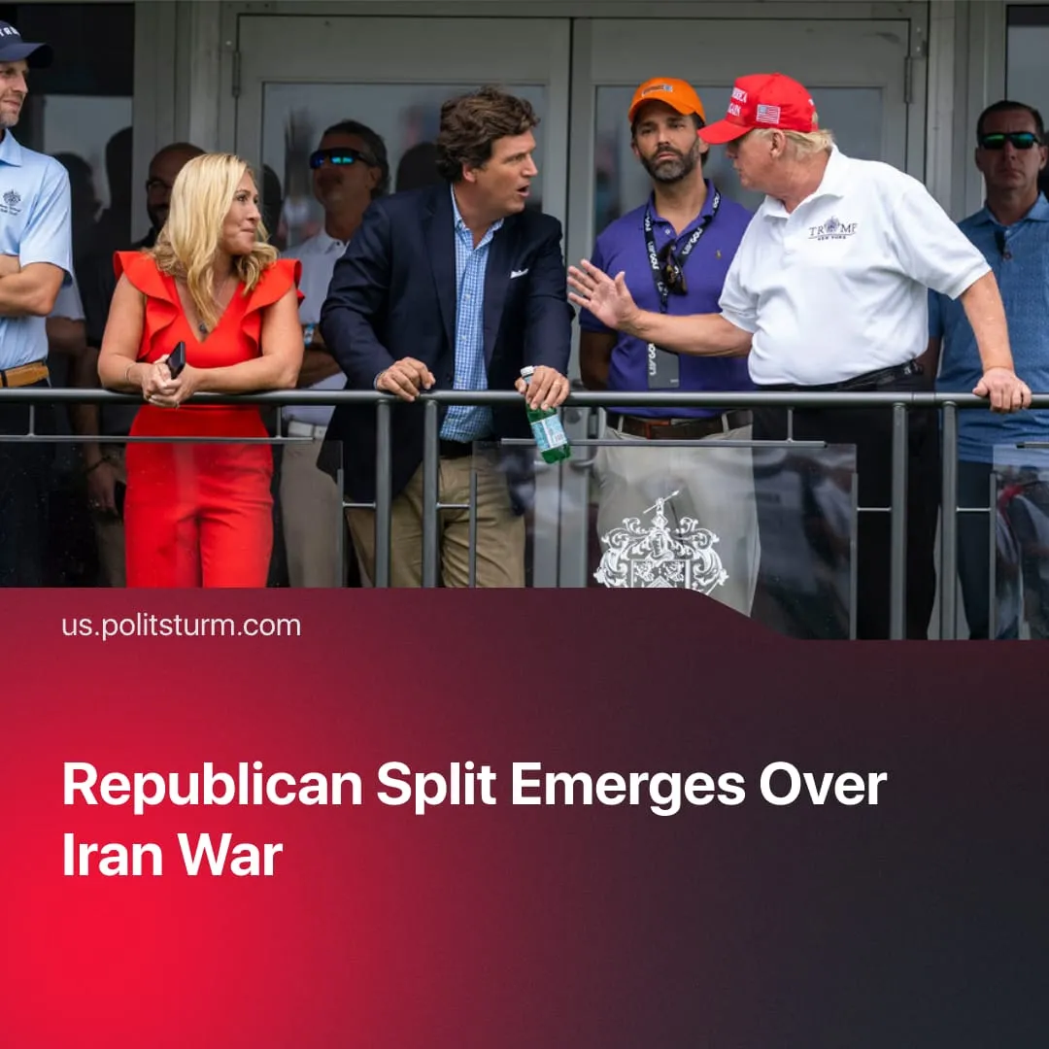

Original article
2026-04-25
2 min read

The right-wing US Republican Party splits over the Iran war and its handling. An anti-Israel tendency emerges within its ranks.
Details. Polls indicate 90% of pro-Trump MAGA Republicans back the strikes on Iran, whereas only 54% of non-MAGA Republicans support the US military action. Up to 36% of anti-Trump Republicans oppose the strikes.
► Previously pro-Trump figures like Tucker Carlson, Nick Fuentes, and Marjorie Taylor Greene now accuse the President of putting America "last". This wing of the Republican Party opportunistically uses the conflict in the Middle East to boost its own popularity and discredit the President, claiming he is controlled by Jews and calling for the US to "detach from Israel". Carlson broke with MAGA, describing the attack on Iran as “absolutely disgusting and evil” and claiming “this is Israel’s war”.
Context. Most American capitalists still align with their Israeli proxy, securing imperialist profits through attacks in the Middle East. Collaboration with Israel has been pursued by both the Biden and Trump administrations. US imperialism has long used Israel as a bulwark against the regional expansion of rival Chinese capital, waging war to preserve American capital’s global hegemony – but this risks greater destabilisation domestically.
► Trump campaigned on ending “forever wars,” delivering peace, and improving living standards under “America First,” yet in office he has intensified repression at home and escalated imperialist aggression abroad – from threats of invasion and continued blockades to a so-called “limited” operation in Iran that developed into full-scale conflict.
► The conflict with Iran has driven oil prices sharply higher, pushing US gas prices up and increasing overall inflation. Surveys show that over half of Americans expect negative personal financial impacts. $6 billion was spent bombing Iran in just the first week; afterwards, Trump gave a speech explaining that it is “not possible” for the US to pay for Medicare.
► Trump’s disapproval rating has risen to 58% as his "America First" programme fails to meet Americans' needs. The majority of Americans now disapprove of Trump’s immigration policy, tariff increases, and foreign policy, especially statements about annexing Greenland and Gaza. The Democratic Party and anti-MAGA Republicans are opportunistically using this outrage to gain popularity by expressing disagreement with some of Trump’s policies while serving the same capitalist class.

Original article

