Rents Surge as Landlords Cash In
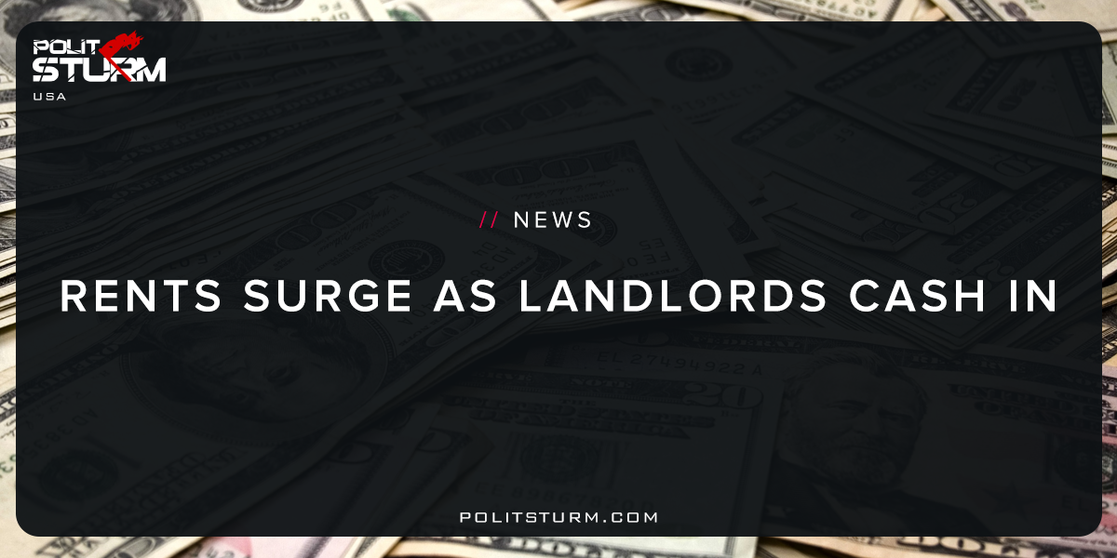

Original article
2018-01-17
2 min read

In the third quarter 2017, the median asking rent for vacant rent units was $912. Approximately 87.1 percent of the housing units in the United States in the third quarter 2017 were occupied and 12.9 percent were vacant. Owner-occupied housing units made up 55.7 percent of total housing units, while renter-occupied units made up 31.4 percent of the inventory in the third quarter 2017. Vacant year-round units comprised 9.9 percent of total housing units, while 2.9 percent were for seasonal use. Approximately 2.6 percent of the total units were for rent, 0.9 percent were for sale only and 1.0 percent were rented or sold but not yet occupied. Vacant units that were held off market comprised 5.4 percent of the total housing stock — 1.6 percent were for occasional use, 0.9 percent were temporarily occupied by persons with usual residence elsewhere (URE) and 2.9 percent were vacant for a variety of other reasons.
Politsturm: 31.4% of the American housing stock was being rented out by landlords as of the third quarter of 2017. Additionally, a large portion of the housing stock is vacant or serve as vacation homes for the bourgeoisie. This is how the capitalist economic system distributes housing in a “rational” way. It is “rational” for the landlord class who is able to get a cut in the profits produced by the working class. The two main groups who profit from this operation are financial capitalists and landlords. Money lenders generally benefit by earning interest accrued from outstanding loans on real estate. There are also various fees associated with the origination and servicing of loans. Landlords earn ground rent which is a portion of the profit over and above the principal, interest, taxes, and maintenance costs associated with the property.
One of the tremendous benefits of being a landlord, so graciously decreed by the bourgeois government, is the ability to depreciate rental property. The IRS allows rental property owners, the people who own 31.4% of the U.S housing units, to deduct the cost of the property from their taxes over time. The reason for this act of charity is that the bourgeois American sees the landlord reaping non-labor income and declares it to be capital. Due to a fundamental misunderstanding of how capitalism functions rental housing, business property, and machinery are all “capital” in the deluded mind of the capitalist. This dimwitted view completely ignores the fact that workers, along with the produce of nature, provide for the reproduction of our society. Machinery, property, and businesses on their own do not create the social surplus. The truth of the matter is that landlords and capitalists are rather the parasites who subsist off the unpaid labor of the working class and bring us down.
Sources: 1, 2

Original article

