Rent Prices and Homelessness Skyrocket in Argentina
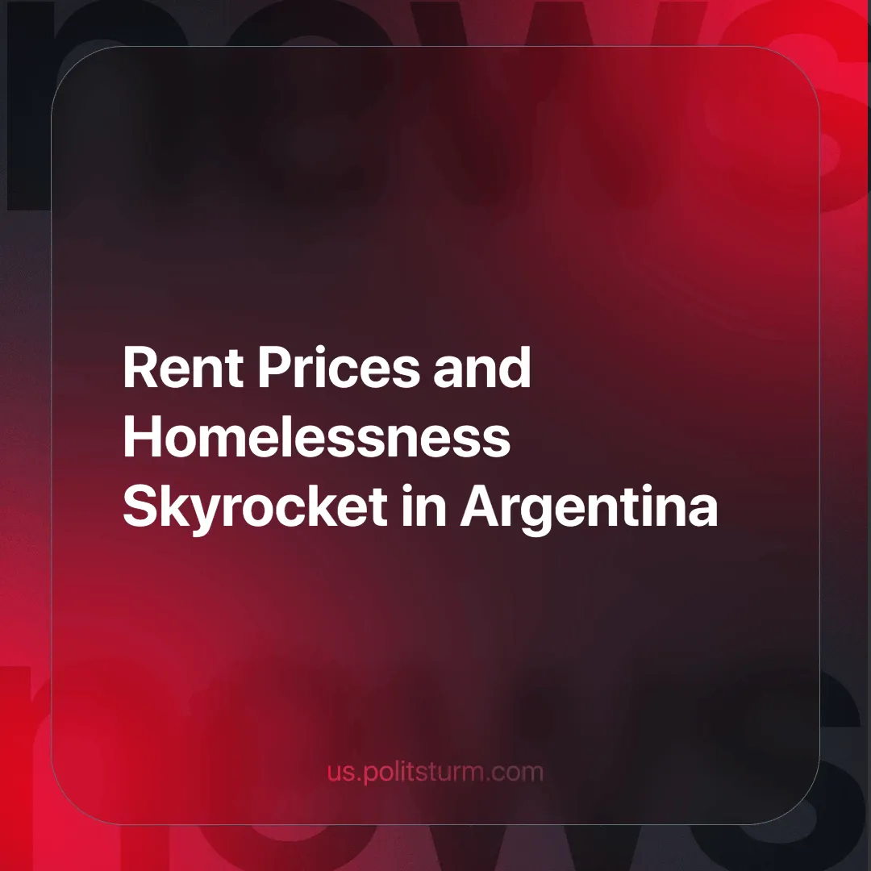

Original article
2025-02-22
5 min read

The administration of the ‘anarcho-capitalist’ Argentine President Javier Milei has intensified its austerity agenda with the launch of "Motosierra 2.0" (Chainsaw 2.0), starting with Decree 70/25, which dissolves Argentina's Secretaría de Hábitat (Housing Secretariat) and dismantles decades-old social housing programs. Framed as a cost-cutting measure to shrink the state and promote private sector "solutions" [1]. The rhetoric of "shrinking the state," "fighting against corruption," and "efficiency" serves as an ideological pretext to conceal the savage nature of capitalism, and to strip it of as many regulations, and welfare programs as they can, as we’ll see. We have previously written about Milei’s administration and how it arose.
We only need to look at the 2020 "Ley de Alquileres 27.551" (Law of Rents), which regulated the rental market in Argentina by, among other things, setting prices in Argentine pesos (ARS) and prohibiting the use of United States Dollars (USD) as a means of collecting rent. The intention was to protect the tenant from the uncertainty of the dollar price, given that most Argentines earn in ARS, and that the USD price rises faster than wages do.
So, for example, if your rent was 30 USD, (which was initially equivalent to 60 ARS a month), it might rise to 120 ARS in a short period just because of currency conversion rates and inflation. And because wages in ARS don’t automatically increase with the price of USD, the practical effect is an absolute and relative increase in housing costs.
“Federico Prior, representative of the National Tenants Federation in Neuquén, … describ[ed] the proposal as the "institutionalization of the law of the jungle." He assured that the relationship between tenants and owners is unequal and asymmetrical...” [Translated by Politsturm] [2]
You don't have to live in Argentina to see that tying the USD to the lease price would only serve the interests of landlords. After it was repealed, there was a "skyrocketing housing supply" which was cheerfully reported by Newsweek without explaining how that would affect the working masses.
“With Argentina's inflation reaching 211.4% — the highest in 32 years — rent prices were adjusted every 12 months, and leases had to last at least three years. The law, introduced in 2020, ended up distorting the real estate market and hurting both landlords and tenants.” [3]
To understand the omissions of the article and the real effect that tying the rent price to USD has on rent prices, we must understand the relationship between inflation and exchange rates. First inflation is a persistent and generalized increase in prices; in practical terms, it reduces the purchasing power of money (in this case the Argentinian peso (ARS)). This would make the ARS less attractive to hold (because of the reduced purchasing power) consequently causing its price to fall relative to other currencies. In other words, the inflation would cause the price of the USD to rise in ARS terms, for example 1 USD = 10 ARS, to 1 USD = 13 ARS.
The article continues:
“Since Millei's repeal of rent control laws took effect on December 29, the supply of rental housing in Buenos Aires has jumped by 195.23%, according to the Statistical Observatory of the Real Estate Market of the Real Estate College (CI).” [3]
The increase, gleefully referred to as "skyrocketing," is due to the effect described above. Renting suddenly became very attractive to landlords, and to the same extent, but in the opposite direction, very burdensome to the dispossessed. Since the property owners can now fleece the tenets even more while blaming the currency conversion rates between the USD and ARS. While wages are paid in ARS and would be slow to react, the rent price in USD would fluctuate faster and usually increase.
It is worth remembering that every enrichment of the landlord class as a parasitic, unproductive segment of society is paid for by an equally injurious enrichment of the working class.
Moreover, the increase in the wealth of landlords only shows that the process of transforming housing, a basic human need, into a purely speculative commodity that enriches a few, is accelerating. Landlords prefer to let their property go to ruin before renting it out at a lower price; since such an increase in the supply of rental housing is only possible due to more landlords "willing" to rent out their already existing property. It's almost impossible to increase the supply so quickly by building new buildings.
Chequeado, a fact-checking organization, reports that in Buenos Aires, the same province where the “skyrocketing” of housing supply happened, homelessness also skyrocketed. According to government statistics “Between November 2023 and November 2024 (last data available), [the homeless population] grew from 3,286 people to 4,049 an increase of 23.2%”. [Translated by Politsturm] [4]
Milei’s agenda of furthering cuts and deregulation of Chainsaw 2.0 explained by the Minister of Deregulation and State Transformation can only follow the same path. He explained on Twitter:
“To solve the housing problem, […] the important thing is to have an orderly [macroeconomy] and a small State that frees resources for private housing credit to grow. A process that already began to occur in 2024
The closure of the [Housing] Secretariat allows significant savings in personnel (there were hundreds of people without real work), buildings, equipment and services. In addition, there was a hidden army of those hired through universities for supposed audits, in some cases of very small constructions.” [Translated by Politsturm] [5]
This will have two different adverse effects on the exploited masses. First, it will leave the dispossessed classes at the mercy of the most implacable and unforgiving capitalism. They will be at the mercy of a landlord class whose profits increase directly in the same proportion as the desperation of the masses who need a house to live in.
Second, by laying off state workers, from construction workers to administrators, they displace them to other branches of government and industries. Increasing the competition there, by being “precipitated into the ranks of the working class, and they will have nothing else to do than to stretch out their arms alongside of the arms of the workers. Thus the forest of outstretched arms, begging for work, grows ever thicker, while the arms themselves grow every leaner.” [6]
The housing crisis in Argentina cannot be resolved through capitalist mechanisms whether regulated or not, since capitalism capitalism inherently requires classes of people without property and those with property incentivized to make the maximum possible profit, lest they fall into the dispossessed class. Under capitalism, landlords and developers have no material incentive to provide universal housing; why would a system driven by rent extraction prioritize shelter for all when doing so would halt rent extraction? Even regulated markets in the best cases merely soften exploitation temporarily, leaving intact the parasitic relationship between property owners and workers who are forced to surrender wages for basic survival.
As we recently covered, London too has a housing crisis, with historic records of homelessness. The solution to the problem in London is the same as in Argentina, as it is around the world. Following the Soviet example in which despite its shortcomings, such as long waiting lists, or departments being not that big, the socialist system achieved what capitalism structurally cannot: housing guaranteed as a universal right, free from commodification and profit-driven exclusion. There are already more houses without people in most cities, than people without houses, the solution isn’t complicated.
But to achieve it, we need a party that represents the interests of the workers in building socialism. Politsturm is intended to aid in the building of communist parties capable of class struggle to achieve socialism, join us in achieving such a goal.
Sources:
[1] Forbes México — “Gobierno de Milei inaugura la 'Motosierra 2.0'” — 11/02/2025
[2] RED/ACCIÓN — “Milei deroga la Ley de Alquileres: qué dice la norma actual y qué pasará con los contratos de los inquilinos” — 21/12/2023
[3] Newsweek — “Javier Milei Got Rid of Rent Control in Argentina. Housing Supply Skyrocketed” — 12/08/2024
[4] Chequeado — “Aumentó un 23% la población en situación de calle en la Ciudad de Buenos Aires en el último año” — 15/02/2025
[5] Fede Sturzenegger Twitter — “"El Decreto 70/25 …” — 11/02/2025
[6] Karl Marx. Wage Labour and Capital. Marxist.org: 1847 — “Wage Labour and Capital. Chapter 9”

Original article

