Red Hussars VS White Cossacks
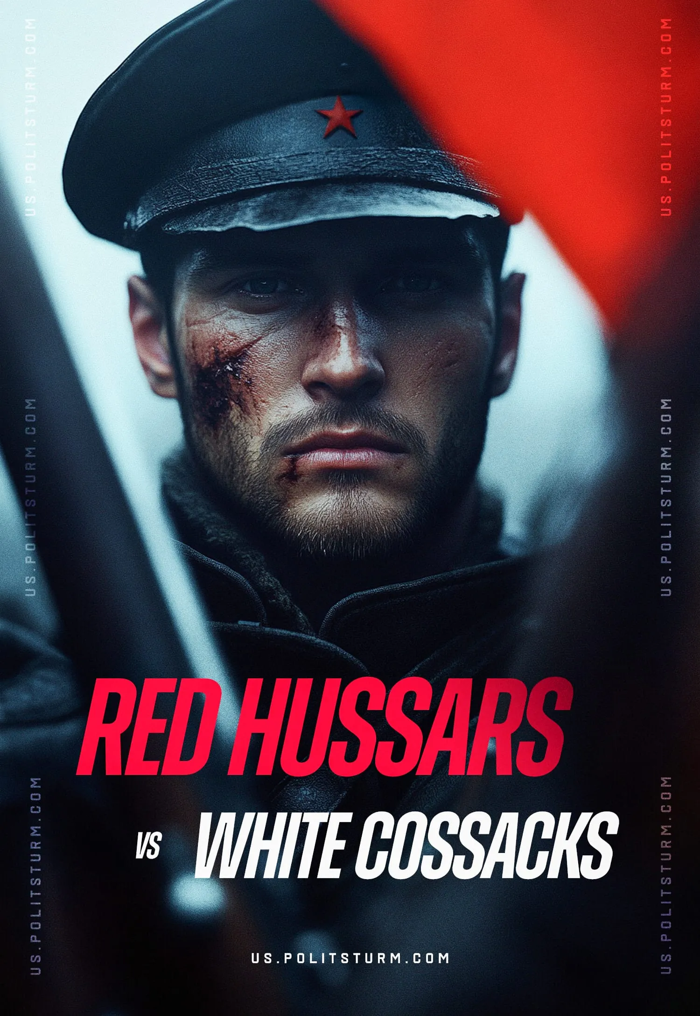

Original article
2025-01-25
32 min read

Preface by Politsturm:
In a previous publication, we translated an article that dispelled myths about Hungarian involvement in the Russian Civil War, shedding light on misconceptions and narratives about Hungarian internationalists. This article presents the next work in the series by Grigory Tsidenkov, a Russian historian, focusing on the Hungarian Hussars and, more specifically, one of their most prominent figures — Lajos Wienermann. Although Tsidenkov does not share left-wing views, his article offers valuable historical material that provides significant insight into the topic of internationalist struggle.
The article explores the role of foreign fighters in the struggle for Soviet power during the Russian Civil War. Through the lens of Wienermann’s life and military achievements, it examines the broader contributions of Hungarians who joined the Red Army, embodying ideals of solidarity and collective resistance against reactionary forces.
Addressing this subject is essential not only for understanding the practical role of internationalists in revolutionary movements but also for highlighting their contributions to shaping the early Soviet state. Wienermann’s story reflects both individual bravery and ideological commitment, but it gains its full meaning as part of the collective efforts to establish a society free from exploitation.
At the beginning of the Russian Civil War, the Reds clearly lacked professional cavalrymen. The sabers of Hungarian hussars (light cavalry warriors) freed from prisoner-of-war camps came in handy. One of them was 30-year-old sergeant Lajos Wienerman. "I can't explain to you how handsome he was!" - said N. Pavlova, the secretary of the Pugachevsky district party committee, recalling her meeting with the commander of the Astrakhan International Regiment 40 years later. However, the qualities of the brave hussar were not limited to beauty.
Lajos Wienermann was born in 1888 in the Hungarian town of Jászberény near Budapest. From an early age, he helped his stepfather, a tinsmith, and learned the trade. In Jászberény he joined the Social Democratic Party and became active in the trade union movement. By 1914 he was the secretary of the town's tinsmiths'' union.
With the outbreak of World War I, Wienermann was drafted into the Imperial Royal Army and assigned to one of the Honved hussar regiments. At the front, he earned a reputation as a brave cavalryman and was promoted to sergeant, but the Russians captured him in 1915. After several months of waiting in the Darnitsa filtration camp, he was sent to the Tomsk prisoner-of-war camp.
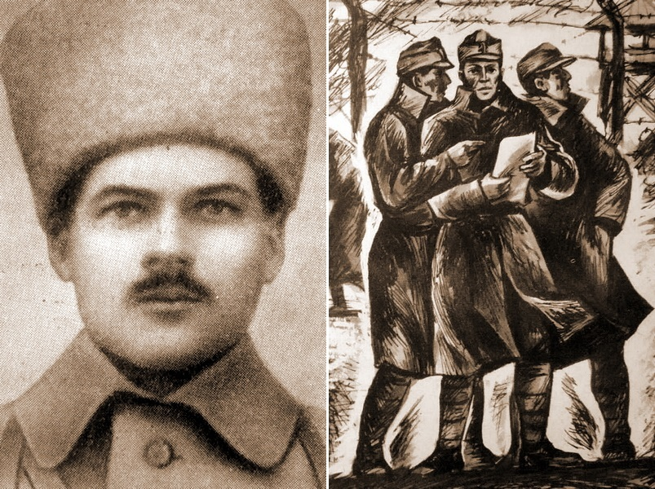
On the left is a portrait of Lajos Wienermann (1888-1918). On the right is a drawing from Z.A. Dymov's book “My Dear Friends” depicting Hungarian prisoners in the Totsk camps
The Tomsk camp was probably the most politicized of all the camps in the Russian Empire. The prisoners here were divided not only into soldiers and officers, as in all the other camps, but also into groups based on political views and beliefs. Wiermann immediately became close to a group of socialists led by Béla Kun and Ferenc Münnich, some of the best-known Hungarian revolutionaries and communists whose biographies are widely available in literature and on the Internet. Ferenc Münnich, a career officer, shared all his officer's pay and parcels from home with the socialist soldiers, further uniting their political group and provoking open hostility from the other officers.
Political debates in the camp were heated and often degenerated into fights. Wienermann was never considered a brilliant orator, but his self-confidence, great strength, and ability to fight with anything at hand came in very handy for the socialist group. His mere presence and calm gaze reduced the heat of the debaters' passions. Although Wienermann never wrote articles and could not conduct theoretical debates, Bela Kun and Ferenc Münnich quickly came to regard him as a close friend. Wienermann worked hard to educate himself to the level of his new friends.
After the February Revolution of 1917, the camp regime was significantly weakened. Driven by homesickness and intent on agitating among the soldiers of the Austro-Hungarian army for an end to the war and the establishment of Soviet power, Wienermann escaped the camp. He was able to travel secretly to Belarus, where he attempted to cross the front line into a section of German forces during a cease-fire and soldier fraternization.
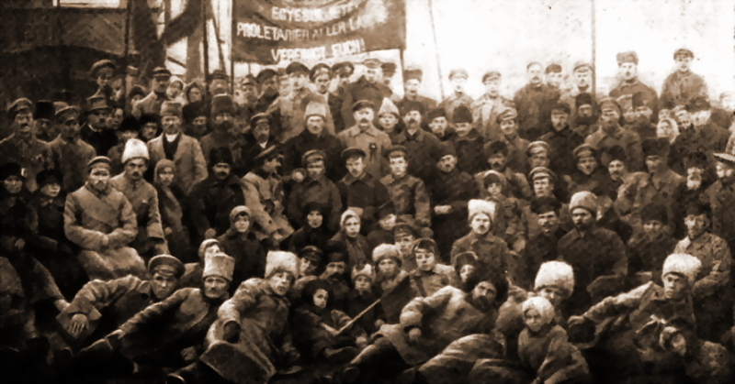
Hungarian internationalists in Nikolaevsk, renamed Pugachev in November 1918. Nikolaevsk district was the main area of ​​operations for Wienermann's detachment
The German riflemen let the Hungarian pass freely to the rear, but there Wienermann met an officer's patrol that was restoring order and driving the soldiers back into the trenches. Seeing a man in a Russian overcoat, the patrol pointed their rifles at him, and the officer ordered him to leave immediately. Lajos had no choice but to return. He returned from the front line to Minsk and got embroiled in the revolutionary events in the city. There he joined the Red Guard unit of the city committee of the Russian communist party and was appointed commissar of the international unit that was being formed.
Wienermann was very active in this position. At first, he sent propaganda leaflets to the prisoner-of-war camps in Minsk, and soon convinced socialists and communists among Czechs, Slovaks, Serbs, and Croats began to enlist in the unit – Belarus mostly contained prisoners of Slavic nationalities. Wienermann's unit grew impressively, gained independence, and became known as the 1st Minsk International Detachment of the Red Guard.
In February 1918, Wienermann's detachment took part in the unsuccessful defense of Minsk against the advancing German troops. The Red Army units were defeated and abandoned the city. Wienermann and a few men managed to fight their way out of the encirclement, but the detachment no longer existed. They could not locate the headquarters, or at least some command, of the Red Internationalists in the chaos of the retreat, and so they decided to head for Moscow.
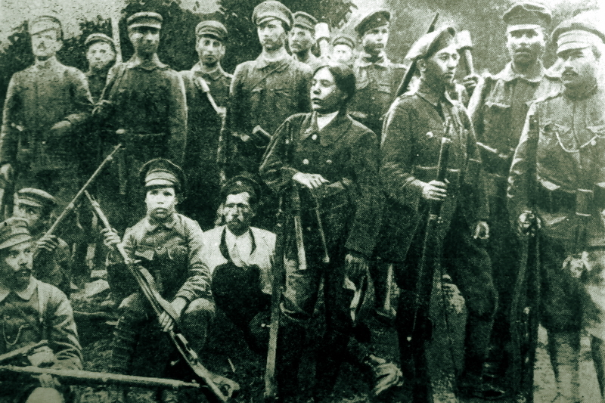
Soldiers of the 1st battalion of the 1st Moscow International Detachment. The group includes people of at least six nationalities
In March 1918, a thin and ragged Wienermann came to Moscow in his ruined boots. He went to the People's Commissariat for Military Affairs and asked where to find the Hungarian section, where he met Bela Kun. He introduced him to the commander of the 1st Moscow International Unit, Tibor Samueli. After a brief interview, Wienermann was immediately appointed commander of the 1st battalion unit. This unit, composed of Hungarians, Germans, Latvians, and Chinese, guarded the Kremlin. At the battalion headquarters, the new commander personally interviewed volunteers. Within a month, the battalion grew to 700 strong and became a full-fledged combat unit.
In late May 1918, Wienermann was sent to Astrakhan to help local councils form international detachments. 300 volunteers from the battalion, mostly former prisoners of war, agreed to go with him. In Astrakhan, Wienermann's unit became known as the 1st Moscow International Detachment – names of internationalists rarely shone with originality and were often repeated.
At the same time, the Czechoslovak Corps mutinied and captured Samara, and united with the Cossacks (a layer of people in the Russian Empire who were in military service for the Tsar) of Ataman A.I. Dutov (The rebellion of the Czechoslovak Corps was an armed uprising by units of the Czechoslovak Corps against Soviet power during the Russian Civil War of 1917–1922). The Red Command was faced with the real danger of a breakthrough of the combined forces of the Whites and the Czechoslovaks in the southern direction and their connecting with the southern forces of the counterrevolution. In the Nikolayevsky and Novouzensky districts of Samara Province, which remained partially under Red control, rapid defense preparations began.
The most reliable and combat-ready part of the Reds in this direction was V.I. Chapaev's detachment. To reinforce the Chapaevs, a detachment of Wienermanns was sent from Astrakhan to the front near Krasnoye Kut. In the first battles, the detachment suffered losses but grew to 500 men – mostly due to defectors from the Czechoslovak Corps. These were mostly ideological socialists and communists, as well as Hungarians who had joined the Slovak units and escaped prisoners of war from the Novouzensk camp.
The members of Chapaev's detachment called Wienermann's men "Astrakhans". The internationalists did not object, and soon the detachment was referred to in documents as the Astrakhan International Regiment – 500 soldiers was an impressive force for that time and place, and to be called a battalion was simply not respectable. In July 1918, the regiment finally joined Chapaev's Alexandrov-Gai group, but acted separately, covering the flanks. Chapaev gave Wienermann a large operational autonomy due to the regiment's serious trump card - three squadrons of Hungarian hussars.

The Evil Eyes of the 4th Army
In 1918 and early 1919 the Red cavalry, especially on the Eastern Front, was hopelessly defeated by the professional Cossack cavalry of the Whites. The 4th of the Red Army, to which Chapaev's group belonged, despite the fact that it outnumbered the enemy in infantry, had no more than 2,300 cavalrymen, of which only 1,000-1,200 men had good horses and were trained cavalrymen.
The enemy had units of mounted Cossacks with up to 9700 troops and professional commanders. In fact, Cossack detachments occupied the entire space between the settlements controlled by the Reds. They intercepted messengers, destroyed small Red outposts, took prisoners, and immediately informed the White command about all movements of Red Army units. As a result, while the Reds were losing in cavalry, they were also hopelessly outgunned by the Whites in reconnaissance.
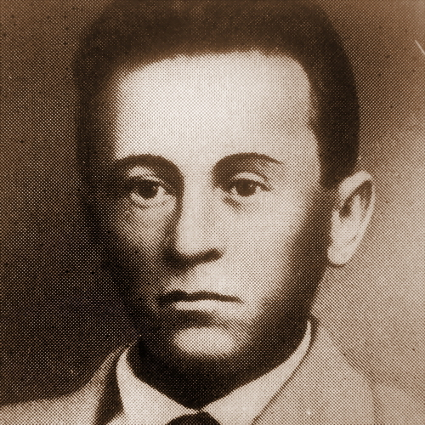
Sandor Kellner (pre-war photo)
The Reds saved their professional cavalrymen for serious confrontations, and other mounted units were only suitable for short-distance patrols. Small units of cavalrymen separated from their infantry were destroyed by the Cossacks, and infantry units with machine guns sent for reconnaissance were simply trapped in the steppe and had to retreat due to fighting and losses after their water was used up. The Red units occupying the settlements had no idea what was going on in the nearest vicinity. The Whites could make sudden raids on small Red garrisons and immediately occupy the settlements left by the Reds.
In December 1917, in the Saratov POW camp, common soldiers and junior commanders of Hungarian hussar regiments – 300 men in all – formed an international detachment of the Red Guard. When horses were allocated to the hussars, the detachment was proudly named the 1st Saratov International Cavalry Regiment. It was commanded by Lieutenant Sandor Kellner. In captivity, the hussars wore all kinds of rags, except for their carefully maintained uniforms: red breeches, blue mentiks (part of the hussar’s uniform, top jacket covered with laces and trimmed with fur), and red hussar caps.
On June 22, 1918, the regiment joined the detachments of the 4th Red Army, advancing on the line Krasny Kut - Novouzensk in order to retake Novouzensk, captured by the Whites on the night of June 17. On the morning of June 24, during the battle for the city, the hussars were in the center of the Red Formation. The White battery began to turn against them, but the hussars suddenly attacked without order and captured it, cutting the crew down with sabers. At the same time, several Hungarians from the Novouzensk camp came to the hussars' position and reported that there was a massacre of prisoners, including Hungarians, in the city prison. The Whites had already executed all the communists and socialists in the camp.
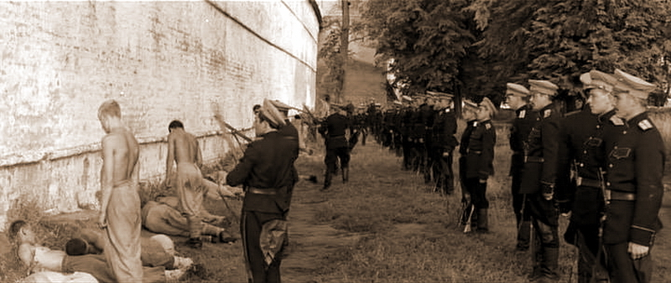
A still from the Hungarian film Stars and Soldiers (Csillagosok, Katonák) shows, in a somewhat embellished manner, the Whites' massacre of Hungarian Red Army soldiers
The hussars came out of the battle and rushed straight into the town. On the outskirts of the town, they attacked a detachment of Whites who were transporting prisoners to be shot and cut them to pieces. But these were the last prisoners — during the night the Whites shot 160 Red Army soldiers, among them 46 Hungarians. The same day, the Whites fled the town.
The next morning, hussar detachments were sent to guard the railroad repair brigade tasked with rebuilding the tracks destroyed by the Cossacks. There they were joined by Wienermann's detachment. The hussars were so happy to meet a countryman who spoke Russian that they immediately asked the command to transfer them to the Astrakhan International Regiment. So, Lajos Wienermann won over another 300 tenacious fighters.

The Capture Of Alexandrov Gai
In August 1918, the Astrakhan and Saratov International Cavalry Regiments were reorganized into a separate Aleksandrov Gai detachment of Wienermann. The group was based in Novouzensk, and its tasks included an attack on Aleksandrov Gai and covering the right flank and rear of Chapaev's 1st Samara (later 25th) Division.
At dawn on August 21, Dutov's Cossacks, with a detachment of 3,000 cavalrymen, launched a surprise attack on Novouzensk. The Novouzensk Rifle Regiment and Wienermann's group were in the city at that moment. The Cossacks managed to push back the Hussars on the outskirts of the city but in the center, they came under heavy fire and were forced to retreat. During the retreat, they tried to destroy the Hussar units, but the Hungarians, led by Sandor Kellner, organized a defense in the houses and then launched a counterattack. According to later recollections by veterans of the detachment, Kellner, who was leading the Hussars into battle, shouted: "Don't die, brothers, until we have chopped up this scum!"
The retreat of the Cossacks turned into a panic flight. Wienermann pursued the fleeing enemy, using an armored car and at the head of the hussars for 15 miles. According to the estimates of the Reds, the hussars killed 400 Cossacks during the pursuit. The main purpose of the pursuit was to capture Cossack horses, which became an excellent supplement for the group's cavalry.
From the beginning of September, Wienermann concentrated on the group's main task – the capture of Alexandrov Gai. This operation was a matter of honor for the Reds because, since May, the Whites had executed more than 700 Communists and Red Army prisoners in the village during punitive operations. The infamous photos of the executions were taken there.
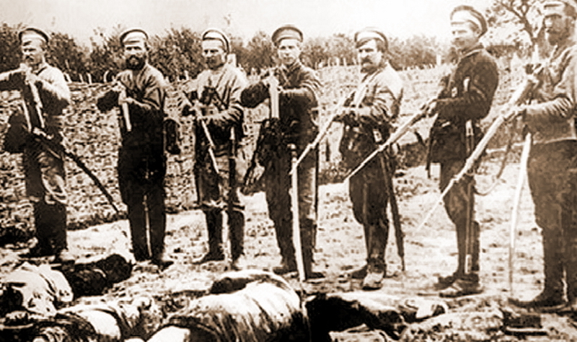
Whites pose near the bodies of executed Red Army soldiers in Aleksandrov Gai
The whole of late August and early September, Wienermann's group was distracted by the suppression of wealthy peasants’ rebellions, which took place in the rear of the Reds with the participation of Сossack detachments. It was only in the second half of September that Wienermann prepared his forces for a decisive strike. On September 21, Wienermann's group, supported by armored cars and two battalions of the Novouzensk regiment, stormed Aleksandrov Gai. The fighters killed in the attack were buried in a mass grave with the exhumed bodies of the victims of the White Terror. An obelisk was erected on top of the mass grave.
A week after the capture of the village, Wienermann's group rested and prepared for new battles. In those days a significant event happened – the detachment received reinforcements from Moscow. There they continued to consider the detachment as the 1st battalion of the Moscow International Detachment. The reinforcing troops consisted of only 11 cavalrymen: seven Hungarians, two Germans, one Italian, and one African. He was a Senegalese circus acrobat, Georges, who had come to Moscow on tour before the war. In the group, and later in the Chapaev Division, Georges proved to be an excellent mounted scout. After the war, he had a successful film career, starring under the name Kador Ben Saib in the first Soviet films.

Hussar Bikers: From Horse to Motorcycle
On the 28th of September, a large detachment of Cossacks reconnoitered the area around Alexandrov Gai and captured two soldiers from Wienermann's detachment, then settled 18 miles from the town in the small village Berezovsky and watched the Reds.
The next morning, a Red prisoner negotiator came to the settlement with a proposal to exchange prisoners, but the Cossacks firmly refused. The next day, Wienermann took a hand-held machine gun, got into a car, and, accompanied by another car armed with a machine gun and an armored car, set off to rescue the prisoners. The improvised detachment consisted of 15 men.
The advance party of the Whites stood on a farm six miles from Alexandrov Gai. The sudden appearance of the Hungarians took the enemy by surprise. Having dispersed the vehicles for cross-fire, Wienermann's men approached the farm from three sides. The Cossacks were quietly having lunch. As soon as the machine gunners opened fire on command, the Cossacks tried to escape through the only unblocked road, fired by Wienermann's light machine gun. Few escaped the trap: most of the Cossacks were killed by bullets or drowned in the stream that skirted the village, and 15 men were taken prisoner. Wienermann was unable to save his men from captivity: the Cossacks had slaughtered them before the Hungarian raid.
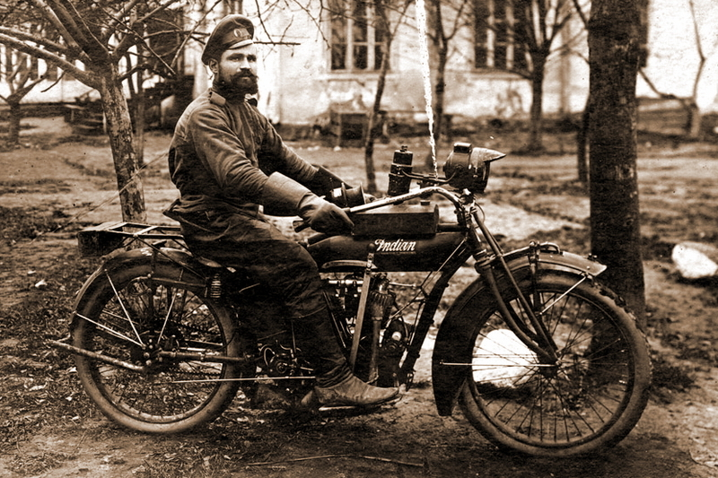
A Russian Imperial Army scooter rider riding a motorcycle from the Indian Powerplus model range. The US Army purchased such machines in large quantities and they were also supplied to Russia. Most likely, Lajos Wienerman also ended up with a similar “steel horse”
Only one Wienerman soldier was killed in the battle. One of the Hungarian prisoners hacked to death by the Cossacks was the brother of Hussar Ferenc Muller. When he saw the body, he jumped on his horse and ran to catch up with the Cossacks and cut them down. Muller broke away far ahead and was shot.
According to the operational summary of the 4th Army Headquarters No. 1476 as of 10:00 on 2 October 1918, Wienermann captured in the village a 122 mm howitzer with a large supply of shells, two three-inch guns, two machine guns, 36 rifles, 19 sabers, 19 horses, telephones, cables, and other military property. The most notable prize was a 'splendid high-speed motorcycle' made by the American company Indian, which Wienermann immediately took for himself. From then on, both on the campaign and in battle, he traveled exclusively by motorbike, with a Hussar saber strapped to the saddle and a hand machine gun with a supply of hand grenades.
The return of the detachment to Alexandrov Gai was greeted with jubilation by the inhabitants and Red Army men.
Earlier, on 28 September, while the Cossacks were conducting their reconnaissance, Wienermann, at Chapaev's request, had sent his mounted scouts and half a squadron to the International Regiment of the 1st Samara Division, which had no cavalry of its own. The regiment broke through the front of the Komuch army and reached the Syzran-Samara railway line near the Maituga station, threatening to completely encircle the enemy retreating from Syzran. On 1 October, the International Regiment dismantled the tracks at the Sretenka station (now Zvezda), destroying two columns of Komuch and Czechoslovak soldiers, and went to Ivashchenkovo to help the workers who had rebelled the day before.
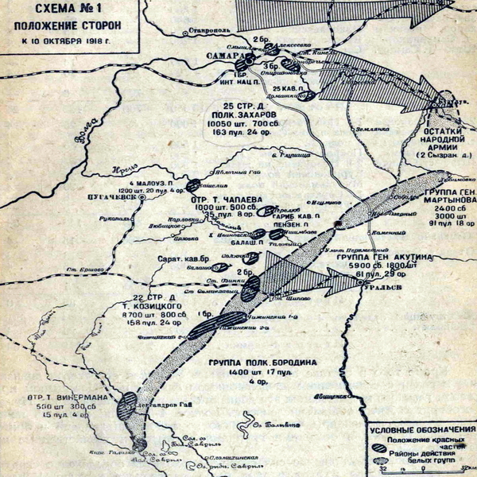
The combat area and the position of the opponents on October 10, 1918
On the night of 2 October, while approaching Ivashchenkovo, the regiment was overtaken by four military echelons of retreating Whites from Syzran, and Czechoslovak legionnaires attacked their rear from the direction of Androsovka. The internationalists were surrounded and fought hard for 24 hours, trying in vain to reach Ivashchenkovo, where the workers and the armed guards of the factory who had joined them held back the Czechoslovak units coming from Samara on the barricades. On the night of 3 October, the workers' defense of Ivashchenkovo collapsed, but several groups of surviving defenders broke through to the internationalists. The regiment, which had lost 600 men and had used up all its ammunition, committed to the one last bayonet charge, broke through the enemy ring and broke out of the encirclement in the area of the Tatarinov farm near the Maituga railway station.
In Ivashchenkovo, Komuch troops and Czechoslovak soldiers, for two days, carried out a brutal massacre of prisoners and workers' families, shooting and bayoneting over 1000 people. Women, children, and old people were tortured and killed in search of workers who had taken refuge. As a result, so many orphans were left in the settlement that after the liberation of Samara, the Soviet authorities had to urgently organise orphanages for them.

Lajos Wienermann's Last Battle
The Red Army liberated Samara on October 7th, 1918. In order to consolidate the success, Red Command developed a plan for further offensive operations. The 1st Army was to advance from Samara to Buguruslan, Ufa, and Sterlitamak, preventing the enemy from gaining a foothold at strategic points and attempting to control the railroad. The 4th Army was to advance with its main forces to Buzuluk and Orenburg, try to stop and throw back Ataman Dutov's main forces, as well as to give a diversionary blow to Uralsk with its right flank.
Unfortunately, the plan was adopted without taking into account the real situation on the ground. Soldiers of the Samara Division even staged open revolts several times, refusing to go to Buzuluk. The front of the 25,000-strong 4th Army stretched 400 kilometers from Samara to Alexandrov Gai, while the Orenburg and Ural Cossack armies together outnumbered it. Again, the overwhelming advantage of the enemy in cavalry was ignored: the units of the 4th Army were separated from each other by a distance of 2-3 days’ marches, could not conduct long-range reconnaissance and could not come to the neighbors' aid in time. The Whites could secretly gather strike groups that outnumbered individual Red units in the rear of the 4th Army, and destroy the advancing formations piece by piece.
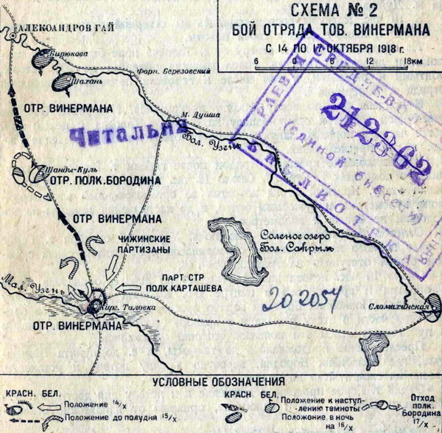
Combat operations of the Wienermann group in the area of ​​Aleksandrov Gai and Kirghizskaya Talovka
The headquarters of the 1st and 4th armies, ignoring Moscow's instructions, made an agreement on October 10th that the 1st army would attack Buzuluk and the 4th army would try to take Uralsk and Iletsk.
On October 12, Commander T.S. Khvesin gave the order to attack. The International Regiment and the 1st Brigade of the Samara Division led the offensive from Samara to Buzuluk together with parts of the 1st Army. The main attack on Uralsk was carried out by Chapaev's group consisting of the Balashov and Penza rifle regiments supported by the Garibaldi cavalry regiment. On the flanks, it was covered by a brigade under the command of A.V. Sapozhkov from the 22nd Infantry Division.
On the right flank of the army, acting independently, was the Alexandrov-Gai Wienermann group. Its task was to hold that flank and, if possible, to carry out an attack on the village of Slomikhinskaya and the town Lbishchensk, threatening the Guriev - Uralsk communication lines. Later, in 1919, the commander of the 4th Army, M.V. Frunze, would consider this direction as the key to the capture of Uralsk.
Wienermann's group had 500 infantrymen, 250 cavalrymen, 15 machine guns and four artillery pieces. The same front on the White side was occupied by Colonel N.N. Borodin's group of 700 infantry and 700 cavalry with 17 machine guns and four artillery pieces (there is a mistake on the map). Borodin also supervised Sapozhkov's brigade.
On October 13 Wienermann marched from Alexandrov Gai to the village of Kirgizskaya Talovka. Colonel Borodin, leaving small pickets in front of Sapozhkov, secretly followed Wienermann. On the approach to the village, Borodin ordered a hundred Cossacks to fire at Wienermann's detachment. However, the hussars immediately engaged in a skirmish with the Cossacks and began to outflank them. The Cossacks hastily retreated to their main forces.
In the evening, Wienermann occupied Kirgizskaya Talovka. Borodin, having received reliable information about the strength of the Red detachment and correctly assessing the situation, cut off the communication lines of Kirgizskaya Talovka with Aleksandrov Gai, i.e., Wienermann with Sapozhkov's brigade, which was already too far away to come to the rescue in case of emergency.
At dawn on October 14th, Borodin, with infantry reinforcements, led an attack from two directions - east and north - on Kirgizskaya Talovka, expecting to take the Reds by surprise and force them to the swampy Maly Uzen.
However, Wienermann's men were on the alert and engaged in a fierce firefight. Wienermann, who brought his infantry into the battle, withdrew the cavalry to a position behind the village and began to prepare the hussars to attack the rear and flank of the white infantry advancing from the east. At this moment Borodin mistakenly thought that all the red units were already engaged in the battle and threw the 9th Cossack Regiment into the attack along the Alexandrov Gai - Kirghizskaya Talovka road.
The advancing hundreds of Cossacks broke into the village and began to suppress the Red infantry. Wienermann immediately assessed the situation, switched from motorcycle to horse, and led the Hussars in a counterattack. The Cossacks, not expecting serious resistance and relying on their numbers, galloped toward the Hungarians. The enemies clashed at full speed in the middle of the village. In a short but fierce fight, the Cossacks who had entered the village were cut down, and their remnants retreated. The hussars began to chase them and, having moved past the outskirts of the village, met the main force of the 9th Cossack regiment.
The trailing hundreds of Cossacks rode at a trot to the battlefield, not having time to bring their horses to a gallop, but, pikes in hand, surrounded the hussars in a ring and began to squeeze them. The red horsemen had nowhere to retreat. Wienermann, parrying the Cossack pikes with his saber, took out his Mauser and began firing at the Cossacks at close range. The rest of the hussars, who had revolvers, followed his example. Gaps appeared in the wall of the Cossacks, and the hussars immediately rushed into them, swinging their sabers with lightning speed. The Cossacks, who had no serious fencing skills, trembled and ran. Their regiment was saved from defeat by the cavalry battery that Borodin had hastily sent forward, which drove the hussars, who were capturing Cossack horses, back into the village with shrapnel fire.
At 10:00 the Whites stopped the attack and began to retreat to the village of Shandy-Kul for regrouping and rest. The whole field in front of Kirghizskaya Talovka and the streets of the village were filled with corpses of men and horses. On the northern outskirts of the village, Wienermann set up a detachment to assess the losses. It turned out that the Whites had taken several prisoners. Wienermann knew what tortures awaited the Internationalists in captivity, so he did not hesitate for a second. He grabbed a submachine gun, jumped on a motorcycle, appointed Sergeant Gerbe as temporary leader of his detachment, and with 15 of the most desperate hussars rushed in pursuit.
The hussars caught up with the Whites in a valley where they had gone to rest their horses. The Cossacks did not expect an attack and were surprised when grenades were thrown at them. Panic set in, no one could understand what was happening. The prisoners were quickly located by joyful shouts in Hungarian. They were immediately released and galloped back to their troops. The Cossacks quickly came to their senses and gave chase. Wienermann, seeing that the horses with the two riders were lagging behind, got off his motorcycle, took off his machine gun, and ordered the detachment to move without him under cover of his fire. Before the machine gun jammed, the Red Hussar commander managed to fire several rounds at the pursuers and was killed in the ensuing hand-to-hand fight...
Gerbe formed the detachment into the formation of an infantry square and led it back to Alexandrov Gai. In the vanguard went the armored car, in the center the artillery and the wagon in which Wienermann's body, covered with numerous wounds, was picked up on the road. The hussars rode behind as a rear guard. Borodin's Cossacks made several more attacks from the rear and flanks, but when they encountered the concentrated fire of the cavalry and saw the hussars ready to attack and eager to fight, they retreated. The chase continued to the village of Shandy-Kul, where the Cossacks were finally exhausted. Borodin withdrew his group to Slomikhinskaya and did not take any active actions in his area until the spring of 1919, when he restored the lost combat effectiveness.
Gerbe brought the detachment safely to Alexandrov Gai, where it remained throughout the Ural operation, clearly carrying out the order to "hold the right flank of the army". The Internationalists conducted a deep reconnaissance in the vicinity of Slomikhinskaya and found out that the Cossacks had suffered serious losses and would not attack in the near future. This allowed Gerbe to regroup and replenish the detachment, which had lost 200 men killed and wounded on the march to Kirghizskaya Talovka.

Memory
On October 15, 1918, at the general meeting of the fighters of the Alexandrov-Gai group, it was unanimously decided to rename the group as the International Regiment in honor of Wienermann. The body of the dead commander was sent to Moscow.
In the following days, the Soviet press and the internationalist newspapers published numerous obituaries about the death of Lajos Wienermann. A large number of people gathered in Moscow for his solemn funeral. The procession was filmed and included in the newsreel. The body was buried in a communal grave near the Kremlin wall. At the rally that followed, Béla Kun vowed that Wienermann's dream of a Soviet Hungary would surely come true. Later, in 1927, when Béla Kun was awarded the Order of the Red Banner for his services to the revolution, he stated that he accepted the award on behalf of Wienermann as well.
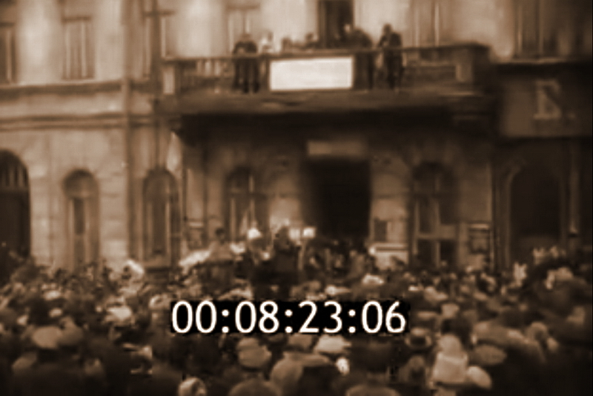
Still from a newsreel of Lajos Wienermann's funeral in Moscow
At that time, the name of Lajos Wienermann was well known and quickly became a legend. There were two main reasons for this. First, the October offensive of the Reds against Uralsk ended in defeat. The heroic deed of Lajos Wienermann stood out against the general background and lightened the bitterness of those events. Secondly, the personality of Lajos Wienermann fully fit the ideal image of the commanders of the first spontaneous semi-guerrilla units of the initial stage of the civil war, who were characterized by personal bravery and whose fate was inseparable from the fate of their fighters. Such actions were unacceptable and practically impossible in the regular army that the Reds had already created in 1919. Among the veterans, however, the memory of the former freedom, soldier's democracy and blood brotherhood lived on for a long time.
[PS: This author’s assertion that "such actions were unacceptable and practically impossible in the regular army that the Reds had already created in 1919" is overly simplistic and reflects a romanticized view of the guerrilla army. Historical evidence demonstrates that even within highly disciplined, regular armies, acts of extraordinary courage were both possible and frequent.
The regular army did not negate the capacity for bravery but rather contextualized it within the needs of collective strategy and discipline.
The "former freedom" of the guerrilla units might have been a source of inspiration, but the centralization and professionalization of the army were highly crucial in ensuring its success in the Civil War.]
The fate of the International Regiment named after Wienermann is connected with the 25th Chapaev Division. At the end of 1918, the regiment was replenished with a squadron of lancers from German prisoners of war, which brought the regiment's mounted reconnaissance to full operational strength. Wienermann's men took the most active part in the famous Slomikhinsky battle of the Chapaev Division, representing one of the most combat-ready cavalry units of the division. In May 1919 the regiment was disbanded due to the mass departure of Hungarian internationalists for the defense of Soviet Hungary, and the remaining soldiers were distributed to other parts of the division. One of the streets in the village of Aleksandrov Gai, Saratov Region, deservedly bears the name of the Red Hussar Lajos Wienermann...
Sources.
- A. Jozsa, D. Milei. Hungarian Internationalists in the Struggle for the Victory of October. In two volumes — M.: Progress, 1977
- Hungarian Internationalists in the Great October Socialist Revolution. Collection of documents of the Military Historical Institute of the Hungarian People's Army - M.: "Voenizdat", 1959
- Hungarian Internationalists in the October Revolution and the Civil War in the USSR. Collection of documents in two volumes — Moscow: Politizdat, 1968
- Dymov Z.A. My dear friends - Moscow: "Politizdat", 1985
- Internationalists in the Battles for Soviet Power: A Collection of Articles / Institute of Slavic Studies of the USSR Academy of Sciences, Scientific Council of the USSR Academy of Sciences on the Complex Problem of the “Great October Socialist Revolution” edited by M.A. Birman — Moscow: “Mysl”, 1965
- Kopylov V.R. Foreign internationalists in the October Revolution, 1917–1918. — M.: “Mysl”, 1977
- Kutyakov I.S. The Defeat of the Ural White Cossack Army - M.: "Voenizdat", 1931
- Popov F.G. 1918 in the Samara province. Chronicle of events - Kuibyshev, Kuibyshev book publishing house, 1972
- Shcherbakov Yu.N. Brotherhood sealed with blood: participation of foreign internationalists in the struggle for Soviet power in the Middle Volga region in 1918–1919 — Kuibyshev, Kuibyshev Book Publishing House, 1961
- Szolnok Megyei Néplap – 1977 – October 16 – p.10

Original article

