EU Recognition of Palestine Produced No Material Change
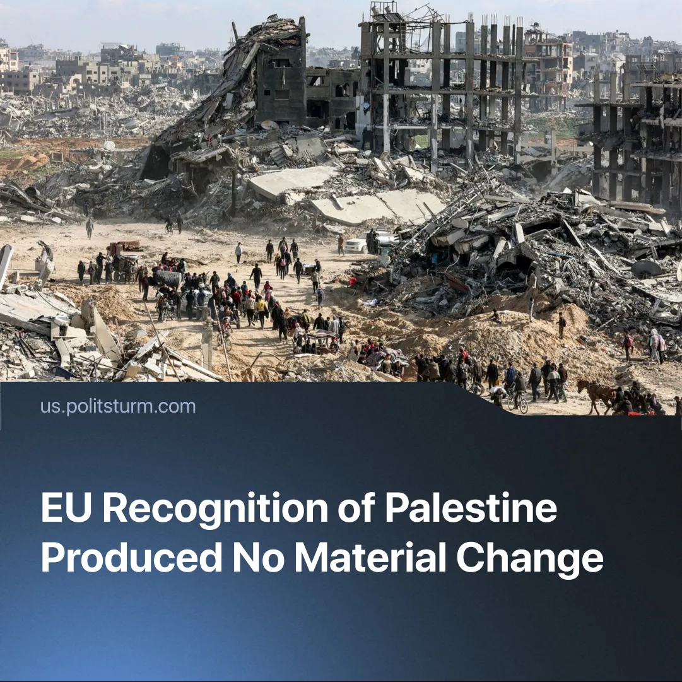

Original article
2025-11-29
2 min read

EU recognition of Palestine has led to nothing. Instead, arms supplies to Israel have resumed.
Details. The United Nations Security Council has approved a resolution endorsing the American “peace plan” for Gaza. It hands control of the Strip to a “Board of Peace” made up of US-aligned imperialist governments. The eastern bloc – Russia and China – did not use their veto to block it.
► The Israeli military occupation will be replaced with “International Stabilisation Force” peacekeepers, who are now tasked with removing Hamas from power. These are claimed to be temporary transitional measures.
► Despite Israel repeatedly breaking the ceasefire on multiple occasions, Western governments continue to normalise relations with Israel, forgetting their prior criticism of Israeli actions in Gaza. Germany, which provides 30% of Israel’s imported weapons, will officially resume suspended arms shipments to Israel from November 24th.
Context. In September, Canada, Britain, France, and other US allies recognised Palestinian statehood despite Washington’s objections. As we previously explained, this was a symbolic gesture by European imperialists seeking to posture against the US amid strained relations.
► The UN formally claims the role of overseeing international law and state recognition; in practice, it has become increasingly powerless, as imperialist interests have diverged. Its Gaza resolutions are routinely ignored, and multilateral climate efforts have recently collapsed under competing imperialist interests.
Important to Know. Official recognition of Palestinian independence was a popular demand of the anti-war movement in Western countries. Because of opportunist and adventurist tactics and the lack of an organised working class, this movement failed to materially impede the imperialist war. Spontaneous and sporadic workers’ strikes did not have the desired impact.
► EU recognition served European imperialist aims while pacifying domestic unrest. It was not a victory of the protests. Such bourgeois declarations are a form of propaganda, designed to deceive the workers. They formally appease popular demands, but are empty of any actual content. Although numerous countries now recognise Palestine, this has made no material difference for the workers in the region.
► The Palestinian masses will not have any more or less say over their affairs than before the recognition of Palestine. After the ceasefire, Hamas regained control in multiple parts of Gaza, continuing the rule of a reactionary Islamist group. The US and Israel allowed this for the sake of stability, but under the new peace plan, Hamas will be disarmed and removed from governance of the Strip.
► As Lenin stressed during the First World War, “the imperialist Powers and the imperialist bourgeoisie cannot grant a democratic peace. [...] Not a single fundamental democratic demand can be achieved to any considerable extent, or any degree of permanency, in the advanced imperialist states, except by revolutionary battles under the banner of socialism.”

Original article

