One in Four Russians Believe In The Evolutionary Theory Of Human Origins
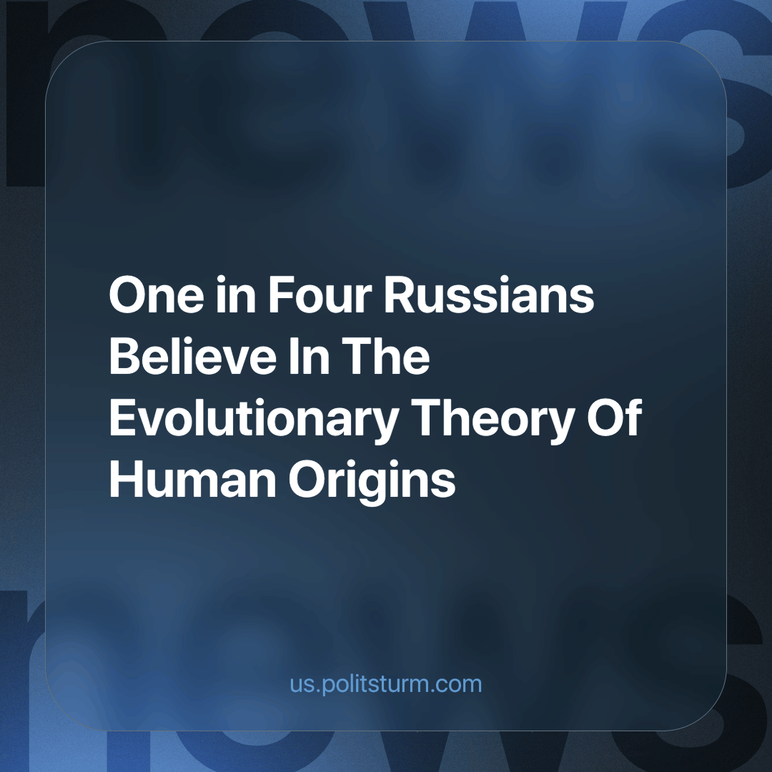

Original article
2024-04-05
2 min read

According to a recent survey by the Russian Public Opinion Research Center (RPORC), only 28% of Russians believe in the evolutionary theory of human origins.
Among the 1,600 respondents, the prevailing opinion is that modern science is currently unable to answer the question of human origins (39%), while 23% adhere to the "divine" version of human origins, 3% believe in extraterrestrial intervention, and 1% admit to being uninterested in the issue.
The data from the survey is highly indicative, both in terms of the percentage distribution of opinions and in terms of the age and social status of the respondents.
Among supporters of Darwin's theory, 99% were young people aged 18-34. Additionally, more than half of them (56%) were atheists.
Supporters of the "divine" version of human origins are predominantly citizens who profess Islam (56%), with 46% residing in the North Caucasus Federal District.
What conclusions can we draw from the presented results?
Firstly, the majority of the population leans towards superstitious and pseudoscientific theories. This is a direct consequence of the degradation of the legacy of science and education left by the Soviet Union, intentionally attacked by the ruling class for over thirty years, through privatization. The goal of education in modern Russia is no longer to nurture a well-rounded individual. Market relations impose new tasks on contemporary educational institutions - extracting profit and cultivating individuals limited in their knowledge and aspirations, mere cogs in the machine, consumers, and powerless workers.
However, it is worth noting that despite all the efforts of modern propaganda and the system of educational services, there are many curious minds among young people who strive for knowledge and a material understanding of the world in contrast to the idealistic picture imposed on them.
Secondly, the idealistic (superstitious) perception of the world is prevalent mainly among the poorest regions of Russia and areas where religious propaganda is most widespread and aggressive. For example, according to statistics from Rosstat published in 2023, the Republic of Ingushetia was recognized as the poorest region of the Russian Federation in terms of the population with incomes below the poverty line. Among the top ten in this ranking are three regions of the North Caucasus Federal District where the majority of citizens who believe in the “Divine” origins of man reside.
Pseudoscientific theories, like religious propaganda, are easier to accept and take deeper root in the minds of the most disadvantaged segments of the population. The poorly educated, who are forced to exist in impoverished conditions are ready to grasp any idea promising them a better life. Propaganda like this provides a simple, unanalyzed explanation of the world and society's structure, as well as reasons for their impoverished existence.
Capitalism has run its historically progressive task, at one point rapidly improving humanity's productive power and connecting the entire globe, but now due to the private ownership of productive power, it presents no progressive force and only hinders our development. No aspect of our lives is untouched by this decay.
The capitalists try to conceal this decay in order to prevent workers from becoming conscious of their position and maintain their privileged position. Only working people themselves can change this system. A conscious, materialist and scientific understanding of the world and society, is required to overcoming the problems that we face today.
Sources:
Urban News Agency "Moscow" - "RPORC: 23% of Russians Believe in Divine Human Origin, 28% Support Evolution Theory" dated February 8, 2024.
Visasam.ru - "TOP-10 Poorest Regions of Russia: Rating 2023-2024" dated January 9, 2024.

Original article

