Putin and Trump Met in Alaska to Broker Ceasefire
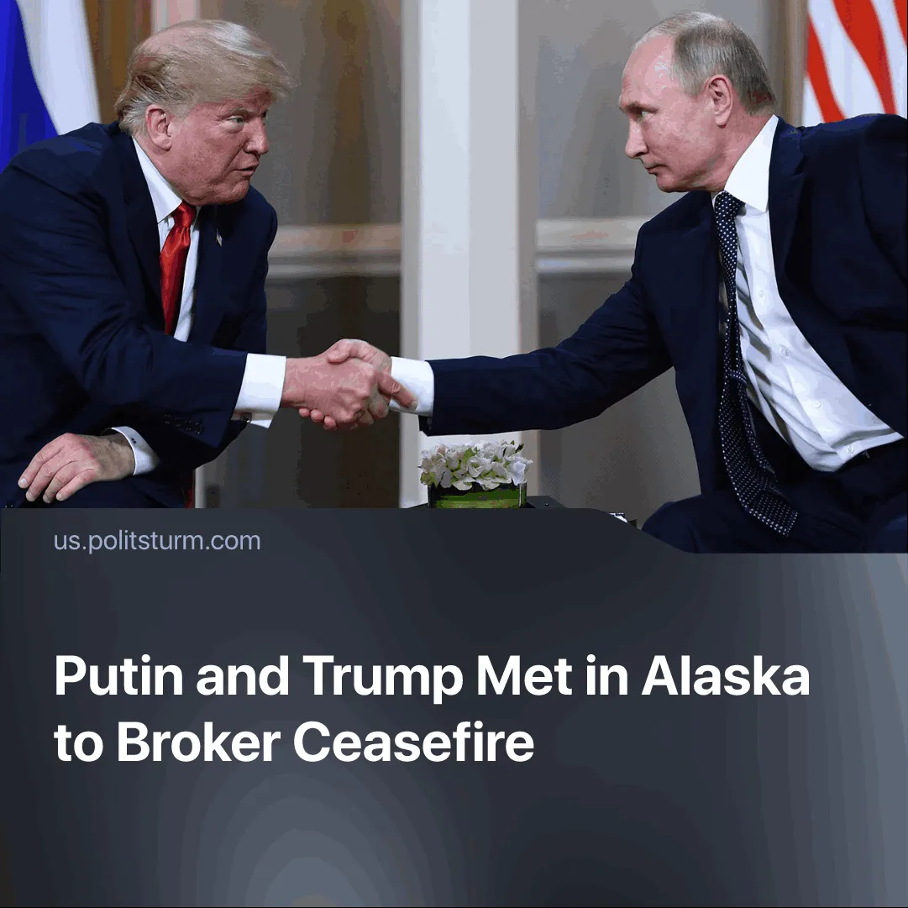

Original article
2025-08-18
2 min read

Following consecutive setbacks to Russia’s sphere of influence in the Middle East, Putin and Trump met to negotiate peace terms, but no agreement was reached.
Details. On August 15, 2025, Presidents Vladimir Putin and Donald Trump met for roughly three hours at Joint Base Elmendorf-Richardson in Anchorage, joined by top aides.
► No ceasefire was announced. Instead, Trump shifted from demanding an immediate halt to fighting to framing the discussions around a broader “peace deal.”
► Trump will meet with Zelenskyy on 18 August to discuss the outcome of the talks before any further steps are taken.
► Putin proposed freezing the current front lines if Ukraine ceded control of Donetsk, an offer Zelenskyy rejected.
► Putin openly argued that negotiations should be conducted in secret: "in order to approach the issue peacefully, it is necessary to conduct detailed conversations. And not in public, but this must be done calmly, in the quiet of the negotiation process."
Context. The Alaska summit followed a series of defeats and pressures that weakened Russia’s regional influence and economy.
► Russia’s sphere of influence has suffered major blows in recent months. During the “12-day war,” Moscow was unable to provide direct material support to its ally Iran, and Tehran’s influence in the region has been weakened as it became cut off from its proxies. In the Caucasus, Trump secured control of the Zangezur corridor, previously under Russian oversight. In Syria, the collapse of the Assad government eliminated one of Moscow’s last major footholds in the Middle East.
► Sanctions after the “SMO” shrank Russia’s export markets. In response, trade with China surged to a record $240 billion in 2023, with China now supplying about 40% of Russia’s imports.
► Trump has recently escalated pressure through threats of 100% tariffs and secondary sanctions, such as seen in India, a NATO agreement for the EU to spend $40 billion on arms for Ukraine.
Important to Know. These talks will not bring genuine peace; they are part of a broader imperialist re-division, and the causes and conditions for another war remain. The conflict has made Russia more dependent on China and accelerated an economic crisis. By pursuing a settlement and rapprochement with the US, Russia seeks to regain access to export markets blocked by sanctions.
► The US aims to freeze secondary conflicts in order to concentrate resources on its main rival, China. By neutralising Russia — or even drawing it into partial rapprochement — Washington would weaken one of Beijing’s largest trade partners and military counterweights. This would further isolate China, shrink its export markets, and push it closer to a crisis of overproduction. Such “peace initiatives” are, in reality, preparations for the decisive confrontation between the two main imperialist blocs.
► Putin’s call for secret, non-public negotiations recalls past imperialist treaties. In 1916, Britain and France secretly concluded the Sykes-Picot Agreement, dividing the Middle East into colonial spheres of influence without the knowledge or consent of the peoples living there. Or many of the secret treaties for the re-division of the world, signed by the major belligerents of WWI, that the Bolshevik government exposed after taking power.
► The Alaska summit reflects the same process. Spheres of influence are to be decided behind closed doors, with Russian businessmen such as Finance Minister Anton Siluanov and sovereign wealth fund chief Kirill Dmitriev present to safeguard elite economic interests. This shows clearly that these negotiations are conducted in the service of capital and ruling classes, not in the interests of peace or working people, whom they are otherwise happy to send to the slaughter.

Original article

