Putin Signed a Law Taxing Excess Profits for Large Companies
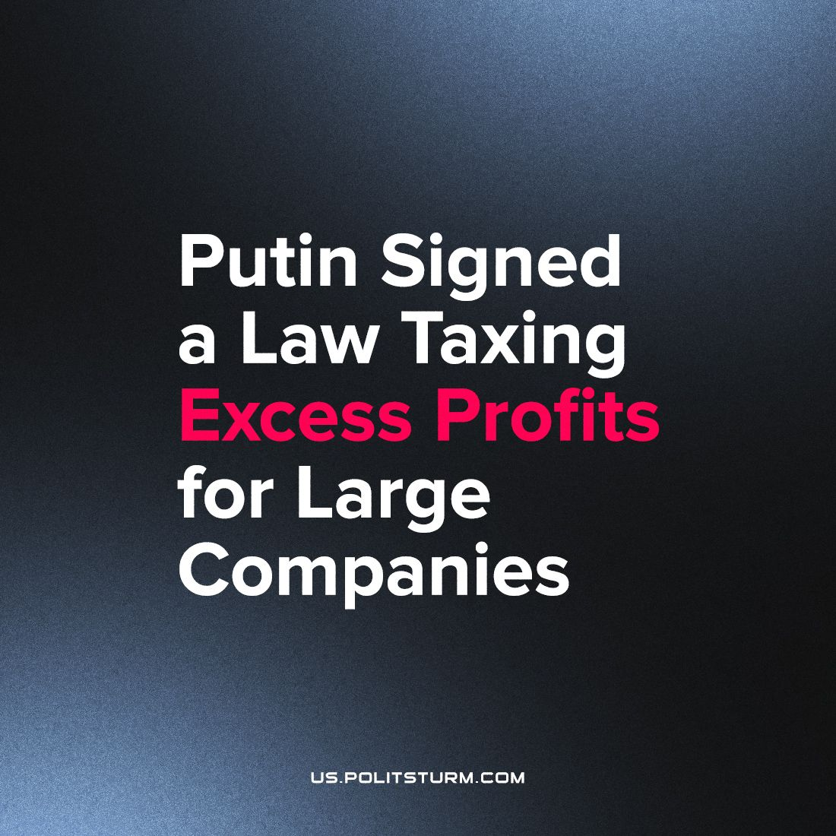

Original article
2023-10-13
1 min read

Russian President Vladimir Putin has signed a law which introduces a 10% excess profits tax for large companies. The law will come into force from 1 January 2024.
The tax will have to be paid no later than January 28, 2024. It will be credited to the federal budget and will be of a one-off nature. The list of those who are exempt from paying this tax includes companies in the oil and gas and coal mining sectors, small and medium-sized enterprises, payers of a single agricultural tax, developers who did not pay dividends, troubled financial organisations, as well as companies that actively invested and therefore had no revenue in 2018-2019.
It is worth noting that the amount of tax will be calculated by taxpayers themselves. At the same time, it can be halved to an effective rate of 5% if the security payment is made between October 1st and November 30th, 2023.
The tax will have no significant impact on the situation of both entrepreneurs and ordinary citizens. The former will continue, following all the laws of capitalist society, to extract super-profits from the activities of hired workers, and the latter will again be "satisfied" with a negligible part of the result of their labour.
No reforms in the bourgeois state can affect the living conditions of the labouring masses. Such accounting manipulations reflect the struggle of the various financial groups and create the appearance of social justice. Only the transition to socialism, only the replacement of private ownership of the means of production by public ownership, will make it possible for the workers themselves to take charge of their industries and put an end to all exploitation.
Source: "Putin signed the law on the tax on excess profits for large companies" from 4 August 2023

Original article

