Putin Rules Out USSR Restoration
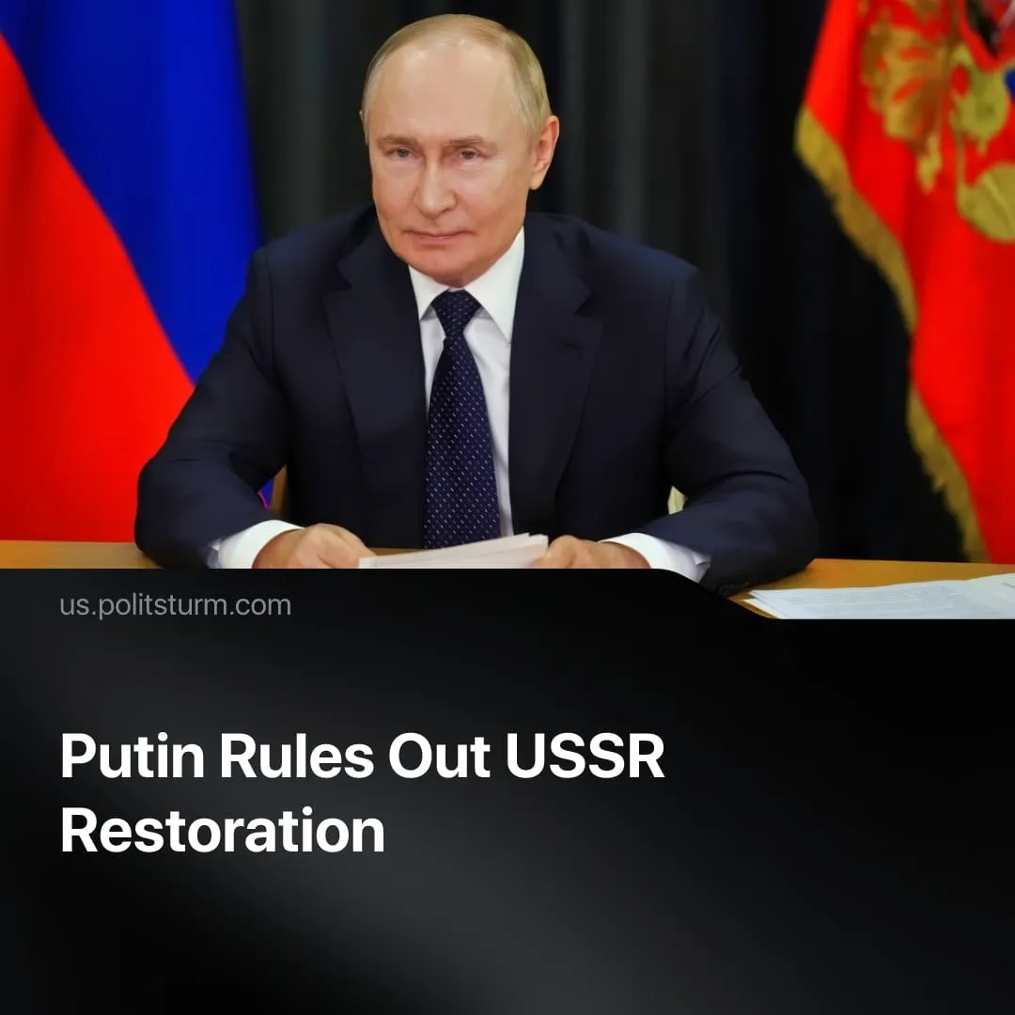

Original article
2025-12-11
1 min read

Restoration of the USSR is senseless according to Putin, contradicting liberal and social-chauvinist claims that he seeks to restore it.
Details. President of Russia Vladimir Putin stated in an interview with India Today that restoration of the USSR is “not on the table” and doesn’t “make any sense”.
► He added that reviving the Soviet Union in current circumstances is irrational, “because it would critically change the national and religious composition of the Russian Federation”.
► Putin also suggested that assigning blame for the USSR’s collapse is pointless, arguing that “it was the system that turned out not to be viable.” He noted that the people “always believed it was so big, so great” that nothing could happen to the country, and any potential problems would not affect it.
Context. Since 2014, Western media and liberal commentators have claimed that Putin seeks to “restore the USSR.” This narrative equates the modern Russian capitalist state with the former socialist Union, presenting current Russian actions as alleged Soviet “expansionism” to reinforce anti-communist sentiment among workers.
Important to Know. Putin's statement that restoration of the USSR is “not on the table” is unsurprising, given that he represents the modern Russian capitalist state and openly maintains an anti-communist worldview.
► Some examples include an accusation that the soviet economy supposedly produced "only rubber shoes”, that the Marxist-Leninist ideology is “a beautiful fairy-tale” or that Bolsheviks wanted to “socialise” wives.
► At the same time, Putin exploits Soviet nostalgia – such as the victory in WW2 or Stalin’s image as a strong leader – in a nationalist way, ignoring the role of class struggle and the socialist nature of Soviet achievements.
► Some social chauvinists echo these claims that modern Russia is the spiritual continuation of the USSR, but instead portray it as a “progressive” and “anti-imperialist” defender of communist interests. They falsely claim that supporting Russia serves the international proletariat, while in reality it prioritises the interests of a single capitalist state.

Original article

