Putin on the Top Priority of the State
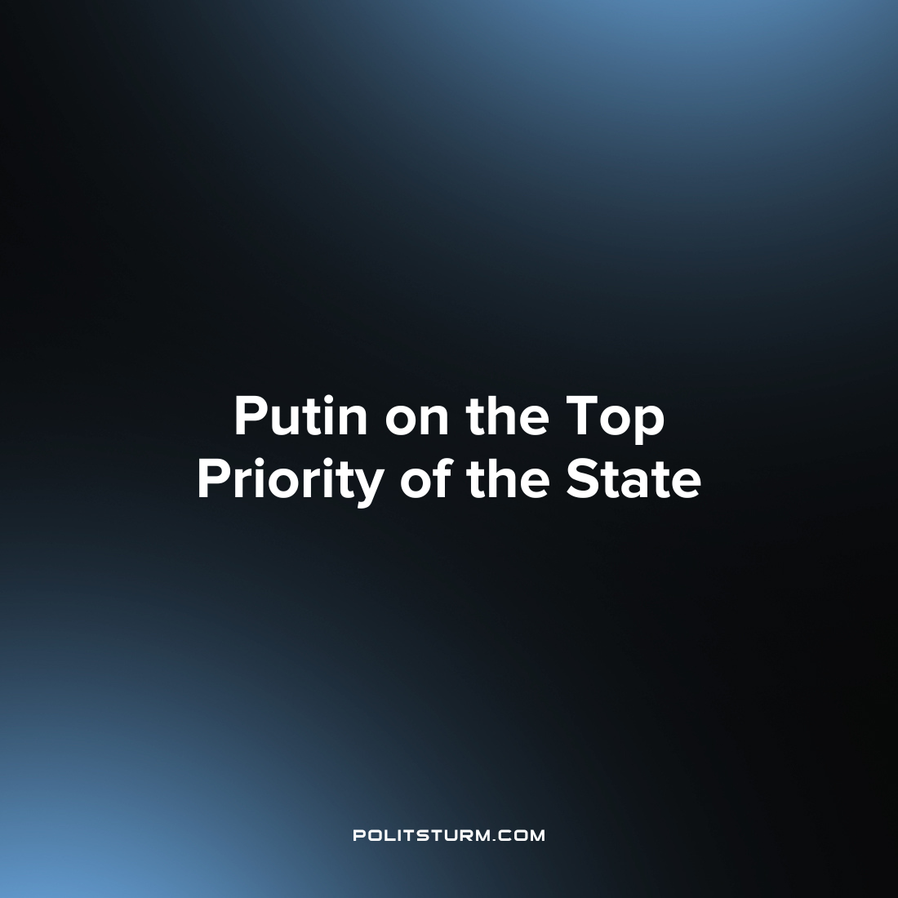

Original article
2023-05-25
2 min read

“The primary task of the state is to increase people's real incomes and increase their well–being,” Russian President Vladimir Putin said when he spoke with workers during a visit to the Tula Railway Engineering Plant.
“Well, yes, prices are rising, but salaries are not very high. The question is the most key for the whole country, for any working person - his level of well–being, income level. And the solution of this task is key for the state. Absolutely the number one task is to ensure that the incomes of Russian families meet modern requirements and are worthy,” the President of TASS reported.
Vladimir Putin also said that real wages in Russia this year should grow by 3-5%, and real disposable incomes – by 2-3%.
It is worth noting that Tulazheldormash is one of Russia's largest manufacturers of machinery and equipment for the construction and maintenance of railways. The company is a system-forming one. At the moment, more than 2.5 thousand technical devices created at the Tula plant are used in Russia and CIS countries.
The bourgeois state, as an institution, exists primarily to suppress the working classes of society and to smooth out the contradictions between them and the ruling class of capitalists. He has never had and cannot have the goal of improving the material situation of the proletariat. It is only able to make some concessions in connection with the strengthening of the labor movement and the aggravation of the class struggle. But this is always only a temporary measure designed to stabilize the situation in society, when the previous methods of violent suppression do not work, and tougher measures lead in the long run to loss of profits or to escalation of confrontation.
The primary goal of the bourgeois state is to maintain order on the national market so that capitalists can safely exploit the population, trade and resolve contradictions among themselves without crossing certain dangerous boundaries. It also helps capitalists consolidate amongst themselves in the most difficult historical moments. And besides, as in the case of Russia, it, on top of everything else, acts as a capitalist itself since it controls large enterprises.
Only under one condition can the state really take care of the welfare of the people – it must become socialist, that is, pass from the hands of the capitalists into the hands of the working people. Only when the state is an instrument in the hands of the proletariat, in the hands of the majority of the population, will it act in the interests of the majority, and not a tiny handful of oligarchs.
Source: Solidarity - "Putin called the number one task the growth of citizens' incomes" from April 04, 2023.

Original article

