Putin Meets Former Enemy to Regain Regional Influence
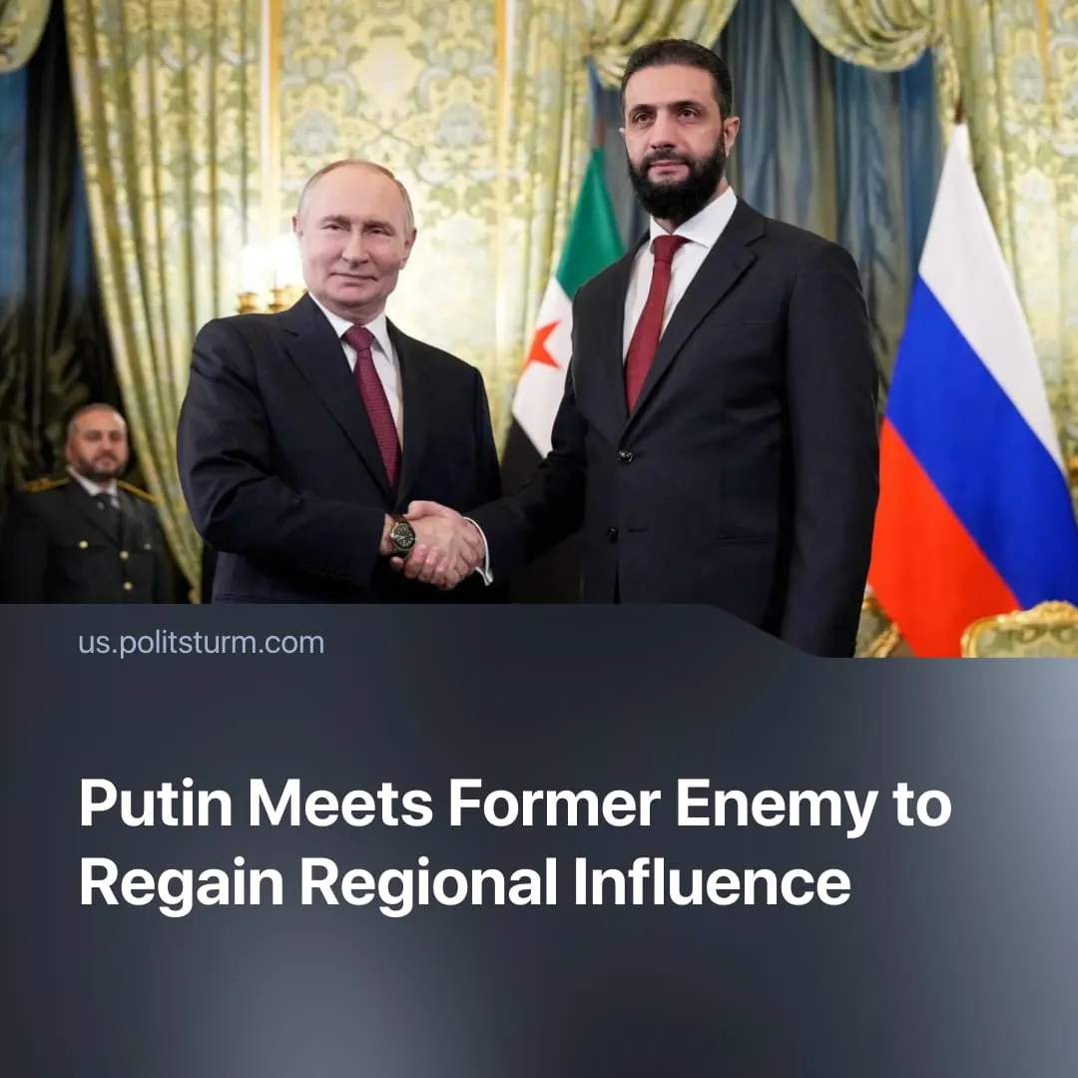

Original article
2025-10-22
1 min read

Putin has met with Syria’s new president. Moscow wants to cooperate with a former adversary amid its waning influence in the region.
Details. Syrian President Ahmed al-Sharaa travelled to Moscow on October 15 for talks with Vladimir Putin, marking their first meeting since the fall of the Assad government.
► President Sharaa stated that his government would honour all existing agreements between Damascus and Moscow, signalling that Russia will keep its military bases in Syria. These installations provide Moscow with a warm-water port and enable operations extending into Africa.
► Russia has continued to supply Syria with oil, grain and other vital resources at discount prices. Russian ministers said they were ready to help repair damaged power and transport infrastructure.
► President Sharaa has requested the extradition of Bashar al-Assad. However, Russia is unlikely to comply, as Foreign Minister Lavrov said Monday that Assad and his family were granted asylum because they had "faced the risk of physical elimination".
Context. In 2015, Russia intervened militarily in Syria to keep the Assad regime in power, while designating the current leadership, Hay’at Tahrir al-Sham (HTS), as a terrorist organisation.
► Since then, Russia’s position in West Asia has weakened following setbacks, including the fall of Assad, US-Israeli strikes on its ally Iran, and Washington’s takeover of the Zangezur Corridor.
► These setbacks have been compounded by a contraction in the Russian export economy, with the state-owned rail monopoly reporting a sharp drop in the transport of oil and ferrous metals during the first five months of 2025, creating the need to secure new markets.
► In line with this strategy, Russia has also recognised the reactionary Taliban in Afghanistan.

Original article

