Protests in Nepal: Important to Know
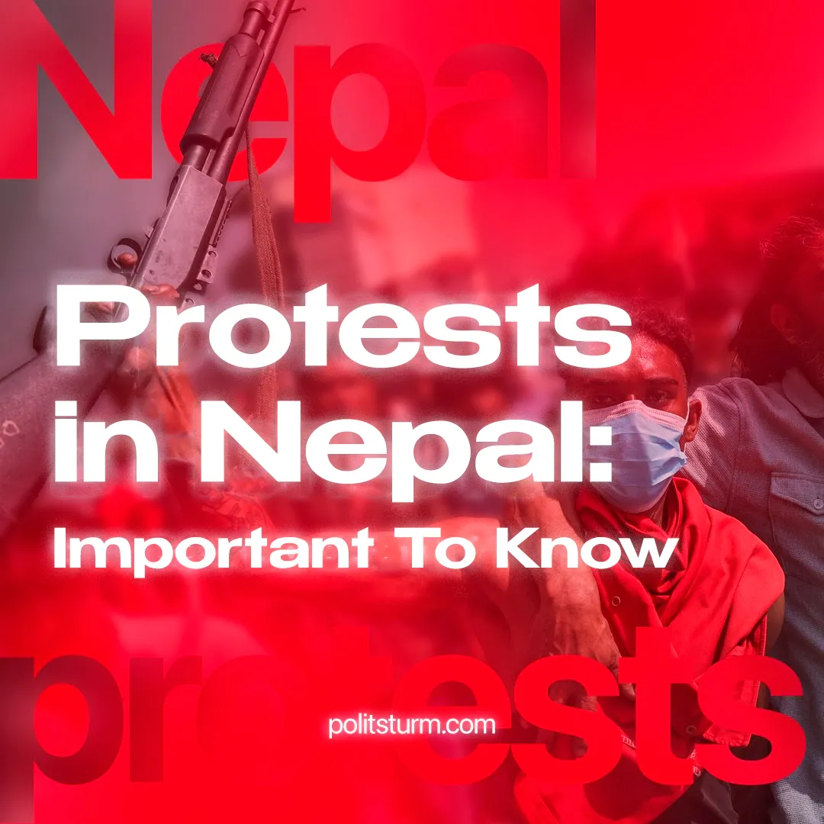

Original article
2025-09-09
3 min read

The protests in Nepal began after the government imposed a ban on major social media platforms. The situation escalated sharply on September 8, when government forces opened fire on demonstrators. At least 19 people were killed and more than 100 injured. The government rushed to lift the ban. Despite this, by the end of the day, protesters had begun seizing official buildings, effectively paralyzing the government and forcing it to resign.
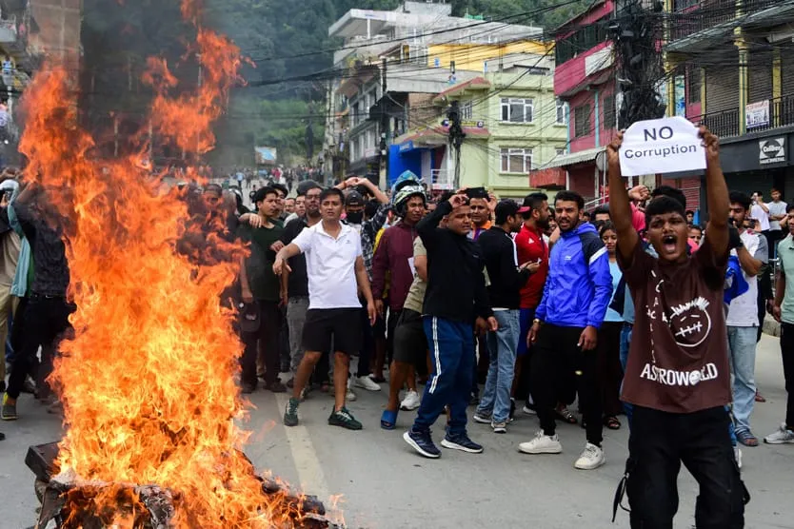
► At the heart of the protests lies the dire socio-economic condition of Nepal’s workers, youth, and the people as a whole. Official unemployment exceeds 10%, while youth unemployment is above 20%. Public outrage has been fueled by rampant social inequality. Capitalists and their representatives squandered vast sums on a life of luxury abroad – a typical phenomenon for dependent states in the system of imperialism. The driving force of the uprising was the youth, embittered by worsening social and economic conditions.
► The government that fell in the wake of the protests was led by K.P. Sharma Oli, head of the opportunist, pro-Chinese “Communist Party of Nepal (Unified Marxist-Leninist)”. Leaders of this party held key ministerial posts within the government. A week ago, Oli visited China, where he held talks on expanding Nepal's participation in Chinese projects.
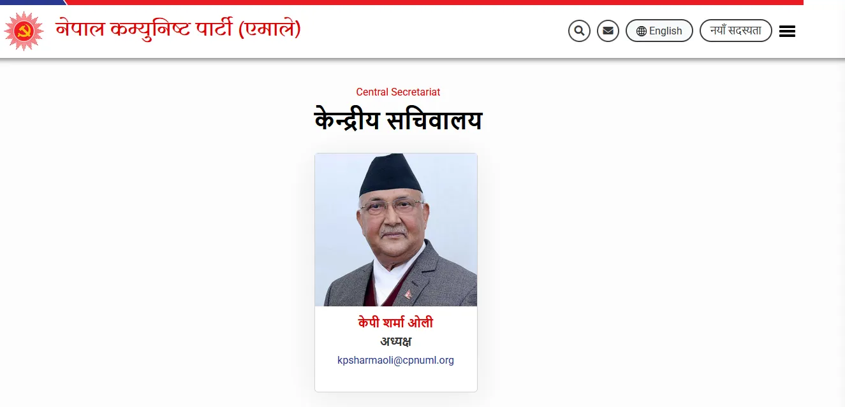
A screenshot from the CPN (UML) website, showing former Prime Minister Oli as the head of the organization
► The “CPN (UML)” is a member of “SolidNet”, a broad association in which the Communist Party of Greece plays a leading role. In 2018, a representative of the CPN (UML) declared at the 20th “International Meeting of Communist and Workers’ Parties”: “We are happy to note that we have deeply internalized and used Marxism-Leninism in Nepal as per Nepali characteristics.” In practice, however, Oli’s party undertook no socialist transformations while in power.
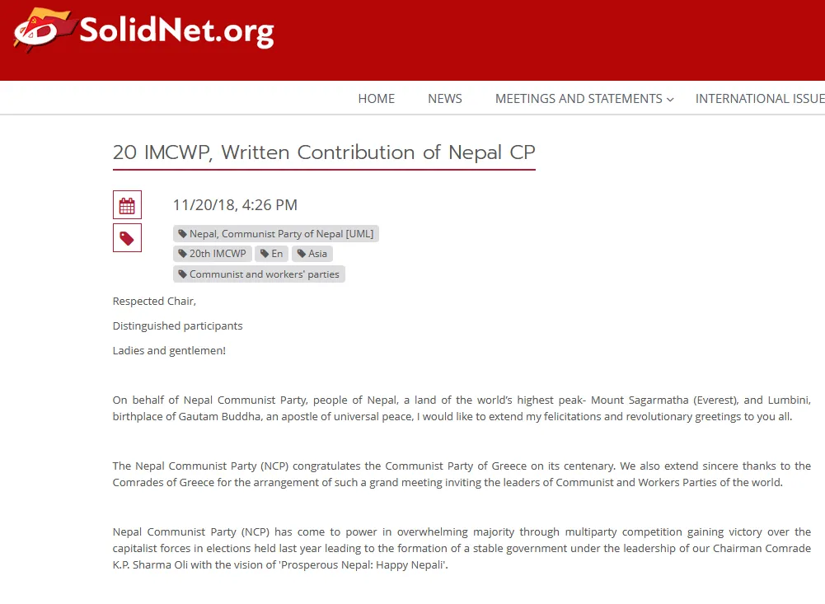
► The fury of the protesters was not only directed at government institutions but also at the headquarters of the ruling party and the opposition “CPN (Maoist Centre)”. This organization, advocating for moving towards Indian capitalists, left the government coalition in 2024.
► Both the “governing” pro-Chinese opportunists and the “opposition” Maoists discredited themselves. The people saw no defenders in these so-called ‘communist parties’. On the contrary, these structures revealed themselves as part of the ruling elite. The bourgeoisie cloaked its dictatorship with false ‘communists’. This fact discredits Marxism and risks paving the way for a takeover by right-wing nationalist forces.
► Over the past five years, similar waves of protest and uprisings have swept through Sri Lanka, Bangladesh, Myanmar, and Indonesia. Spontaneous movements of youth and workers against poverty and misery – products of the capitalist system and their countries’ subordinate place within it – have become a recurring feature in Asia. Lenin’s theory of the imperialist chain is once again proven to be relevant.
► The growth of political activity among workers is, in itself, a progressive development. However, the movement remains spontaneous. It lacks class consciousness and a vanguard party. Combined with Nepal’s own weakness, this means that the current events will not bring lasting improvements to workers’ lives.
► What has been exposed, however, is that the dictatorship of the bourgeoisie is being carried out by figures from pseudo-communist organizations with a pro-Chinese orientation. This underlines the importance of cleansing the communist movement of opportunism and exposing China and all pro-Chinese pseudo-communist parties and currents. Communists must put an end to the passivity that prevails within “Solidnet” and make a decisive break with the agents of capital in their own ranks.
► The brutality of the protests was determined by the actions of the bourgeoisie itself. Coupled with the dire socio-economic situation of workers, youth, and the masses, this provoked an inevitable backlash from the people. The bourgeoisie will stop at nothing to defend its rule. The army and police exist precisely for this purpose in the bourgeois state.
► No lasting improvement will result from these developments. The weakening of pro-Chinese factions will only strengthen pro-Western imperialist influence – above all that of the United States, which is actively intervening in the region to compete with China. For ordinary people, there is no genuine choice under these conditions.

Original article

