Protests Erupt After ICE Kills Women in Minneapolis
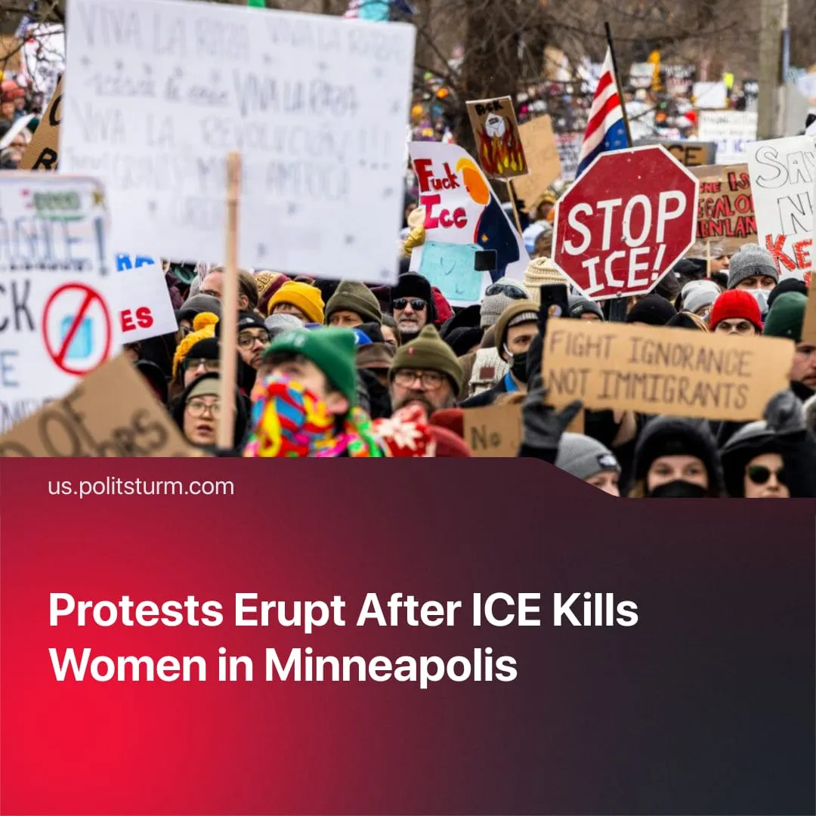

Original article
2026-01-17
2 min read

Minneapolis has again erupted into mass unrest, five years after the George Floyd protests. Are these protests likely to repeat the failures of 2020?
Details. On January 7th, an American woman was shot dead by an ICE officer in Minneapolis, whilst attempting to drive away from US federal agents who stopped her in traffic and demanded she exit her vehicle.
► The US Federal Government has justified the action by claiming it was self-defense, with President Trump and his officials declaring the woman a “domestic terrorist” aided by a “professional agitator” who aimed to “weaponize” her vehicle and “run over” the federal agents.
► Video footage shows the woman beginning to slowly turn and drive around the ICE officer, contradicting the pretext that she posed a lethal threat.
► Large protests followed in Minneapolis and major US cities, sparking clashes between protesters and federal agents. Alongside vigils for the victim, demonstrations called for the removal of ICE from their cities and accountability for police violence. Washington responded by deploying “hundreds more” federal agents to Minneapolis and threatening to use the Insurrection Act against protesters.
► Minnesota Governor Tim Walz, running mate of Kamala Harris in the 2024 election, called for protesters to remain peaceful. He condemned the Trump administration’s “governance designed to generate fear, headlines and conflict.” Despite saying this, he has since put the Minnesota National Guard on standby to suppress the popular unrest.
Context. The police killing of George Floyd in 2020 caused similar outrage, sparking nationwide Black Lives Matter protests and riots. Only minor concessions, such as President Biden ordering law enforcement agencies to improve their rules of engagement, were achieved by this liberal-anarchist–led movement. Five years later, 72% of Americans said the George Floyd protests hadn’t led to any helpful changes, and only 11% said police violence had improved since then.
► Most Americans now disapprove of ICE operations and consider their methods “too forceful” according to a new poll. State violence has surged in the US: in 2025, there were as many law enforcement assaults on journalists as in the past three years combined.
Important to Know. These spontaneous protests, like the Black Lives Matter protests, express justified working-class anger against the capitalist state and its violence. However, their demands remain limited and their organisation weak. As in 2020, this leaves them incapable of stopping further killings or gaining any significant concessions.
► As throughout 2025, Democratic politicians will continue to exploit the crisis for political gains, intervening to manage the unrest while leaving the institutions of state violence intact once in power. This was shown by the Biden administration’s record ICE deportations and increased federal police spending.
► Given the accelerating fascisation of the US, riots and protests will likely be used by the federal government to justify further repression. Although Trump has ended his unpopular military deployments in American cities for now, the US government may reverse this through the Insurrection Act.

Original article

