Massive Protests in Argentina Against University Defunding
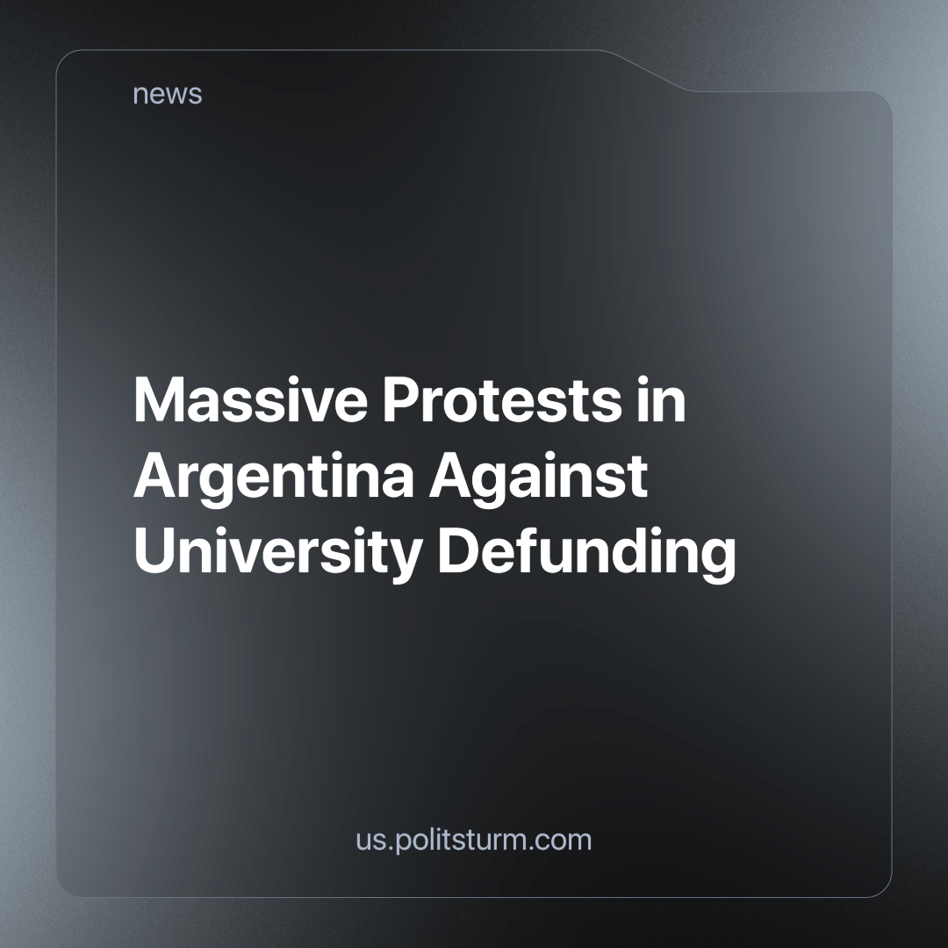

Original article
2024-05-06
3 min read

On 23 April, Argentine cities witnessed one of the largest protests against Milei's government. The authorities estimate that around 100,000 people marched in Buenos Aires and 500,000 nationwide, while the teachers' union says that one million people protested across the country. The main reason for the protests was an effective budget cut for state universities. The government claims that the operating budget was increased by 70% in March, but this figure is very misleading as operating costs represent only 10% of state university expenditure and the services covered by this budget accumulate almost 300% inflation [1].
The budgetary asphyxiation of public services is an integral part of Milei's government plan; it's exactly what he promised Argentines during his electoral campaign as the only way to eliminate the budget deficit and inflation. Far from libertarian promises, monthly inflation has been over 10%, starting at 25% in December, and poverty rose to over 50% in January. Despite this, the government retains 43% of popular support, slightly less than when it began, as its supporters hope that their economic situation will improve once the crisis has "bottomed out" [2].
More related to academia, Milei has promised to close or privatise the National Council of Scientific and Technical Research (CONICET) and is defending it by freezing its budget, firing its staff and cutting grants to less than half of last year's level. Milei justifies the effective closure of state-funded research by telling the scientists that they are parasites on the state and that their council isn't profitable, even though it is already considered the leading one in Latin America [3]. Currently, both CONICET and the University of Buenos Aires (UBA) are struggling just to pay their expenses, mainly energy, to the point that the former will close in two months because its budget will be completely exhausted [3], and in the latter, the professors are teaching without microphones and projectors [4].
This crisis reveals the reactionary character that capitalism has taken on. Of course, not all sectors of capital manifest this in the same way, but none of them is really interested in solving society's problems in a progressive way. The financial, commercial and commodity-exporting sectors that support the current Argentinean government not only fight against any possibility of industrialising the country, which is the immediate purpose of professional education and research in a dependent country, but they also put a lot of effort into denying science.
For example, the international allies of Milei (such as Trump and Bolsonaro) and the ideological organisations that support their proposals (such as CPAC and the libertarian "think tanks") promote anti-scientific trends such as the denial of the climate crisis or its relativisation, or anti-vaccination and anti-lockdown campaigns in the critical years of the last pandemic. This is no coincidence; the economic interests they are fighting for depend on the deepening of the same imperialist relations of dependency and the same technological infrastructure that are being heavily criticised by international science for their obvious role in the current crises, so they can only rely on philosophical irrationalism. For them, production and society are illusions; the only real economic movement is that of the individual who buys something in order to sell it later at a higher price.
On the other hand, the opposing section of capitalists to Milei is nationalist and reformist, but not fully interested in progress. The "anti-imperialist" leaders in the dependent countries make no real effort to develop a national heavy industry; at most, they want to nationalise some commodity-producing sectors and give them a little more work to develop a subsidised national light industry under the supervision of "alternative" imperialist powers, mainly Russia and China. At the same time, these developing imperialist centres are actively looking for colonies to get cheap raw materials and labour.
In the scientific field, this project represents the continuation of the current concentration of research in the metropolis, while its results are appropriated by scientific editorials, which profit from keeping knowledge away from those who cannot pay for subscriptions. Against this sad backdrop, the only real alternative for the development of the dependent countries and the improvement of science through the participation of the workers in its production and criticism is socialism. That is, the establishment of open and rational planning in an economy for the benefit of those who actually contribute to it and the restoration of the ecological cycles that capitalist decadence and waste have already broken.
To achieve socialism in Argentina and throughout the world, we need communist parties to guide the workers towards this goal. However, in the majority of countries, the task of building such a party has yet to be done. Join us if you want to be involved in this work.
Sources:
[1] https://www.france24.com/en/live-news/20240423-large-crowds-march-against-argentina-public-university-cuts
[2] https://apnews.com/article/milei-100-days-argentina-poverty-inflation-6011d71963b4203accbfadb4044cd43e
[3] https://elpais.com/america-futura/2024-04-17/el-ajuste-de-milei-asfixia-a-la-ciencia-investigadores-temen-nueva-fuga-de-cerebros.html
[4] https://www.nbcnews.com/news/latino/argentine-students-professors-protest-university-budget-cuts-milei-rcna149200

Original article

