Protests And Unstable Governments Across South Asia
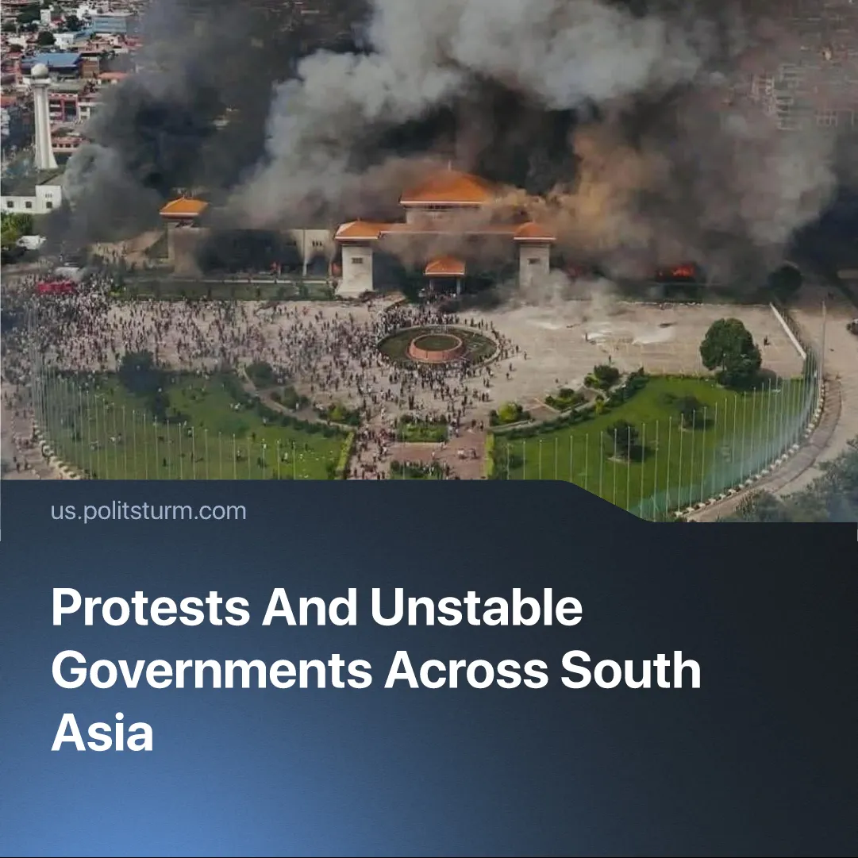

Original article
2025-09-18
2 min read

The protests in Nepal are the fifth in South and Southeast Asia in the past five years.
Details. In Nepal, protests erupted following a ban on social media, which was further exacerbated by the dire socio-economic conditions. The clashes have already left more than 70 people dead and more than 1,300 injured.
► Nepal is one of many Asian states that have repeatedly failed to maintain stability and instead relied on brutal repression. Similar crises occurred in Sri Lanka (2022), where mass protests over an economic collapse forced the president to flee; Myanmar (2021), where a military coup triggered protests and civil war; Bangladesh (2024), where unrest over corruption and unemployment led to deadly crackdowns and the prime minister fleeing; and Indonesia (2025), where rising living costs and corruption scandals sparked nationwide protests met with police repression.
► Regional instability is also seen in interstate tensions, such as the Thailand–Cambodia border clash in May 2025, which led to a fragile truce.
Context. The Indo-Pacific region, spanning both South and Southeast Asia, has become a zone of fierce rivalry between Chinese and American imperialism. Both powers intervene directly in local crises, as seen in Sri Lanka’s 2022 debt collapse. China had become a major creditor through Belt and Road loans, while the IMF — dominated by the US and its allies — stepped in with a $3 billion bailout that imposed harsh austerity.
► These pressures illustrate how these countries are dependent states in the imperialist system. Foreign loans, trade deals, aid, and remittances shape their budgets and economic stability. Nepal alone has turned to the IMF nine times since 1976 to stave off balance-of-payments crises.
► This dependence exacerbates economic crises. Myanmar’s GDP has fallen 18% since 2021, with 77% of households now considered “poor” or “near-poor”; Sri Lanka has faced unprecedented inflation and rising prices for basic goods, with unemployment climbing from 5.7% in 2022 to 8.3% in 2023; Indonesia and Bangladesh face similar pressures, driving social unrest.
► These economic pressures drive protests, as seen in Nepal. Youth unemployment exceeds 20%, living costs rise, and capitalists siphon wealth abroad, deepening public resentment. However, these movements have been largely spontaneous, lacking vanguard leadership and class consciousness, meaning that these uprisings have largely failed to improve the dire conditions of the people.

Original article

