Protests Against The Far-Right in Germany
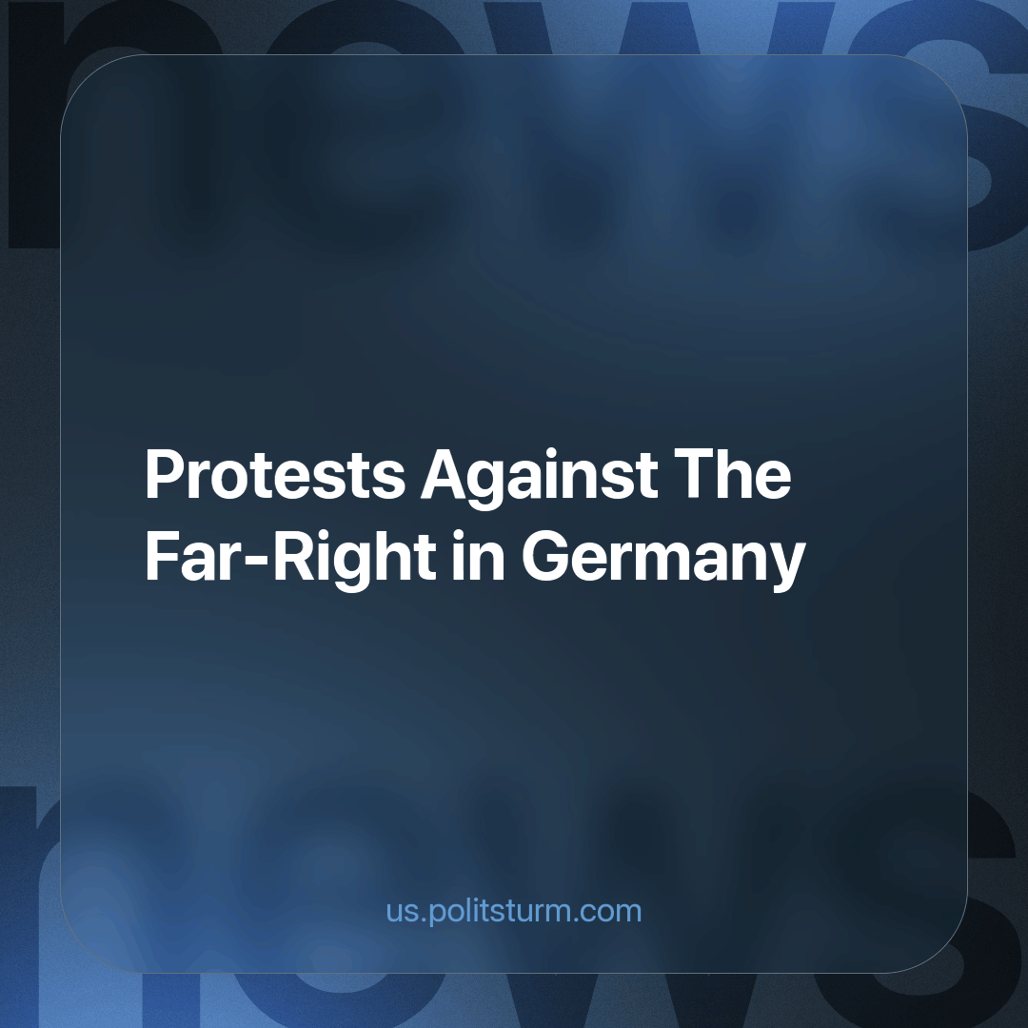

Original article
2024-01-30
3 min read

Hundreds of thousands of people protested against the far-right and for democracy in cities across Germany over the weekend, attending events with slogans such as "Never again is Now", "Against Hate", and "Defend Democracy". [1]
The demonstrations began after reports that right-wing extremists had recently met to discuss the deportation of millions of immigrants, including some with German citizenship. The meeting was attended by some members of the far-right Alternative for Germany (AfD) party. Recall that this party tried to join the farmers' protest and gain even more popularity against this background.
According to the Spiegel news agency, at least 80,000 people in Hamburg and Munich, 100,000 people in Berlin, 20,000 people in Karlsruhe and Stuttgart and up to 40,000 people in Dresden took part in the protests. According to police, hundreds of thousands of people took to the streets across Germany over the weekend against the right and for democracy.
The organizers say that the total number of participants in the demonstrations on Friday, Saturday and Sunday amounted to 1.4 million people. [2]
The protests over the weekend showed that the so-called “Alternative” does not cause great enthusiasm among the people and, on the contrary, causes concern. Even the organizers of the actions did not expect such large-scale activity from the population.
The catalyst for the protests was a report by Correctiv media about an alleged far-right rally in November, which was attended by representatives of the extremist Identitarian movement and the AfD. A prominent member of the Identitarian Movement, Austrian citizen Martin Zellner, presented his "remigration" (note - this is when it is planned to expel people from the country, migrants or those who recently become German citizens) vision of deportations, the report says. [3]
The AfD stated that they had nothing to do with this meeting, and those party members who attended the event did so of their own volition. And they even condemned this meeting, but the political points have already been lost.
Is it worth being afraid of the AfD? Why are protests against far-right rhetoric so popular now?
The AfD was founded as a Eurosceptic party in 2013 and entered the German Bundestag for the first time in 2017. According to polls, it now ranks second nationally with about 23%, more than double the 10.3% it received in the last federal election in 2021. [4]
Last summer, the AfD candidates won the first mayoral and district council elections in the party's history, becoming the first far-right party to do so since the Nazi era. In the state elections in Bavaria and Hesse, the party achieved significant success.
The party is leading in several East German states. The regions where its support is strongest are Brandenburg, Saxony and Thuringia, where elections are scheduled this fall.
But is there a party in the country now that really expresses the interests of the people; the interests of the vast majority of the German population? There are no such parties now. It’s worth noting that people defend democracy and condemn Nazism in their slogans.
The people's request is understandable, but a workers' party in Germany is missing. In this situation, mass and high-quality agitation could push people not just to condemn Nazism, but to demand the improvement of workers' rights, a shortening of the working day, a reduction of the tax burden on the population and, conversely, an increase of it on companies. People can also defend democracy, but we can do even better; demand for a socialist democracy. Under which, there will be no property qualification in elections, no farcical game of democracy (with a constant change of faces but “surprisingly” stable and constant anti-social and austerity politics), and real workers' democracy with the right to recall elected persons no matter the position that they may hold.
The general crisis of the government, anti-social policy, the general decline in living standards, economic stagnation and the growing popularity of the far-right are signs of decay in the capitalist system.
Sources: 1, 2, 3, 4

Original article

