Protests in East Germany Against Recession, AfD Leads Support for Russia
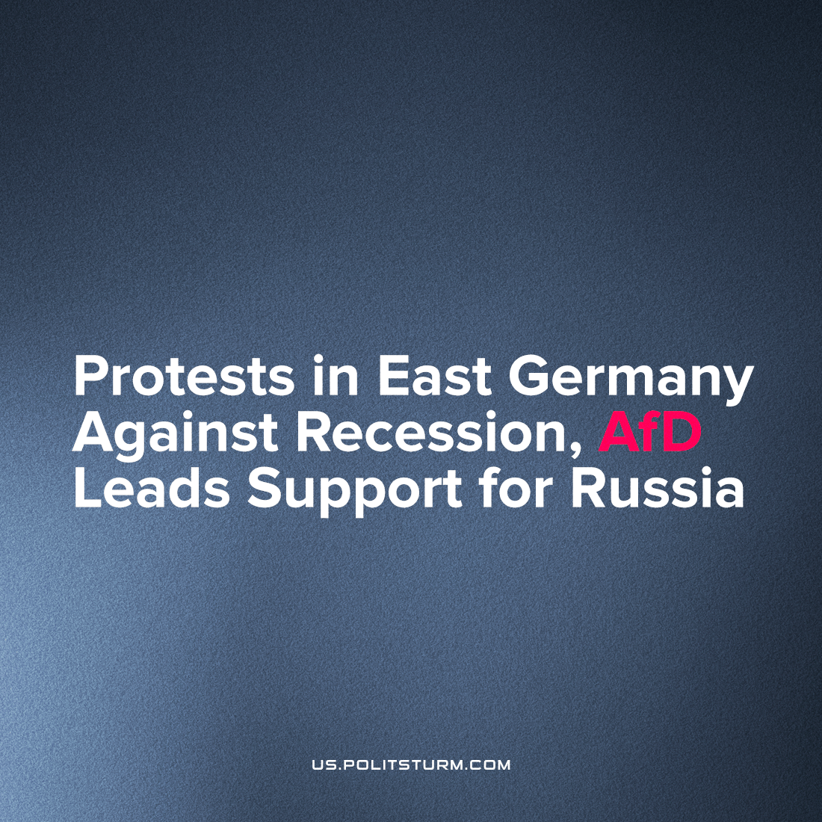

Original article
2022-12-12
1 min read

Thousands took to the streets in Thuringia, Saxony, Saxony-Anhalt and other regions of East Germany to protest on November 24th. In recent months, such actions have been held every Monday, and the number of participants increased every week.
Most of the demonstrators put forward economic demands, expressing their dissatisfaction with inflation, rising unemployment, declining purchasing power and lack of energy resources which have caused homes to go under-heated throughout Germany. To alleviate the economic hardship, demonstrators called on their government to make peace with Russia, cancel the sanctions against it and re-open NordStream 2 immediately.
According to the protesters, the German government plays the role of "a puppet serving the interests of the United States and NATO." With the exception of some left-wing activists, the protesters were primarily pro-Russian. Despite the organizers' calls not to show support for the Russian armed forces, Russian flags and other symbols of the Russian state were widely present at the rallies.
The far-right party Alternative for Germany (AfD) is particularly prominent in organizing and supporting the protests. This fact, however, did not prevent some left-wing activists from demonstrating shoulder to shoulder with neo-Nazis. In some cities, such as Augustusplatz in the town of Leipzig, left and right activists even held a joint action against the "warmongers from NATO".
Such a bizarre mixture of political forces cannot effectively organize the masses to resolve the current political and economic crisis. To end these crises, it's necessary first of all to understand the essence of current events not through individual "instigators" from Washington and Brussels, but emerging from the capitalist system as a whole in which Russia, too, plays its part.
As long as the capitalist order rules the world, new armed conflicts between imperialist states will inevitably arise. To resist the system that breeds war, it is necessary to unite the working class, arm it with Marxist-Leninist theory and introduce a consistent class struggle without making compromises on principle with contradictory political forces which only look for short-term victories.
Sources: 1, 2

Original article

