Thousands Protest Against Lithium Mining Company in Serbia
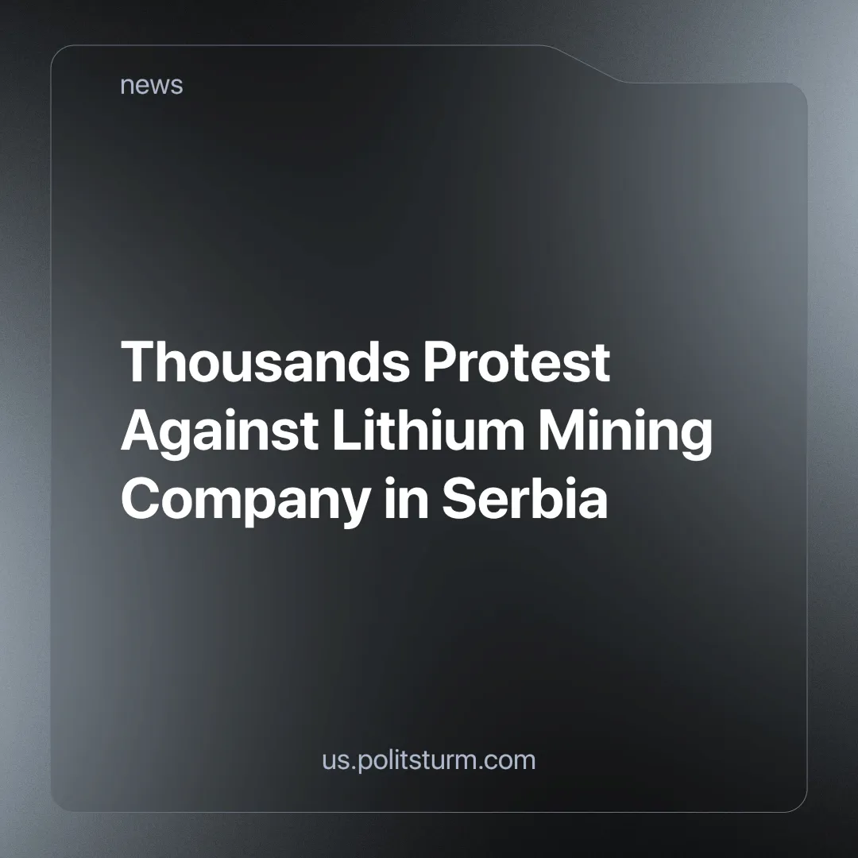

Original article
2024-08-21
3 min read

On the 19th of August in Serbia in the city of Valjevo (located 60 kilometers from Belgrade) a large protest demonstration gathered against the project to develop a lithium deposit by the "Rio Tinto Group".
Rio Tinto Group is an Australian-British company, the third-largest transnational mining and metallurgical construction company in the world.
Earlier, on August 10, a demonstration was held in Belgrade itself on the same occasion. Official authorities stated that the demonstration was political in nature and was directly aimed against the current president Aleksandar Vučić.
During the demonstration in the city of Valjevo, the demands of the protesters also included "To end chase on green activists".
Since August 10, government representatives have conducted more than 40 searches in the apartments of activists which had connections with the demonstration or were spotted in criticizing the Rio Tinto project. Last month, the Serbian government reinstated Rio Tinto's patent for what promises to be Europe's largest lithium mine.
It should be noted that two years earlier, the government had suspended the patent after massive protests by environmental groups. Perhaps it was done in attempt to give public opinion time to cool down, only for them to return to their plans again.
The mine project, currently known as "Jadar", has an estimated value of $2.4 billion. This deposit should cover 90% of Europe's lithium needs and make Rio Tinto one of the world's leading lithium producers.
We remind our readers that lithium is a strategically important resource, as it has a very wide range of applications beyond battery manufacturing, from nuclear power and electronics to chemistry and medicine. Serbia has one of the largest explored reserves of lithium in Europe.
As stated on the project "Jadar" website, the mining is going to be done using the "Hard Rock Mining method", extracting lithium-containing minerals from underground. Neither this specific mining method nor lithium itself is particularly harmful to the environment at this stage. Of course, only if the norms and standards of mining are followed, it would be possible to minimize the harm. But the protesters are well aware of how mining is done around the world and that all measures to prevent damage to the environment are perceived by companies as unnecessary expenses. To them, the health of workers and people living nearby is something completely irrelevant.
Serbian authorities claim that this project will give economic growth and will be useful for the entire region. But in the end, one can only expect the opening of a certain number of jobs. Almost all the benefits will be appropriated by Rio Tinto. Something will certainly be received by the people who ensured the issuance of a construction permit and some part will go to the budget as taxes in the hope that maybe someday it will become something useful for the citizens of Serbia. So far, the potential environmental damage from the construction of a huge mining center outweighs the illusion of improving the economy. It definitely did not bring prosperity to Argentina and Chile which are the biggest producers of lithium in the world.
The market price of lithium in 2024 has fallen sharply due to a decrease in its consumption in China. It is quite possible that the Jadar project will be suspended again. Therefore, we would like to note that if it happens, it will not be permanent and largely not due to the efforts of environmental organizations or spontaneous protests of the citizens of Serbia.
Rio Tinto, and corporations like it, are an ordinary element of the capitalist economic system; it is inevitable for them to cut costs by pushing all possible health and environmental standards to the limit until something like the infamous British Petroleum incident of 20th April 2010 happens. Not because the companies consciously choose to, but because if they don't, someone else who does will put them out of business. As a result, the only motivation the capitalist economy has is profit, the end result of the production cycle itself is seen by capital as irrelevant, ending with lithium being sold back and forth hundreds of times on the market for extra money made out of thin air. So, consequently, any collateral damage is also acceptable to them.
The only way to influence such events in the long term is through the efforts of a communist party that influences politics in the country in favor of the working class. As long as the interests of the working people are not truly represented in the government, as long as the people do not have the opportunity to dictate their will. No standards in industry will be followed and we will have one environmental disaster after another, which will be paid for with our health and the future of the next generations.
Sources:
https://www.reuters.com/world/europe/scores-central-serbia-rally-against-rio-tintos-lithium-project-2024-08-19/
https://www.riotinto.com/en/operations/projects/jadar

Original article

