Productivity Growth Is 5x Greater than Wage Growth
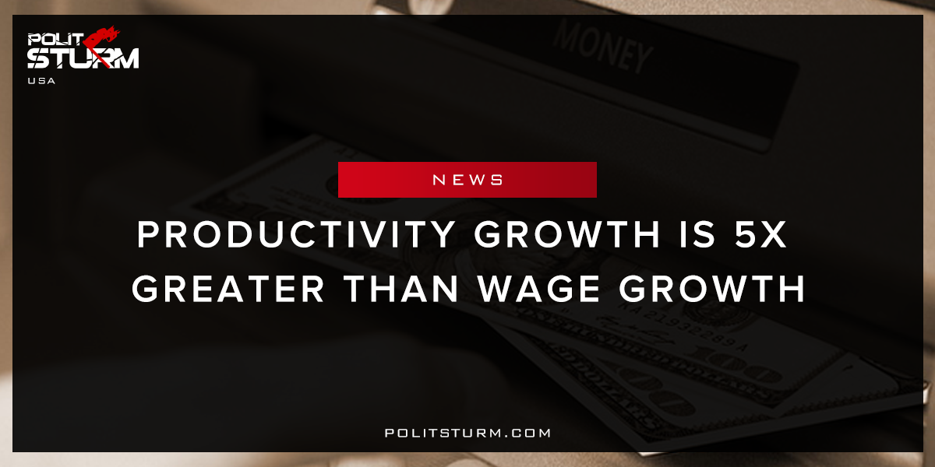

Original article
2018-02-22
1 min read

From 1973 to 2016, net productivity rose 73.7 percent, while the hourly pay of typical workers essentially stagnated—increasing only 12.5 percent over 43 years (after adjusting for inflation). This means that although Americans are working more productively than ever, the fruits of their labors have primarily accrued to those at the top and to corporate profits, especially in recent years.
Rising productivity provides the potential for substantial growth in the pay for the vast majority. However, this potential has been squandered in recent decades. The income, wages, and wealth generated over the last four decades have failed to “trickle down” to the vast majority largely because policy choices made on behalf of those with the most income, wealth, and power have exacerbated inequality. In essence, rising inequality has prevented potential pay growth from translating into actual pay growth for most workers. The result has been wage stagnation.
Politsturm: Even through workers are more productive than they have ever been, wages are stagnating for the working class. Productivity growth is a very simple calculation. It is the growth in the amount of output produced in a given time with a certain amount of labor hours. The workers who are actually doing the labor necessary to produce this output are not seeing the growth translate into increased wages. The capitalists and the landlords are rather siphoning off this growth in wages for their to enrich themselves at the expense of the working class.
The capitalist economic system is producing grave inequality with the capitalists on one end and the workers on the other.The growth of the stock market and corporate profits have enriched the oligarchs beyond belief but it is negligible for workers. The failed economic theories of the bourgeoisie have deprived workers of stable employment, entitlements and wages. There are unused factories, office space and housing that could be serving the interests of the working class that is underutilized under capitalism. Even if workers did had equal wage and productivity growth they would still be exploited. As long as the government represents the oligarchs and not the working class we are doomed to repeat these mediocre results.
Source

Original article

