Pro-Russian Regime in Mali Begins to Collapse
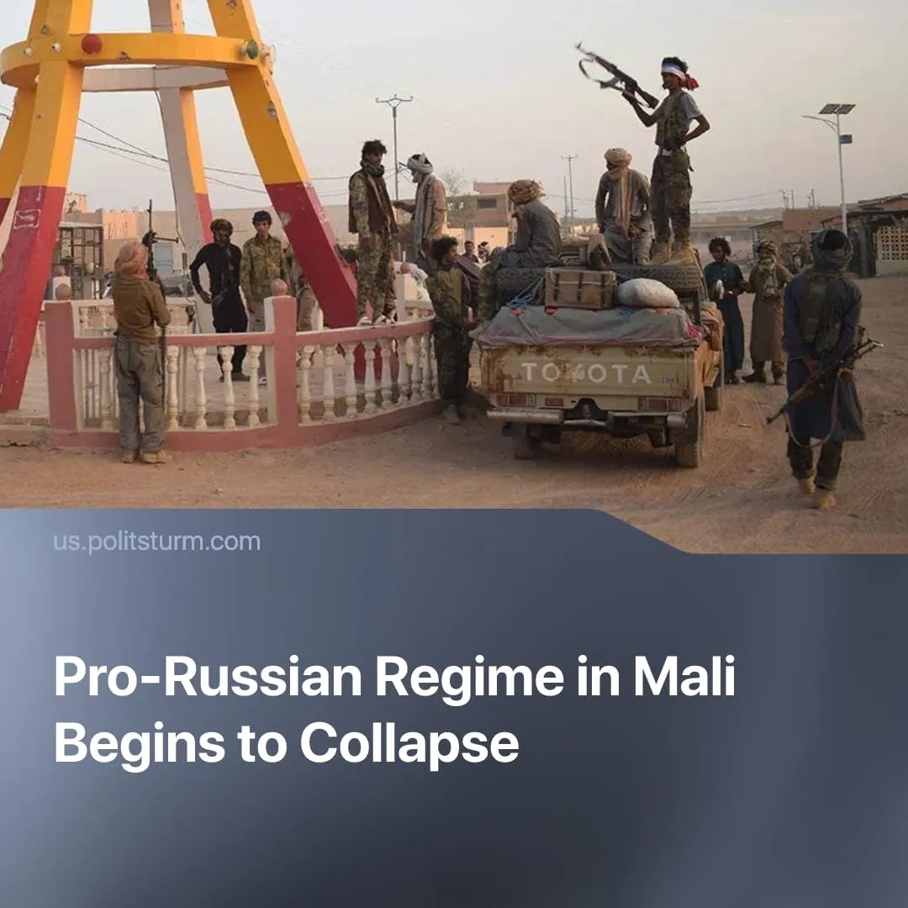

Original article
2026-05-04
1 min read

Mali’s government collapses, marking Russia’s third loss of a dependent country in just 18 months.
Details. On April 25, jihadist group JNIM (affiliated with al-Qaeda) and the separatist Azawad Liberation Front (FLA) launched a major offensive against the pro-Russian military junta in Mali. The rebel attacks were well-coordinated and unexpected, resulting in the killing of Mali’s Defence Minister.
► Mali’s army appears to be collapsing, with rebel forces rapidly capturing strategic locations, and declaring a “total siege” surrounding the capital, Bamako. The jihadist-led insurgency vowed to overthrow the Malian government and called on Russian troops to leave the country.
► The Russian Ministry of Defence alleged that the rebel offensive was Western-backed, citing Ukrainian and EU involvement, but claimed that its Africa Corps "defeated the militants and prevented the coup”. The Russian Africa Corps (previously the Wagner PMC group) is now withdrawing from some areas of Mali.
Context. Two Russian dependent regimes in Syria and Venezuela have fallen in the past 18 months. Russia’s ally Iran has been severely weakened by a five-week US–Israel bombing operation and the ongoing blockade. The US is also maintaining an energy blockade against Cuba – another Russia-influenced state – and has threatened tariffs on any oil exporters supplying the island.
► The USA has a long history of fueling and arming Islamist groups in its imperialist interests. For example, in the 2010s, it armed Al-Qaeda as a proxy in Syria and Iraq – enabling the rise of ISIS. In the 1980s, it armed the Afghan mujahideen as an anti-Soviet force, the basis of the future Taliban. This tactic, which was applied to push Russian imperialism out of Syria in 2024, may now have been used in Mali.
► Russian capitalists are interested in Mali’s resources, such as gold, lithium and uranium. It has exploited the proxy regime to expand trade and used military force to seize control of mines. Mali also serves as an export market and a partner in energy projects.

Original article

