Poverty Level Increases in Four Regions of the Russian Federation
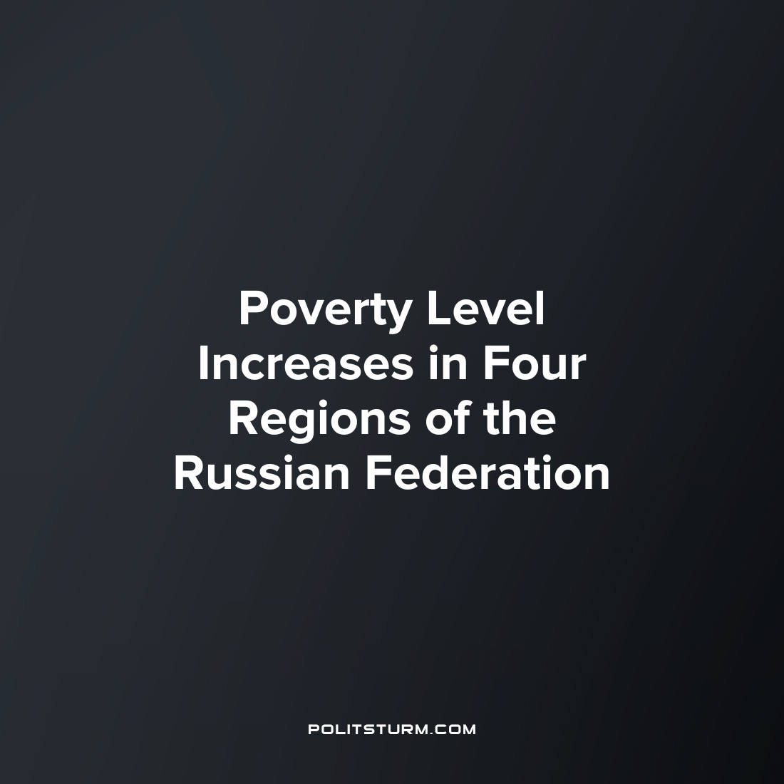

Original article
2023-07-03
1 min read

At an expanded meeting of the Board of the Ministry of Labor of Russia, Deputy Prime Minister Tatyana Golikova said that the poverty level in four regions of Russia has increased by the end of 2022. She noted that these are Khakassia, Ingushetia, Adygea and Tyva.
In addition, nine regions did not reach the poverty reduction target last year. These are the republics of Khakassia, Ingushetia, Adygea, Karachay-Cherkessia, Kalmykia, North Ossetia–Alania, Komi, Orenburg Region and Nenets Autonomous Okrug, Golikova said.
According to Rosstat, at the end of 2022, 9.8% of the population was poor in Russia, which is the lowest level since the mid-1990s. Deputy Prime Minister of the Russian Federation Tatyana Golikova also said that the minimum wage will increase at a faster pace in all subsequent years.
Poverty is an eternal companion of capitalism, as a consequence of the endless thirst for profit of the super–rich elite on ordinary workers. Rising prices for basic consumer goods combined with low wages lead to a situation where a person is barely able to meet the minimum level of their needs.
It is possible to provide workers with a decent life only with the transition to socialism. To do this, workers need to study Marxism-Leninism in order to have the most advanced understanding of the structure of society and its laws. Without this knowledge, the workers will not be able to organize a party that protects their interests, and without their own party, the workers will not be able to organize the transition to a socialist society.
Source: 1

Original article

