Postal Workers Rally Against Postal Service Privatization Scheme
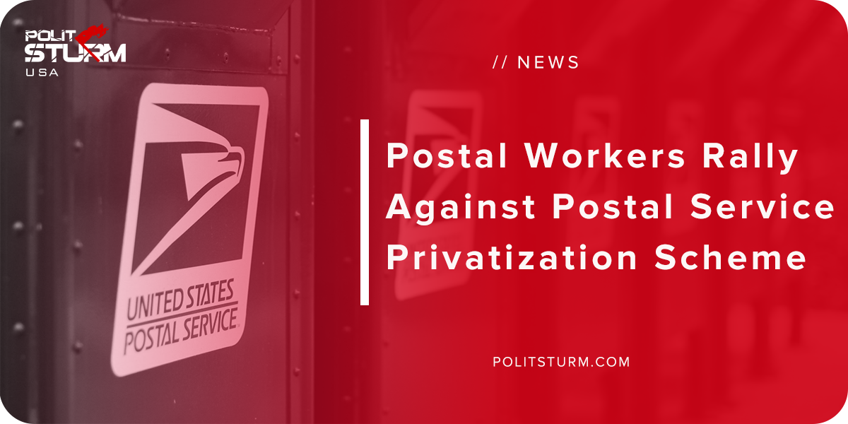

Original article
2018-10-20
1 min read

Postal workers all across the country went out to protest the Trump administration’s plan to privatize the U.S Postal Service (USPS). There were 140 rallies across the country as the postal workers had the day off due to Columbus Day.
The Trump administration claims that the postal service is an unprofitable enterprise that is draining the U.S taxpayers of funds. The workers are not only worried that they will lose their jobs, but that changes would hurt their customers.
“Sorry but delivering mail to rural areas just isn’t profitable, so you’re looking in cutbacks in mail delivery. You have senior citizens that don’t rely on the internet age to get their mail. They rely on those hard copy letters and magazines that come in the mail,” said David Miller, with National Association of Letter Carriers.
The Trump administration is intent on cutting federal spending only in areas that benefit the working class. Entitlement spending and government services are targeted for cuts whereas tax cuts for the wealthy are affordable and just.
The only logic to explain this phenomenon is to consider the class interests at play. The Trump administration and their predecessors represent the class interests of the bourgeoisie, or the so-called “1%”. Only a government that represents the interests of the working class and a rational, planned economy would overcome the insane, disastrous results of the capitalist economic system.
Source

Original article

