Pollution sparks protests in Europe
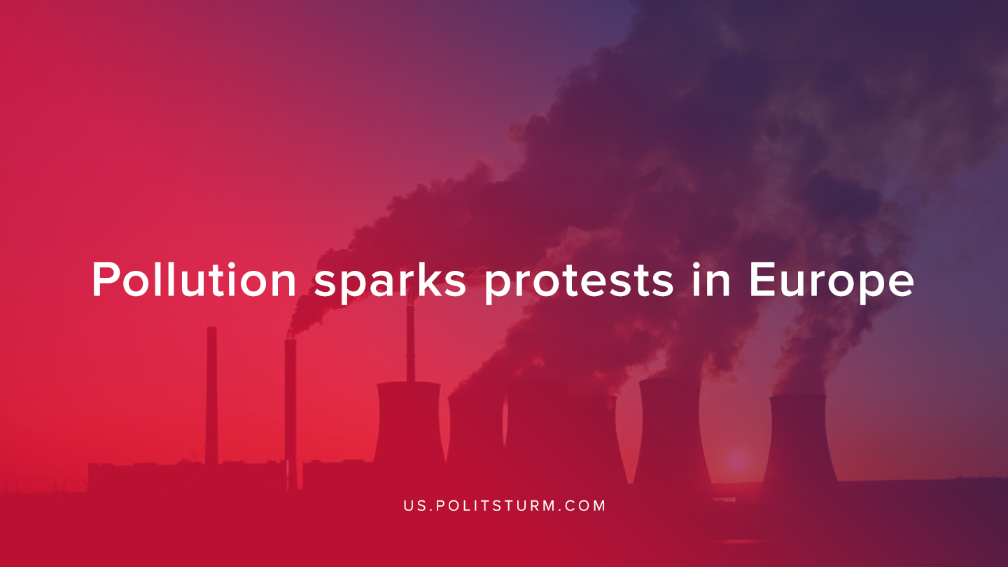

Original article
2019-12-24
1 min read

Recently, London and Manchester have undergone protests demanding action on the high levels of toxicity of the air in London and Manchester.
“One protester, Rosamund Frost, a teacher, said: “We are here demanding action on illegal levels of toxic air in our communities, our schools and our streets. In February 2017, the European Commission issued a final warning to the UK over illegal levels of air pollution.”
“The strikers, including the 76-year-old Peter Cole, have sent a letter to Boris Johnson, the prime minister, inviting him to discuss the climate and ecological emergency with them on Monday.”
Hopeful protesters are fighting with the belief that they can defeat pollution solely by protests and that the system can be reformed to be more eco-friendly. Sadly, this is but a dream. Even if the capitalists are willing to concede, they would simply export their factories where any protests can be easily put down. Green Capitalism is a myth, that in this current time will continue to be perpetrated.
Green capitalism is draining for the European proletariat and will only foresee a further increase in costs. An example of this was in 2015, Germany and Denmark had established the maximum amount of wind turbines and solar panels, possessing the greatest cost for electricity – 29.5 euro cent and 30.4 euro cent Kv/h. Whilst the alternative energy plants in Bulgaria and Hungary, which are nuclear power plants which were built during the Warsaw pact, have had their prices be 9.6 and 11.5 euro cent per Kv/h. Only under socialism and then communism the proletariat will see stability in prices. The aim of the capitalist system is to squeeze the worker dry and no protest will solve it.
Source

Original article

