Politsturm at "Kommunismus Kongress"
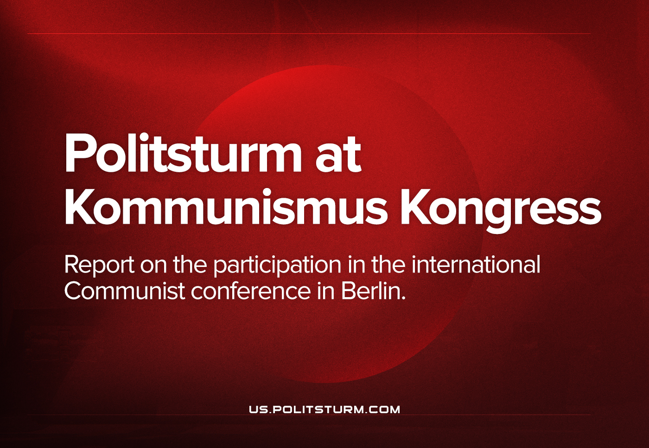

Original article
2022-10-26
4 min read

On September 23rd-25th, representatives of Politsturm took part in an international congress organized by the German Kommunistische Organization (KO) in Berlin.
The purpose of this event was to clarify the theoretical positions of participating organizations on a number of issues: the events in Ukraine, the structure of modern imperialism, and the strategy and tactics of the international communist movement.
The German Communists invited us to make a report on the current situation in Russia and in the Russian communist movement. We also used this opportunity to characterize the current state of the international communist movement, point out its problems that complicate our daily activities, the way to solve them, and convey our position to representatives of other communist organizations.

Error loading image
Among the participants of the Congress were representatives of organizations with fundamentally different points of view on these issues.
On the one hand, the leaders of the Communist Party of Sweden were present, which supported the joint statement of the CPs of Turkey and Greece on current events in March this year. Earlier we posted translations of Swedish materials in Russian and English, as well as interviewed one of its leaders.
On the other hand, among the participants of the event were organizations of a social-chauvinist nature that supported the actions of the Russian Federation, such as the RCWP (“Russian Communist Workers’ Party”), KPD (“Communist Party of Germany”), PSL (“The Party of Socialism and Liberation” from the USA), etc.
Finally, by the time of the congress, the discussion on the attitude to the events in Ukraine continued in KO itself. This event, in fact, became a manifestation of these intra-organizational disagreements. In this regard, we have received a good opportunity to criticize positions hostile to Marxist-Leninist theory.
The Congress was held for three days, from Friday to Sunday. On the first day of the event, our comrades listened to a speech by a representative from the RCWP. Pointing out the contradictions in the position of this pseudo-Communist party, they asked him several questions; the speaker could not clearly answer them. The questions caused some activity among the audience. After the RCWP’s speech, those present turned to our comrades for contacts of our organization.
The speech of our representatives took place on Sunday. Before the presentation, the audience received printed materials with our point of view on the issues raised in the speech: “Is Russia Imperialist?“, “Is Russia Capable of “Denazifying” Ukraine?”, “Russian “Official” Communists on the Russia-Ukraine Crisis”, “Why Do We Criticize?”, etc.
The report of Politsturm was divided into several sections:
- The Current Situation in Russia. We have described the state of the Russian economy, the situation of the broad masses, the political situation in the country and the impact of the recently announced “partial mobilization” on the processes taking place in the Russian Federation.
- The Situation in the Russian Communist Movement. The speakers pointed out the treacherous position of the largest formally “communist” organizations in relation to workers and placed special emphasis on the RKRP, since this organization for many years actually supported Russian imperialism, did not carry out intelligible communist work, but misled foreign communists about the situation in the country and the crisis in the Russian communist movement.
- The Current Position of Politsturm. We gave a brief overview of our organization, its history and current work.
- Problems of the International Communist movement. This point was especially important, because we showed, by the example of several problems, the main shortcomings of the current work of Communists around the world. Using concrete examples, we have shown the lack of a unified theoretical position on many important issues (attitude to the PRC, Cuba, the DPRK; characteristics and attitude to international imperialist blocs; the structure of the modern working class, etc.), formalism in establishing contacts with communists from different countries and holding events, lack of operational communication between organizations, outdated forms of agitation and propaganda and a bureaucratic approach to cooperation.
In conclusion, we expressed our readiness to establish joint work with all those who stand on the positions of Marxism-Leninism and want to help the work of communists around the world.
Our report was based around specific issues that hinder the fruitful work of Communists and take place in other countries. From the very beginning, we hoped to raise issues that, in our opinion, are not given sufficient attention in the international communist movement, and point out the need to solve them.
The speech of Politsturm caused a great reaction from the audience. During the discussion that unfolded after the report, the majority of the audience supported our point of view. Some speakers tried to accuse us of “complicity with NATO” and “spreading Western propaganda”; others did not like to talk about sore subjects related to establishing contacts among Communists. Nevertheless, our speakers managed to answer all the questions of the audience.
Among the listeners was a representative of the Swedish Communist Party we mentioned earlier. The General Secretary of the party, Andreas Sörensen, joined the audience despite the fact that the report of his organization stood at the same time as the report of Politsturm. In a conversation with our speakers after the report, he agreed with the key points in the report.
Summing up the results of the congress, we were able to:
- to assess the state of the international communist movement in practice;
- to note the poor understanding of many foreign communists about the situation in Russia and their incorrect understanding of the essence of a number of leftist and communist organizations in the Russian Federation;
- to establish contacts with the leaders of communist organizations in other countries that share our position and are open to cooperation.
Politsturm will continue to take part in such events and struggle for getting maximum practical impact from all subsequent congresses and conferences.
In the near future we will publish the text of our report and the recording of the speech.

Original article

