Polish PM Says NATO Formed Against Soviet Aggression
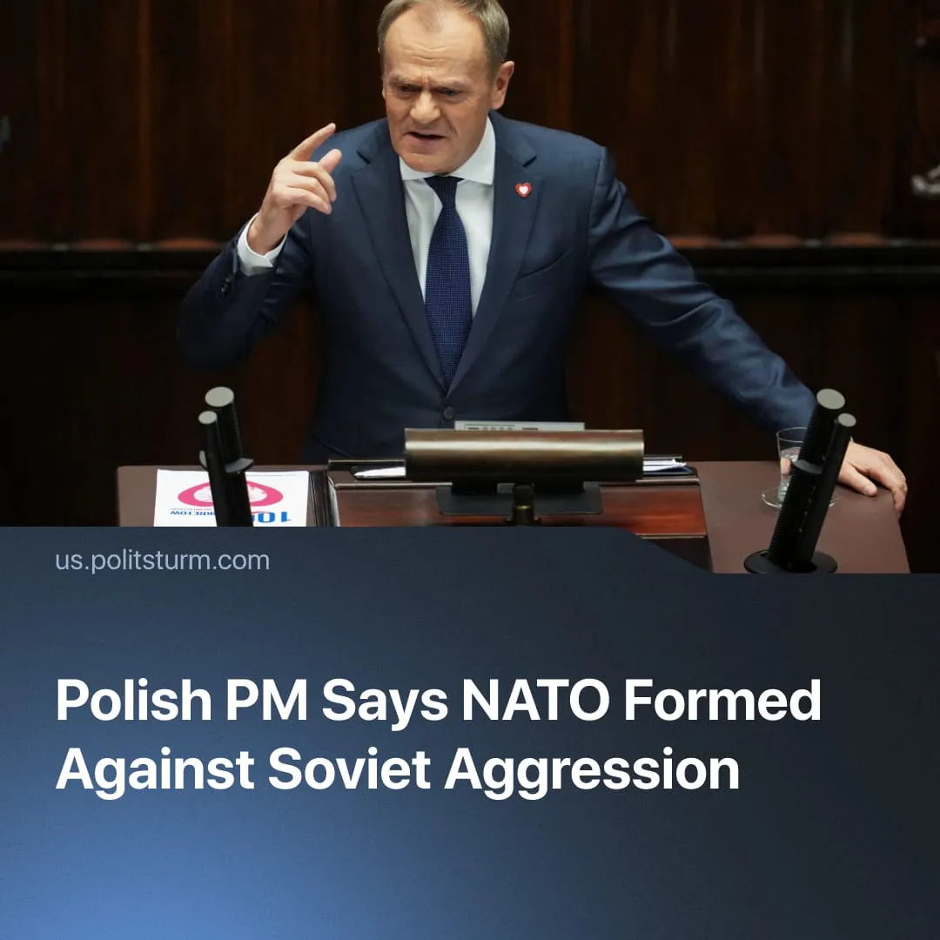

Original article
2025-12-04
1 min read

NATO was founded in solidarity against “Soviet Aggression,” claims Polish Prime Minister.
Polish Prime Minister Donald Tusk published a statement on X defending NATO’s historic mission and insisting that the alliance was founded for solidarity and defence.
Quote: “I wish to remind our allies that NATO was created to defend the West against Soviet aggression, that is against Russia. And its foundation was solidarity, not egoistic interests. I hope that nothing has changed.”
Context. This comes amid growing European frustration with Trump’s attempts to accommodate Russia, which clashes with the EU’s drive to expand its militarisation, sustain the conflict in Ukraine, and prepare for a future confrontation with Moscow.
► Poland in particular has recorded the largest rise in military spending relative to GDP among EU states in recent years, expanding its armed forces and importing new weapons systems at a record pace.
In reality, NATO was never a defensive or peaceful bloc, but an imperialist alliance created to contain socialist forces and maintain Western dominance. The narrative of “Soviet aggression” serves only to obscure this history.
► The alliance was created before the Warsaw Pact, when the USSR’s only “threat” was its appeal to workers worldwide. Western officials openly feared that communist movements in Italy, France, and Greece could take power, and NATO’s founding goal — as its first Secretary General, Lord Ismay, put it — was to “keep the USSR out of Europe, ensure an American presence there, and contain Germany.”
► NATO has not fought a single defensive war. Its key operations – from the 1999 bombing of Yugoslavia without UN authorisation to later actions in Afghanistan, Iraq and Libya – were offensive interventions outside NATO territory, causing civilian casualties and serving Western imperialist interests.
► Its member states consistently acted to suppress socialist forces and maintain imperial dominance, from neo-colonial wars and coups to clandestine anti-communist operations such as Operation Gladio.
► The only solidarity NATO ever embodied was solidarity among capitalist states defending their domination, while the Soviet Union expressed genuine internationalist workers’ solidarity through support for workers and anti-colonial liberation.

Original article

