Polish and German Far-Right Unite to Exploit Migration Crisis
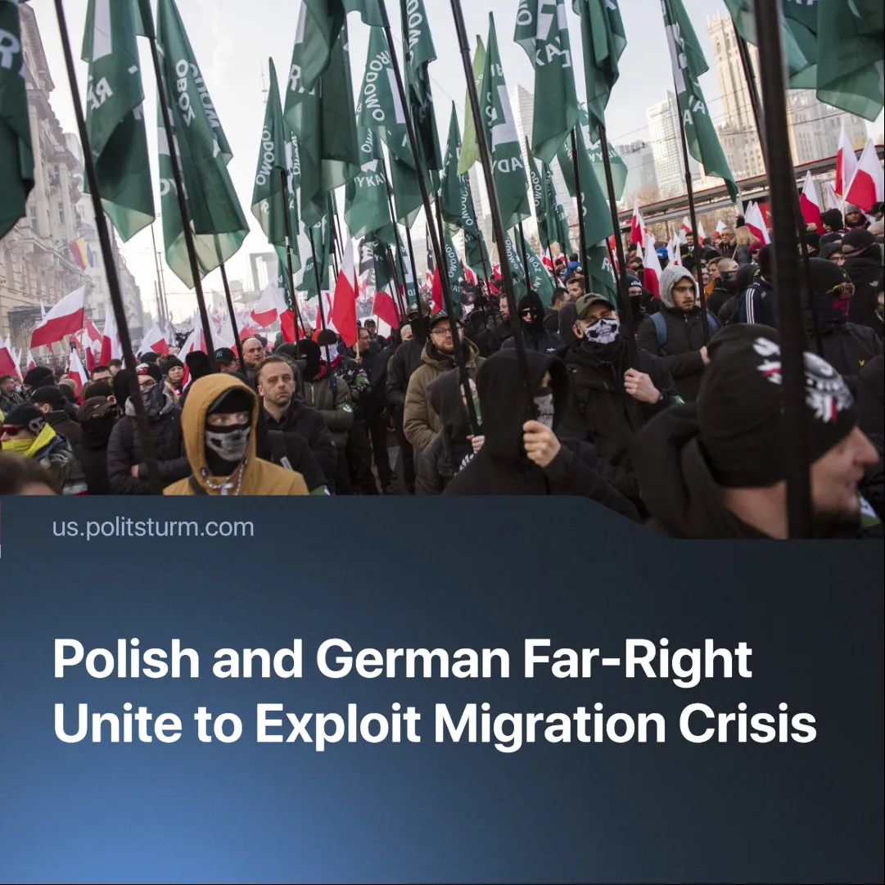

Original article
2025-07-22
1 min read

Poland’s right-wing parties claim to oppose immigration whilst cooperating with Germany’s AfD, whose policies push immigrants back across the Polish border.
Details. Polish party Konfederacja (Confederation) have used the recent reintroduction of border controls, forced pushbacks, and anti-migrant rhetoric to rally support ahead of elections.
► At the same time, they’ve strengthened ties with Germany’s AfD (Alternative for Germany), coordinating messaging, sharing platforms in the European Parliament (Europe of Sovereign Nations Group), and promoting a common narrative of national sovereignty threatened by migration and EU policy.
► Just as Konfederacja blames the EU and liberal elites for “flooding” Poland with foreigners, the AfD in Germany similarly accuses EU institutions and mainstream parties of enabling a “migration chaos” that overwhelmed German cities.
Context. In July 2025, Germany hosted an EU migration summit with Poland, Austria, Hungary, Czechia, and Slovakia. While officially led by the ruling coalition, the summit’s agenda, focused on tougher border enforcement and deportations, mirrored AfD’s platform.
► AfD’s rising influence has pressured the German government to adopt stricter asylum policies, including pushbacks at the Polish border and fast-track deportations. These measures redirected migrant flows into Poland.
► In response to ongoing deportations to Poland, Konfederacja has organised protests in over 80 cities and launched citizen patrols on the Polish-German border—often involving armed hooligans acting as vigilantes, stopping and searching random cars under the guise of “social initiatives.”
Important to Know. Far-right parties like Konfederacja and the AfD present themselves as defenders of national sovereignty against immigration, yet they thrive on the very migration they denounce. It fuels their campaigns, sustains the system they serve by cheapening labour-power, and gives them a tool to divide workers along national lines.

Original article

