Police Union President Demands Respect After Floyd Murder
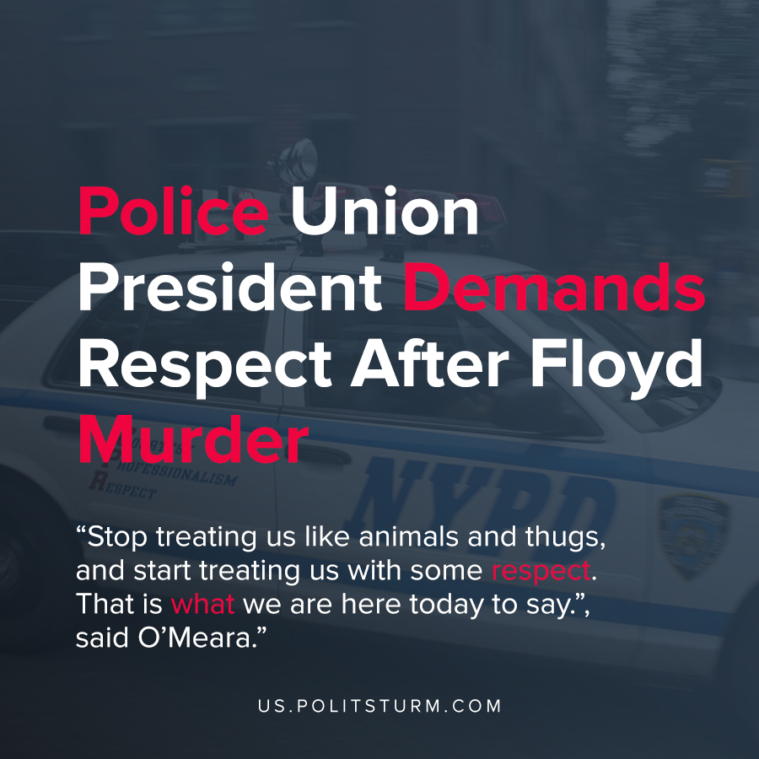

Original article
2020-06-10
1 min read

The President of the New York Police Benevolent Association (PBA) Mike O’Meara defended the police amidst the murder of George Floyd and sweeping protest across the country. The New York Police Benevolent Association is the union that serves the interests of New York police departments.
O’Meara asserted that the press and the public were attempting to “shame” police into being embarrassed of their profession.
“Stop treating us like animals and thugs, and start treating us with some respect. That is what we are here today to say.”, said O’Meara.
O’Meara placed the blame for George Floyd’s death and police misconduct squarely on Derek Chauvin and defended NYPD officers, even though NYPD murdered Eric Garner in a similar fashion to George Floyd in the recent past.
In the midst of calls to defund police across the country, O’Meara took an offensive posture and attacked the media coverage and the public.
The corrupt unions of the police officers defend the interests of the capitalist class in protecting private property and suppressing dissent, as we have seen in the recent protests. O’Meara defends the right of police officers to murder unarmed African American men with impunity, and even goes as far as to demand respect for these actions.
Sources: 1 , 2 , 3

Original article

