Police in Venezuela Kidnap and Arrest Communists
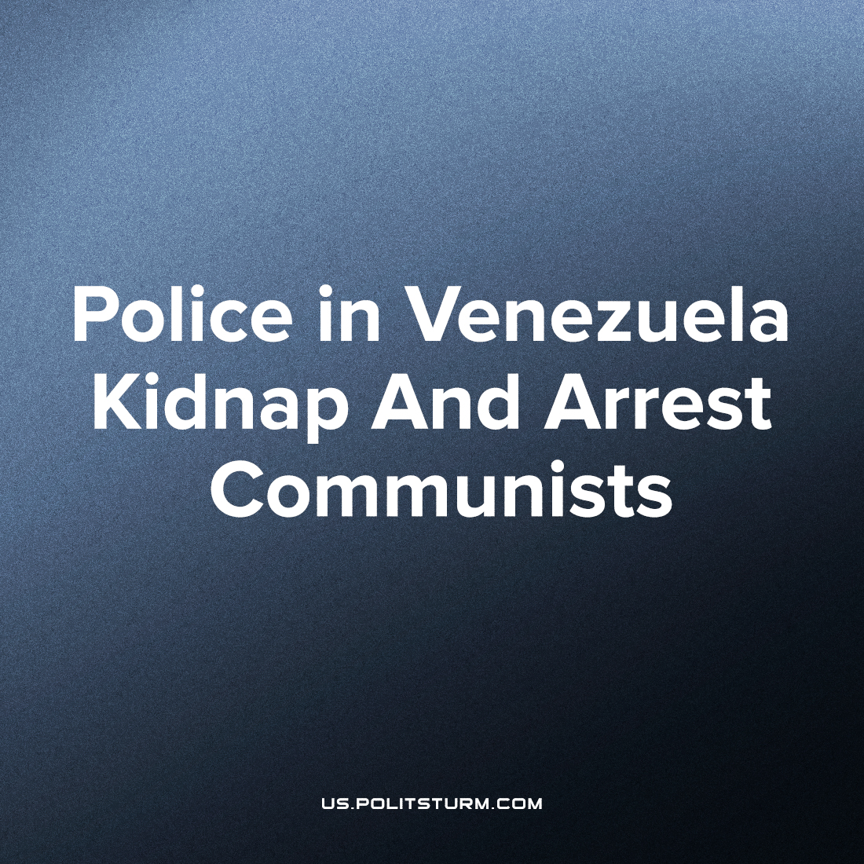

Original article
2022-07-28
1 min read

The Communist Party of Venezuela reports on the repressions of the state against its leading members. The security police surrounded demonstrations together with so-called shock troops from the governing “PSUV” party, beat and kidnapped leading party members.
During a protest organized by FNLCT – National Front for the Struggle of the Working Class – security police and members of the ruling party surrounded the demonstration. They beat and abducted the protesters.
Adelaida Zerpa, a member of the party’s Central Committee and Politburo, was beaten while Ángel Castillo, also a member of the party, was taken away by the police. He was questioned about his relationship with other union members, after which he was released a few hours later. He also received a fine. Castillo is also active in Espacio Sindical Unitario, a labor network formed in protest against the systematic wage cuts implemented by Maduro’s government.
Previously, we published a material about the history of the Venezuelan state.

Original article

