Photos of Inhumane Conditions Emerge Amid Biden's Ban on Photography of Border Policing
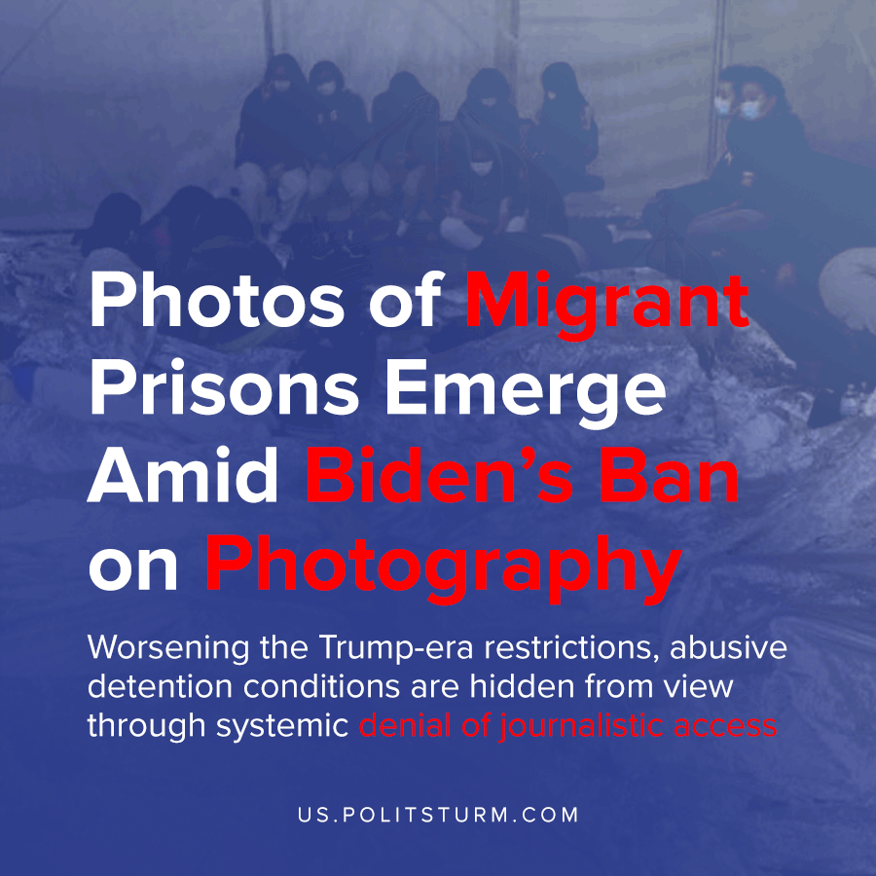

Original article
2021-04-02
2 min read

Early last week, Democratic Texas Congressman Cueller drew renewed scrutiny towards the Biden administration’s mistreatment of refuge-seeking immigrants – by posting pictures from inside the overcrowded Donna, Texas CBP prison building. These photos should not be so remarkable if we compare them to the infamous ‘Kids in Cages’ photos of the Trump era incarceration system. What’s surprising is how unique these images are: few photos, if any, have been published in the standard press under President Biden.
Getty Images Special Correspondent John More claimed in a series of statements that he and other immigration journalists have been barred from taking photos on federal property. This has prevented the publication not only of detention center conditions, but also of CBP policing activities on federal lands along the border.
Biden’s administration has granted permission to photograph migrant detention to far fewer journalists than previous Presidents. In response to a wave of media publicity around this news, Biden distributed his own, approved images with select journalists to be shared ahead of any more leaks.
Heightened restrictions on freedom of press access coincide directly with the abysmal decline of the conditions forced on immigrants by federal border agents. Democrats, and their social-democratic following, have acted as a bloc to advance the cause of the capitalists; which in this case means turning a blind eye to, or attacking criticism of, worsened immigration policies during the transfer of power from Trump to Biden.
These developments further indict the position of social-democrats such as Senator Ocasio-Cortez. Spitting back at her own responsibility for these human miseries, she calls criticism of Biden’s actions a “privilege”.
Terrorism, the use of excess cruelty to advance domination, is the formal policy of the Biden administration precisely because the interests of American business demand it. The state attacks these migrating people so viciously to intimidate the masses of workers in Central America so they will endure immiserated and violent circumstances.
To that end, Biden has sent out U.S. delegations to the Mexican and Guatemalan governments to encourage a more repressive attitude towards immigrants originating in countries to their south. Guatemala instituted “emergency” security orders for its border with Honduras immediately following these talks.
Despite a severe and lethal journey, desperate workers are propelled by the force of the market to enter America to serve as a labor force there that’s subject to an intense scrutiny of the state and will otherwise suffer the worst kinds of living conditions. This ‘illegal’ labor force has been assembled by Capital precisely because it can be exploited in low-paying jobs to the most extreme degree.
In times of declining economy, as the need for this kind of labor falls, the capitalists demand that their state representative cease the human flow of labor traffic that they themselves created. We’re seeing what happens when the state is called upon to deliver its “final argument”.
The only issue the state finds with this formal open hostility is the public outcry that it sometimes creates. Biden plans to avoid this impediment to his work by strictly controlling the widespread publication of the conditions in which thousands of refugees are held.
Sources 1, 2, 3, 4

Original article

