Peru President Ousted After Just Five Months
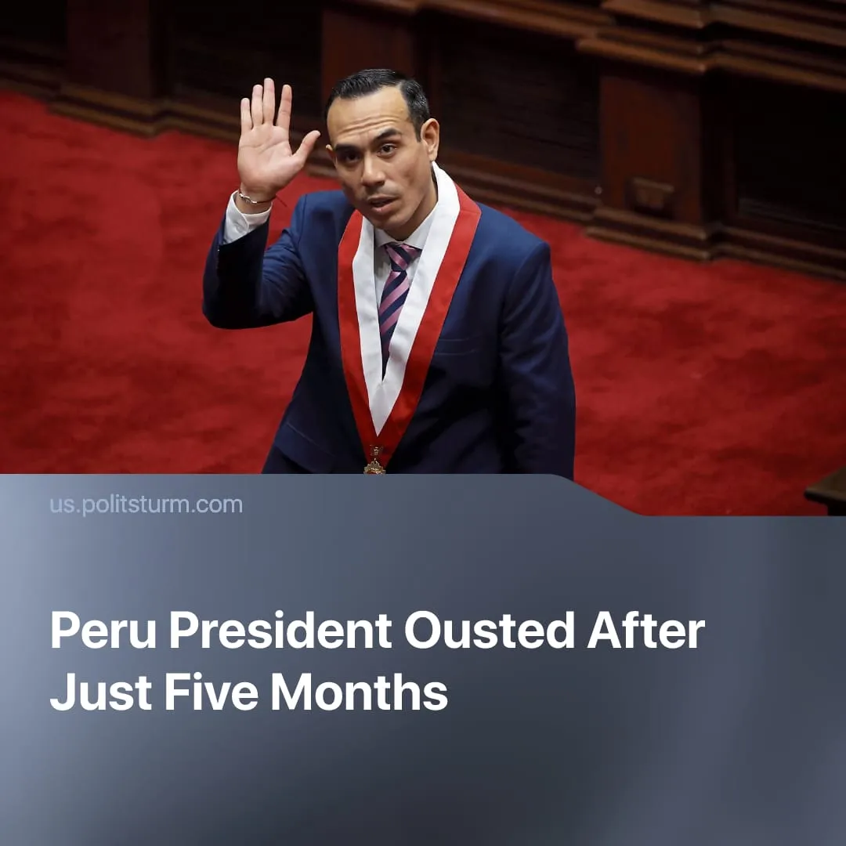

Original article
2026-03-02
1 min read

Peru’s President was ousted after five months amid US efforts to push Chinese capital out of South America.
Details. On February 17th 2026, President Jose Jerí was removed from office after losing a vote of no confidence, making his the 7th Peruvian presidency to last less than 6 months.
► Jerí was accused of unofficial meetings and dealings with Chinese capitalists operating in Peru, namely Zhihua Yang, a commercial and energy magnate, and Ji Wu Xiaodong, who is being investigated for ties to illegal logging.
► The US Bureau of Western Hemisphere Affairs expressed concern that Peru’s weak government is “powerless” to protect the country’s largest Pacific port from “predatory” Chinese owners, warning the nation may lose its “sovereignty” to China. Following US pressure, the majority of Peru’s Congress moved to oust José Jerí.
Context. Through regime change in Venezuela and a stricter embargo on Cuba, the USA is reasserting imperialist control over the Western Hemisphere – pushing out Chinese capitalist influence in South America. This US policy enacts its current National Security Strategy and the Trump Corollary doctrine.
► As part of the “Belt and Road Initiative”, Peru is one of China’s longstanding imperialist projects for its natural resources and ports. This includes the construction of the port of Chancay, funded by the Chinese capitalist state-owned enterprise “COSCO”, and the Toromocho copper mine owned by the Aluminium Corporation of China (Chinalco).
► Peru has been in a major political crisis since last year, with unrest among the working class regarding pension reform and corruption, resulting in the replacement of the former president by Jose Jerí in 2025.

Original article

