People Die, Capitalists Make Profits
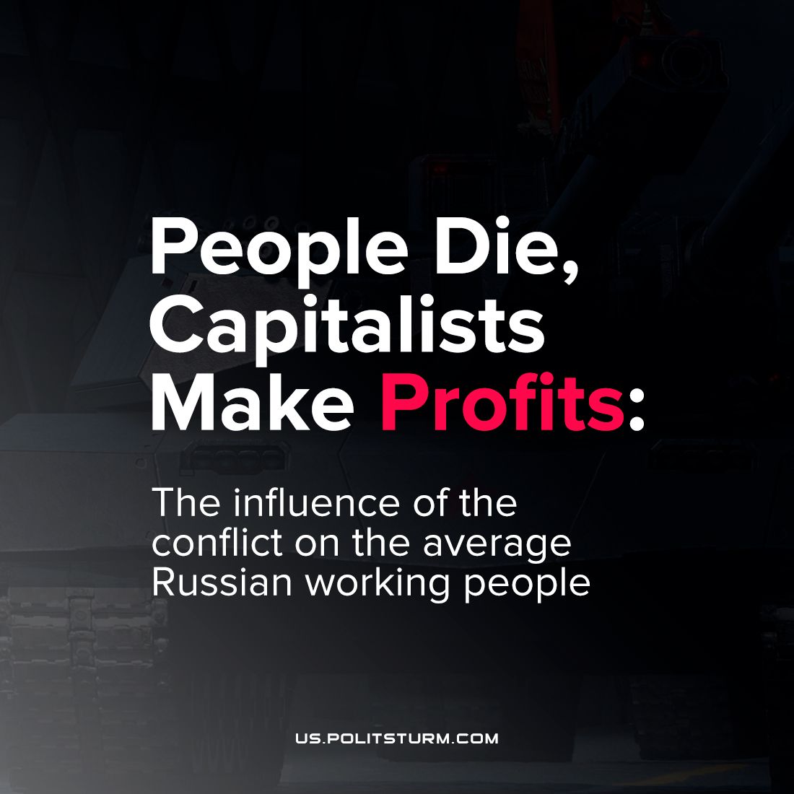

Original article
2022-03-03
1 min read

After the beginning of the so-called “special military operation” of the Russian Federation in Ukraine, the demand for gas in Europe has grown enormously, as have energy prices. The United States has imposed sanctions against “Nord Stream 2” and its operator, which is why a long gas shortage is expected. Nevertheless, the pipe in Ukraine is working normally, and the money continues to flow with even greater force.
The sanctions of the big companies affect not the Russian government, but the Russian people, increasing the drop in living standards. The deaths of people, problems with food, the destruction of infrastructure, and the bourgeoisie is flourishing. Of course, Europe will not be able to completely abandon Russian resources, since liquefied natural gas from the United States is even more expensive, and not all ports can accept it. In Germany, for example, there are no terminals for receiving liquefied gas at all.
And at the same time, the colossal sanctions hitting Russian banks, industry and aviation fall into the pocket of an ordinary worker. For example, the Russian “DNS” electronics store chain has already inflated the prices of goods by 30%. Okay, electronics, you can live without it, right? But the defense industry does not think so, and so do manufacturers of cars and machine tools.
Taiwan and South Korea have closed their microelectronics factories to Russian companies, and there is no large industry in the territory of the Russian Federation capable of producing microelectronics in large volumes.
In Ukraine, In Russia, In the West – the bourgeoisie drains all the juices from the proletariat.
Sources: 1, 2, 3.

Original article

