Pence Attacks Socialism at TPUSA Event
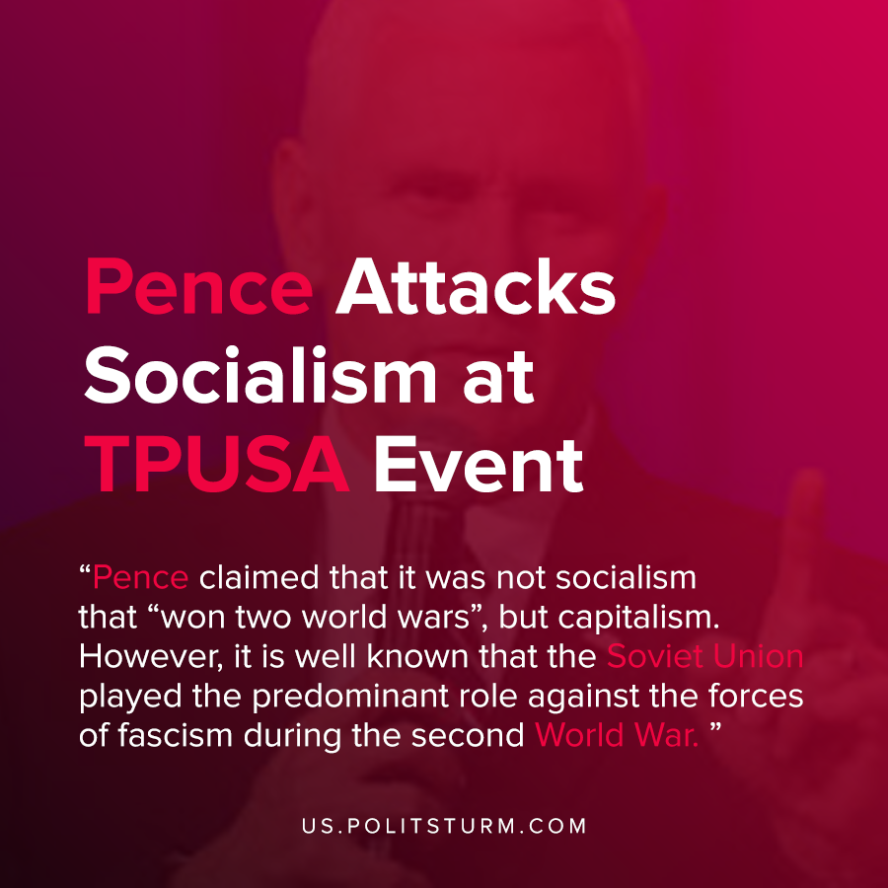

Original article
2020-12-25
1 min read

Vice President Michael Pence made remarks regarding socialism at a Turning Point USA event in Florida. At no point in the speech did the vice president address the hundreds of thousands of Americans who have died of the coronavirus or the crisis sweeping the country.
Rather, the Vice President took the time to address what he considered his administration’s accomplishments and his plans to “keep America Great”.
Pence boasted about the bolstering of the military through increased federal spending and the tax cuts that enriched the oligarchs of the American capitalist class.
He conflated the ‘Green New Deal’ and ‘Medicare for All’ proposals of the Democrats as “socialism”. He then went on to claim that such policies impoverished nations and restrict the freedom of the population.
Pence also claimed that it was not socialism that “won two world wars”, but capitalism. However, it is well known that the Soviet Union played the predominant role against the forces of fascism during the second World War. The U.S. was neutral for the first two years of the war when Nazi Germany invaded Poland in 1939.
Pence neglects to state that the “freedom” that he is speaking about is the freedom of capitalists to exploit and enrich themselves off the hard work of others. Pence is simply using revisionist history to attack socialism and arouse nationalist fervor in response to the contradictions of the capitalist economic system.
Sources: 1 , 2

Original article

