Pelosi Suggests Improving Not Abandoning Capitalism
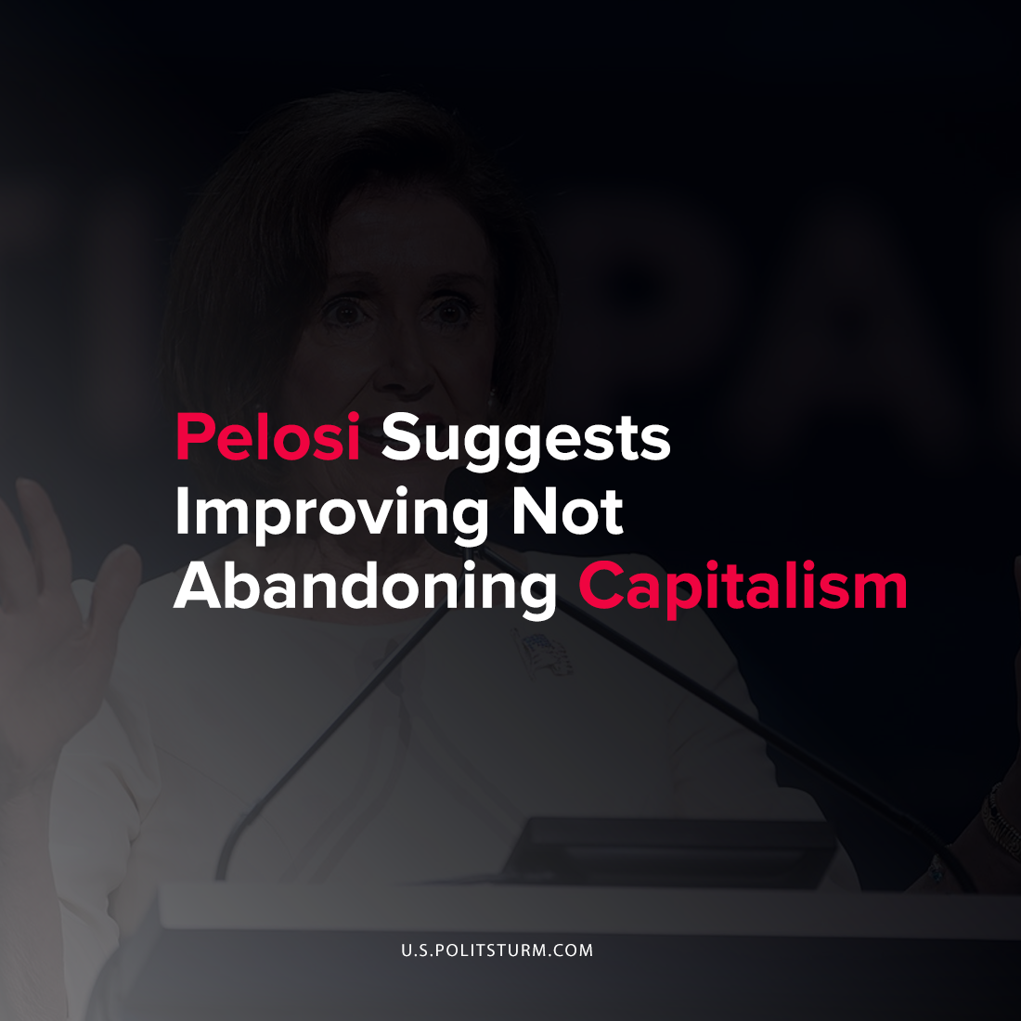

Original article
2021-09-18
1 min read

U.S. House speaker Nancy Pelosi recently made a statement regarding whether capitalism is helping the overall economy while discussing the state of American bourgeois democracy. While the politician remarked that capitalism is “our economic system”, she remarked that it has serious deficiencies that Pelosi suggests can be improved.

“You cannot have a system where the success of some springs from the exploitation of the workers and springs from the exploitation of the environment and the rest, and we have to correct that”, said Pelosi.
While Pelosi suggests that capitalism is not doing well enough for “the economy”, she did not give any information related to those who benefit from the capitalist economic arrangement.
During the period of the coronavirus pandemic, the wealth of the capitalist class grew enormously, by some estimates increasing by as much as $1.8 trillion. Thus it is clear that the dictatorship of the bourgeoisie, capitalism, stands to benefit the private owners of the means of production. Pelosi is merely suggesting that marginal improvements to the conditions of the working class should be made, while maintaining the capitalist economic system which is fundamentally based on the exploitation of the working class. This remark is simply more evidence that Pelosi and other bourgeois politicians serve the interests of the oligarchs and her statements are nothing more than window dressing for the capitalist economic system.
Source: 1 , 2

Original article

