Peace Talks Trigger EU Defence Stock Drop
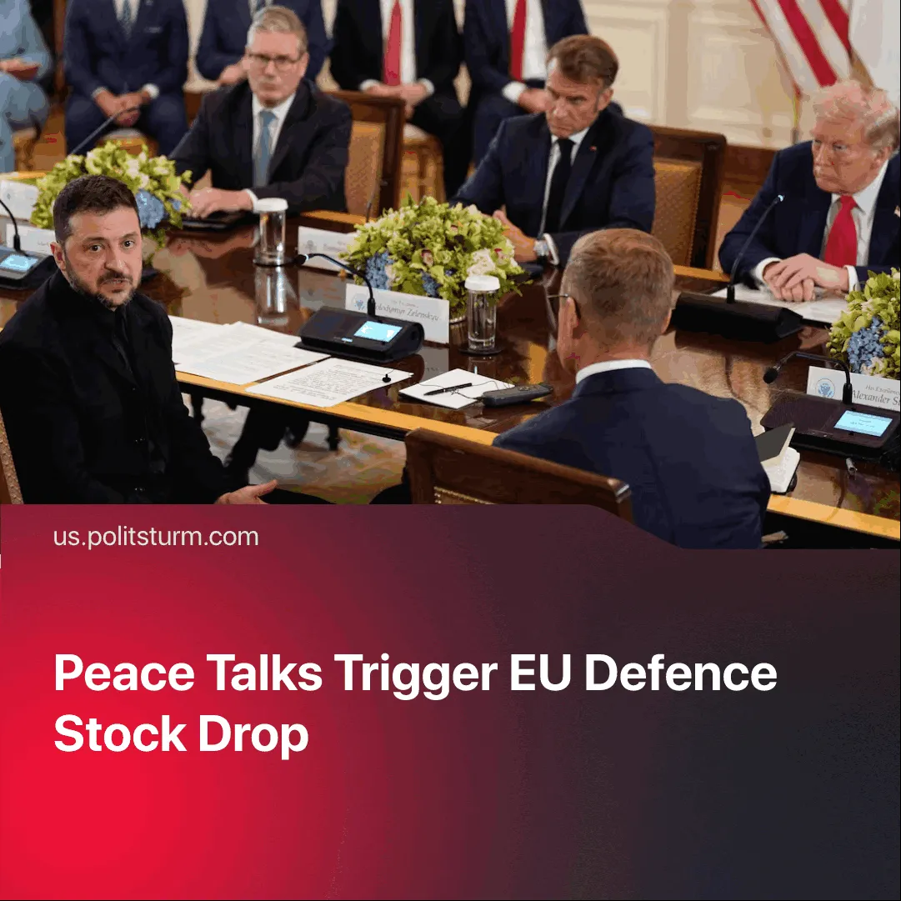

Original article
2025-08-20
1 min read

Planned peace talks with Russia led to a decline in European defence stocks, prompting renewed justifications for military spending.
Details. The announcement of Putin–Trump peace talks led to a drop in major EU defence shares, with Rheinmetall falling 4.6%, Renk 1.6%, and the European aerospace and defence index (SXPARO) reaching a one-month low.
► After the stock drop, one trader media outlet argued that the talks would still benefit European defence stocks, quoting the CEO of Saab, Sweden’s largest defence manufacturer, who admitted that even with a ceasefire, “governments won’t step back and say it’s over.”
► At the EU meeting with Trump following the Putin meeting, security guarantees for Ukraine were emphasised, alongside proposals for a future “reassurance force” that could be sent to Ukraine in case of renewed conflict.
Context. In May 2025, when Türkiye hosted peace negotiations between Russia and Ukraine, defence stocks tumbled by 5–9% across major European firms.► This was followed in June 2025 by a NATO summit, where defence spending was pledged to rise to 5% of GDP by 2035 — guaranteeing long-term demand for arms.
► Smaller states are already straining to meet these targets. Estonia plans to borrow €3.6 billion for new weapons systems.

Original article

