Peace, Capitalism, and Imperialism
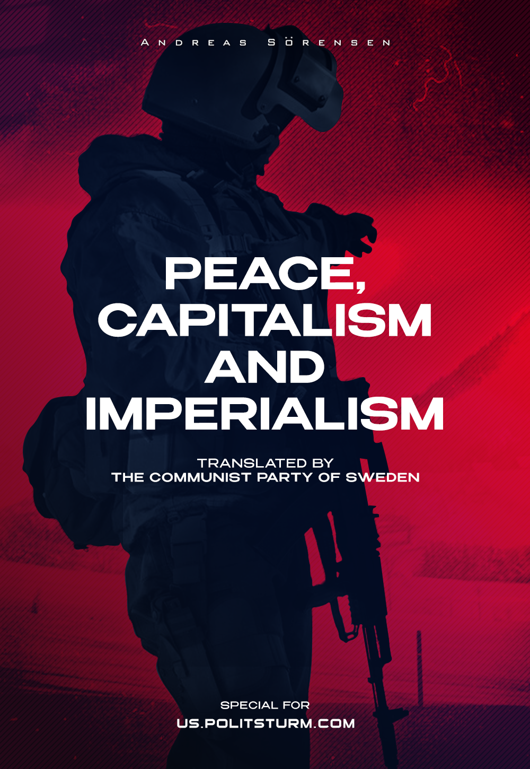

Original article
2022-07-01
15 min read

Preface by Politsturm
This article by Andreas Sörensen – the General Secretary of the Communist Party of Sweden – follows and develops the main ideas of the previous material we published: “Russia and Imperialism”. How are wars created? Is “multipolar” world better than “bipolar”? Should communists keep opposing all imperialists? Or should they put USA in priority as the biggest imperialist in the modern world? These questions are answered in the article.
The original material titled “Freden, kapitalismen och imperialismen” was published in “Riktpunkt” magazine in July 2020, almost 2 years ago.
One of the most difficult theoretical questions that must be solved is that of imperialism. How we understand capitalism, at its present stage, is of utmost importance for how we position ourselves in class struggle, both nationally and internationally. At the invitation of Ulf Karlström and Anders Romelsjö, we would, therefore, like to shed light on this question once again. In particular, through a critique of their book: USA som världspolis.
In an earlier article dealing with Communist Party leader Anders Carlsson’s view of imperialism, in general, and Russia in particular, we focused on one theoretical point specifically: it is not possible to apply Lenin’s analysis of imperialism to individual countries but it must be applied to the capitalist system as a whole.
The conclusion presented by Carlsson, that Russia would be purely capitalist and thus not imperialist, is a theoretical fallacy and with a more careful reading of Lenin, it also becomes clear that this was not how Lenin himself analysed capitalism. Since we have already discussed this issue once, we will not go into it again in depth, but since Romelsjö & Karlström make the same mistake as Carlsson, it may be worth a brief reiteration.

The imperialism of individual countries versus imperialism as a system
Before we begin, we would like to emphasize one thing: although considerable focus has been placed on Russia in discussions about imperialism, it is important to point out that Russia could have been replaced by any other capitalist country. The processes we have discussed above are as active there as in Bangladesh, Poland, and Lithuania as in Sweden, Germany, or the United States.
When Carlsson analysed Russia, he did so based on some of the five features which characterise the capitalist system at its imperialist stage, and which Lenin identified through his study in Imperialism as the Highest Stage of Capitalism. These characteristics, which Carlsson calls “points”, relate to the main trends in the development of modern capitalism:
- Concentration of production and capital
- The formation of financial capital through the convergence of banking and industrial capital
- The increasing importance of capital exports at the expense of goods exports
- The formation of international monopolistic associations that divide the world among themselves
- The territorial division of the world between the great powers is complete
These characteristics, which can hardly be applied to a single country for analysis, were used by Carlsson to analyse a country, in this case Russia. In order to do so, he had to select some of these characteristics that could seemingly fit into the analysis of a country; while leaving others out. Romelsjö & Karlström do the same when they write as follows:
Russia does not meet several important criteria (my italics), with limited capital exports, relatively undeveloped productivity, and high dependence on commodity exports; as well as a few significant monopolies, relative to PPP-adjusted GDP in particular [1].
In order to apply Lenin’s theory to a particular country, one needs to interpret these characteristics as criteria. It then becomes possible to quantify them, though of course with complete arbitrariness and without any pretension to even the slightest scientificity, and to say when concentration reaches a given point, when finance capital develops to a given level and when capital exports develop to a given degree, a country becomes imperialist; before that, it would be capitalist. Apart from not being able to answer when a country reaches a certain level, it is also impossible to explain what to do with the last of Lenin’s characteristics; in particular, it is difficult to apply it to a country. Romelsjö & Karlström do as Carlsson does; they ignore it.
Instead of carrying out violence towards Lenin’s analysis, one must take advantage of what Lenin writes about these characteristics: they are characteristics of “a phenomenon in full development”. [2] The Leninist perspective allows us to capture the movement in the development of capitalism; it shows us that what the characteristics describe are ongoing processes, which explain the policies of various monopoly conglomerates and are not criteria or points for statically measuring the imperialism of individual countries.
In all capitalist countries, these processes are at work and they characterize a developing capitalism. Throughout the capitalist world, the tendency is for the importance of capital exports to increase at the expense of the importance of commodity exports, just as it is for capital and production to concentrate in each individual country, and for finance capital to crystallize more clearly everywhere.
Of course, all this does not exclude that different countries have reached different stages; capitalism, as we know, develops differently. How far the processes have reached in different countries is ultimately a measure of how developed capitalism is in different countries, not how imperialist they are.
To write that Russia does not meet several of the criteria for being imperialist thus misses several points:
- No distinction can be made between capitalist and imperialist states and nations, but we must regard all capitalist nations as capitalist nations within the imperialist system.
- It is not possible to apply Lenin’s characteristics of a developing phenomenon to individual countries; that would violate his analysis and would miss the mark.
- In an analysis of imperialism, it is not relevant how far these processes have reached in a given country but that they are at work there.
We can now conclude that theoretically, all three start from the same theoretical errors and there is no major difference between their views on imperialism.

A bi- or multipolar world?
However, there are some differences between Carlsson and Romelsjö & Karlström: the latter also chooses to emphasize the importance of breaking up, what they call, the “unipolar world order”. This, they also argue, is “the absolutely crucial and most important political issue”. [3]
Put simply, the unipolar world order means one actor, more or less, dominating the world. This is what they call, in quasi-conspiratorial language, the “Hegemon”. This actor is currently the United States and breaking its power over the world is of paramount importance to Romelsjö & Karlström. The reason why they see it as their most important task to do so they describe as follows:
A developed bipolar world order will balance US-NATO, and act as a restraint on their intended war adventures. [4]
Although they go on to note that “increased competition can also lead to serious conflicts and wars”, it is clear that these risks are preferable to a world order dominated by American imperialism.
Is there something in this? Let us start by saying one thing: it is quite true that American dominance is being challenged and inter-imperialist antagonisms are growing. Not only are China and Russia taking more independent positions vis-à-vis the United States, but the European Union, led by Germany, is also acting more and more independently, particularly on the issue of gas pipelines to Russia and relations with Iran.
Other projects such as BRICS, a cooperation between Brazil, Russia, India, China and South Africa, involve the formation of another imperialist pole, while smaller capitalist nations join together in regional and local alliances to protect their interests as Venezuela, for example, has done in ALBA.
So far, it’s hard to disagree. However, it is difficult to agree that this development would be positive and a guarantee against war. When we look a little closer at the claim, it falls to the ground fairly quickly.
A quick glance at the history of capitalism suggests that a multipolar world order hardly opens the door to peace or keeps stronger powers in check through some kind of balance of terror.
Before the First World War, when the world was characterised by several imperialist poles, the peoples of the world experienced virtually constant wars as colonies were expanded and raw materials, market shares, and transport routes were secured. Great powers such as Germany, the US, France, Britain, Russia, Japan, and Italy expanded to secure their own interests. The end result was the first imperialist world war, in which much of the world was drawn into a war, that left over ten million dead.
The world was similarly characterised by multiple imperial poles and centres in the run-up to the Second World War, although some competitors had disappeared and others had been strengthened. German, British, French, American, Japanese, and Italian imperialism remained committed to expanding worldwide and wars followed one another; both in Europe and around the world. Regional powers, such as Hungary, also participated in the division of the world. The end result was, again, a terrible war with tens of millions of deaths.
In theory, the multipolar world would have been more peaceful, but the claim hardly holds. We can easily conclude that the reality is in clear contradiction to the theoretical assumption that a so-called multipolar world would be more peaceful. This does not mean, however, that a unipolar world would be preferable.
If we can say this, we must ask ourselves a very important question: why is the world not peaceful? The answer is to look at the capitalist system itself as the root of capitalist wars. The existence or non-existence of war does not depend on the strength or weakness of a given nation but is an inevitable consequence of the capitalist economy.

The capitalist wars
In the article directed at Anders Carlsson, we briefly quoted Marx when he wrote about “the insatiable hunger for surplus labour” and capital’s “werewolf hunt for surplus labour”. This is also our starting point when we turn our attention to the cause of war and the basic mechanisms of capitalism.
In the capitalist market, there is an iron competition which was further intensified by the transition of capitalism to imperialism. To this, every enterprise must relate, which in short means that every enterprise must choose between eating or being eaten; growing or disappearing. The company that does not grow and expand will be overtaken by the other companies. All businesses are subject to a compelling need, namely, to grow at the expense of others or to shrink and disappear in favour of others.
This situation has two main consequences: expansion forces companies to expand beyond their borders, in order to export their capital to areas where profits are higher, and to increase the extraction of surplus value from their own workers. Two struggles thus arise: that between the various expanding firms, and that between the firms and the workers.
The process is mandatory for every company in every country. It is impossible to stand outside and not grow, or to choose not to increase exploitation. The result is capital expanding from all sides. In each country, production and capital are concentrated and out of each country, grow the strongest monopolies in a struggle for the world market. Friction between the various national capitals is growing stronger and stronger, and in the end can only be resolved by war.
In this process, which has no end, but continues constantly under capitalism because nothing else is possible; if anything else were possible, it would not be capitalism. It is not a uniform process but the strength of the monopolies and their state shifts.
Some economies are overtaking others and thus claiming larger interests for their monopolies in every possible way. They exercise more aggressive diplomacy, carry out more offensive military operations, or are strengthened through mergers, trade agreements, tariffs, and so on. They work hard to push other countries down the imperialist hierarchy, while the latter in turn try hard to cling to their privileges, which ensure favourable conditions for them. This process inevitably leads to an acceleration of the extraction of surplus value and, at the same time as the friction between national capitals increases, their own peoples must also be attacked in order to increase the extraction of surplus value and thus gain an advantage in competition.
One of the means used in the intra-imperialist struggle is precisely war. We saw it before in both the first and the second imperialist world wars, and we see the same tendencies now: the margins of the monopolies are shrinking and, in a number of places around the world, the contradictions are becoming sharp enough to force war. In Syria, not only American and Russian capital, but also Saudi, Iranian, and Turkish capital are facing off in a struggle for supremacy. In Ukraine: Russian, American, and German imperialism clashed. Venezuela is being vigorously attacked by the US, while Russian and Chinese interests are strengthening their positions in the country.
Even if Romelsjö & Karlström’s multipolar world had existed, it necessarily could not have existed because the intra-imperialist struggle continues, forcing new constellations of power and ever sharper contradictions. There is nothing – either historically or theoretically – to support the thesis that increased imperialist competition is conducive to peace or that it is anything other than a disaster for peoples. This is not to say that a single strong power is better, but our emphasis must be clear: capitalism in all its forms is a disaster for all peoples.

The consequences of Romelsjö & Karlström’s view
In their theorizing lies the seed of a denial of the most basic laws by which capitalism operates. There is the seed of a denial of the history and scientific analysis of capitalism and their assumptions have left both Marxist analysis and reality.
Through their assumptions, they present peace as possible under capitalism, shifting the focus from the class character of each state and the struggle for its own monopoly, to the strongest power at the time. In so doing, they contribute to the creation of illusions in the working class in that they tie it to the hope that progress would be possible under capitalism, on the one hand, and to the idea of the road to socialism through the struggle for the lesser evil, which has historically proved to be a powerful defence of capitalism, on the other.
In the end, their position means nothing more than a rejection of the realization that the enemy is in their own country. For Romelsjö & Karlström, the Russian or Chinese working class no longer have their enemies in their own bourgeoisie, but they have a common enemy in American imperialism! But what happens once American imperialism is crushed and Chinese, German, or Russian imperialism has emerged as the world leader? Will they break with their own way of thinking and finally take a stand for socialism, or will they take a stand for Indian or Brazilian capitalism in order to break the power of the strong?
This hard-won insight, which guided the creation of the communist parties over a hundred years ago, has been theorized away. Although it was defining for the communist parties not to take sides with various imperialist powers but to work for revolution against their own oppressors, Romelsjö & Karlström choose the same path as the social democrats in every country that granted war credits to their own imperialism in the run-up to the first imperialist war.
Ultimately, this leads us into the discussion of what the purpose of a communist party is. Is it to lead the working people into a struggle against imperialism, albeit, on behalf of an underdog? Or is it to prepare the people and build the party for a transition to socialism and communism?
I think the answer is obvious. A party or individuals reduced to being servants of the weaker capitals or to be some kind of moral arbiter who stands aside to judge which capital is worth supporting have long since lost their political compass and hardly constitute a guide for a movement that wants to break with capitalism and imperialism.
[1] USA som världspolis, p. 69
[2] Lenin.
[3]https://www.globalpolitics.se/kampen-mot-usa-imperialismen-vilka-kan-vi-liera-oss-med/
[4] USA som världspolis, p. 82.

Original article

