Russian Orthodox Patriarch Has Proposed Protecting the Traditional Values Through a Convention
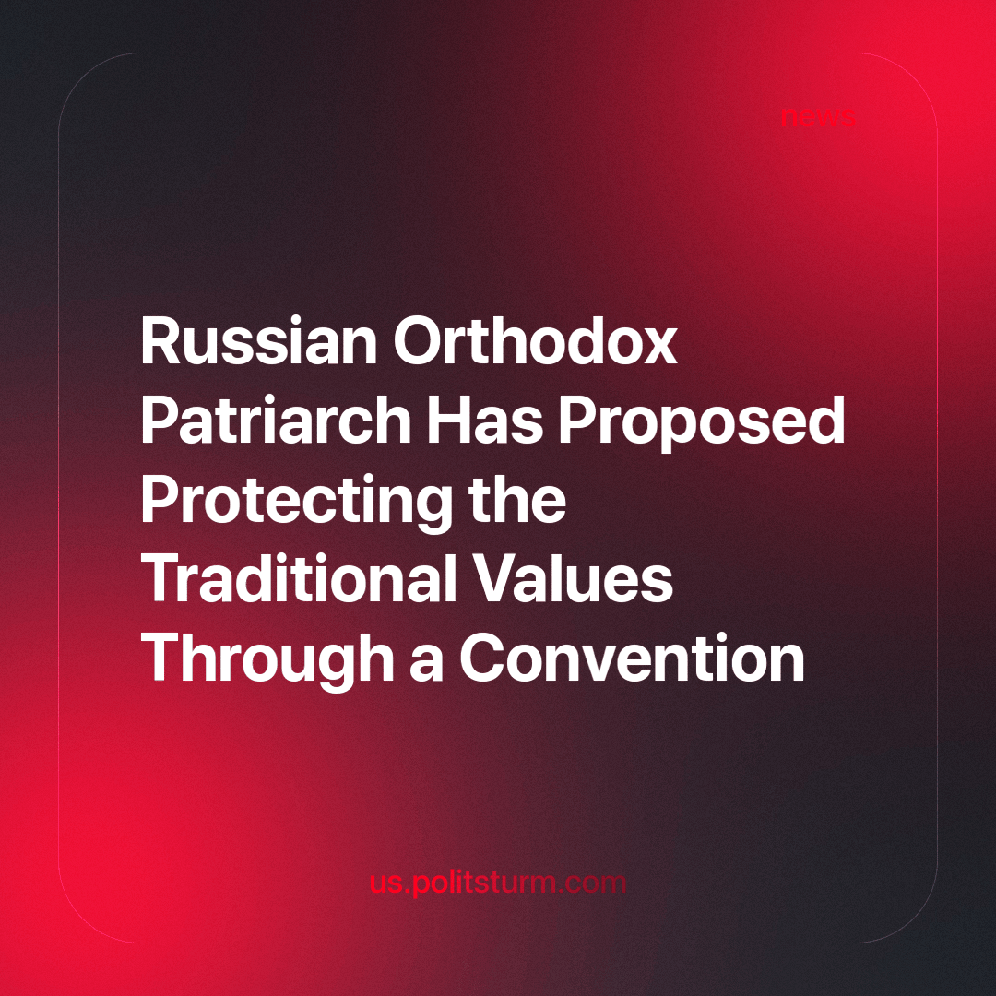

Original article
2023-11-10
1 min read

At an exhibition held in the State Duma dedicated to the All-Russian social project “Family is the Foundation of the World”, Patriarch Kirill of Moscow and all Rus' proposed forming a convention on the rights and protection of the family, which other countries could join.
According to Gundyaev, Russia could become the leader of this movement by initiating the convention. He invited parliamentarians to consider the possibility of developing such a document, with the goal being to create policies providing families with improved social support, appropriate conditions for large families, protections against bureaucratic arbitrariness, and a reduction in the inclination to conduct abortions.
These seemingly noble aims fall apart when the impact of class society is taken into account. Family relationships and the behaviors commonly called “values” are very different among different social classes. The social rules for families of workers are completely different from the social rules for the families of capitalists. For example, if a proletarian woman has an abortion, it is considered “promiscuous” and “immoral”, while it is a simple thing for women of the bourgeoisie to cover it up, and it is rarely mentioned as an issue in political discourse. Social existence is what determines human consciousness, not the dictate of religion.
Mr. Gundyaev does not need to understand such subtleties, because his role as a leader in the church is to push the agenda of the bourgeois state and continue to rest on his laurels as a fighter for spirituality.
The main cause of abortions is poverty, not a lack of spirituality.
The trouble is that the bourgeois government cannot provide any measures capable of ensuring a constant increase in the well-being of Russian families. There is only the misleading rhetoric of Gundyaev and others like him, which will continue to be provided in lieu of actual solutions to poverty and crises.
Source: EADialy - “Patriarch Kirill proposed protecting the rights of traditional families with a convention” dated September 19, 2023.

Original article

