‘Parallel Imports’ US Companies Defy Sanctions to do Business in Russia
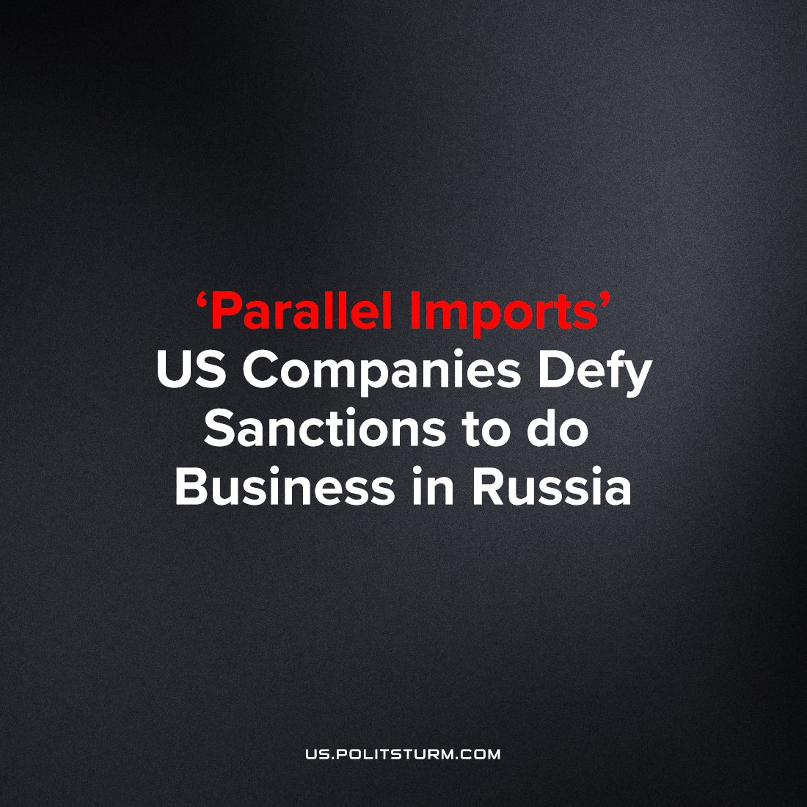

Original article
2023-07-10
1 min read

According to Reuters [1], the American company Extreme Networks Inc., continues to supply goods to Russia with the help of intermediary companies and individuals, even after it had announced the cessation of trade with the Russian Federation. At present, Extreme Networks equipment enters Russia under the flag of Chinese goods, skirting American and European trade sanctions. Trade restrictions are unprofitable and to neglect an entire market, particularly one with as many opportunities for exploitation as Russia, for capitalists means missing out on huge profits. A senior manager of a company in Russia set up his own firm supplying the region with foreign sanctioned equipment. Despite being warned for more than a year, Extreme Networks do not interrupt the prosses.
This situation in Russia is now being termed "Parallel Imports" We have linked examples of parallel imports in the Russian market in the list of sources [2],[3]. This procedure allows Russia to receive the entire range of banned goods, and in fact the producers of these sanctioned goods and their intermediaries receive super-profits from heightened prices.
Essentially, all participants in the current political conflict have interests in concealling their real economic motives. Since none of the parties to the modern political conflict refuses to cease profitable trade with their opponents, as we often report, we can conclude that their real goal is to make super profits. In this case, war and the political crisis are convenient tools in the hands of big business.
The reasons for hiding the true intentions of the participants in the conflict are quite clear; for the sake of big business profits countless people die every day. If not to hide it behind slogans about liberation and the brave defense of the national interests, the grieving people would take hold of this fact and realize their own class interests first by standing against these bloody conflicts.
Sources:
1)https://www.reuters.com/business/top-manager-us-firm-privately-sold-high-tech-russia-2023-06-28/
2)https://www.autonews.ru/news/63ada0999a79472985649c90
3)https://www.reuters.com/business/russia-publishes-list-parallel-imports-goods-2022-05-06/

Original article

